Cleaner / General Assistant
Service  Citywide Services | Reporting to  Area Supervisor | Location  Various | Grade  1B

About the role
- You will contribute to the efficient and effective delivery of cleaning and catering services within Citywide units.
- You will be responsible for the cleaning of designated areas, toilets, and associated facilities against an agreed cleaning specification.
- You will undertake laundry duties as required within the unit.
- You will ensure cleaning equipment is in a safe and clean condition and report any unsafe, faulty, or broken electrical equipment to the Area Supervisor immediately.
- You will ensure the correct dilutions of cleaning chemicals to ensure efficient use.
- You will ensure lights are switched off, doors and windows are secure.
- You will ensure the cleaning cupboard and sluice are always kept clean and tidy.
- You will liaise with the Area Supervisor to ensure adequate cleaning stocks are maintained and issued to cleaning staff as appropriate.
- You will need to report to the Area Supervisor / Caretaker / Manager matters which require attention.
- You will have responsibility for the opening and closing of the building, setting or un-setting alarms if required.
- You will be required to perform domestic duties in the kitchen.
- On occasion, you may be required to assist at other Citywide Services units.
- You will be required to complete relevant training, as directed by Citywide Services within the timescales specified.
- On occasion, you will be required to attend meetings / training courses as required.

Key outcomes
- The cleaning of premises to the required standard and meeting individual customer requirements.
- Keeping people safe by keeping surfaces clean and using the correct dosages of cleaning products.
- You will assist and contribute to the delivery of a quality catering service.
- You will contribute to set hygiene standards being maintained within our kitchens.
- You will contribute to keeping children and adults safe through delivering a quality food service.

What we need from you
- To model and demonstrate our values and behaviours.
- To be able to sweep, vacuum, clean, buff, empty bins, polish, and dust. This includes toilets and associated facilities and fixtures and using the necessary powered equipment where appropriate.
- Ability to work under own initiative without supervision.
- Basic numerical and literacy skills.
- Ability to understand verbal and written instructions.
- To be aware of the importance of providing a quality service and satisfying customer needs.
- To be aware of the importance of Hygiene in the workplace.
- Knowledge of COSHH regulations and Health & Safety in the workplace.
- To be aware of the dangers of mixing chemicals and cleaning products.
- To complete all Citywide training as directed within the timescales provided.
- To possess or be able to undertake and obtain Basic Food Hygiene Certificate within 6 months of appointment to the post.
- To carry out their duties with full regard to the City Councils Equal Opportunities, Health and Safety and Community Strategy policies.

Our vision and priorities

Our vision
The council has a vision is to create 'A fairer, greener and healthier Salford'. To help us achieve this vision we have identified some key priorities to tackle the problems people in Salford are currently facing, the Great Eight.
Salford is beginning a journey of economic transformation, with the mapping out of the city’s economic future through key pieces of city council work. We’re calling this The Salford Way.
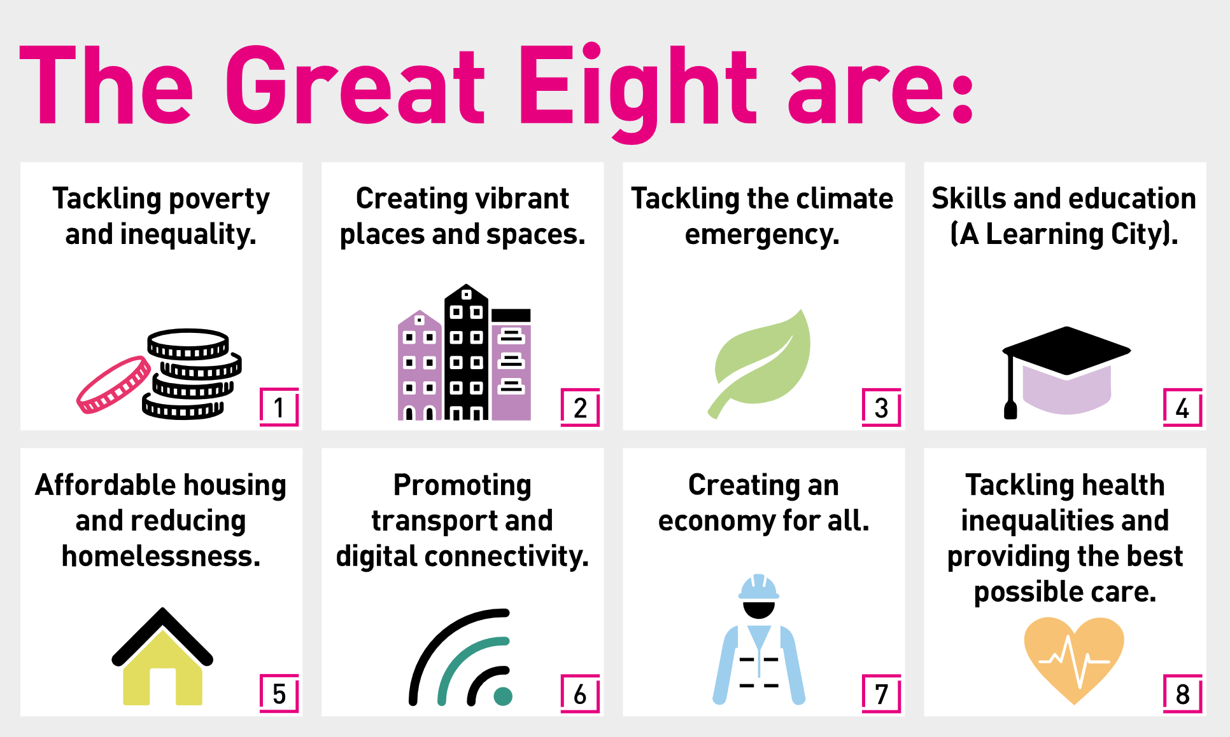

Our organisation’s values
We have four values: Pride, Passion, People, Personal responsibility.
Our four values are central to the way we communicate about the council and the way in which we behave with colleagues, customers, and partners - so that we live and breathe our values each day.

Application guidance
We are a values-based organisation so reflecting our values or a values-based approach in your evidence will support your application.
The different sections of this role profile are there to give you an understanding of the purpose of the role. The ‘what we need from you’ section outlines the minimum criteria you will need to meet within your application.

Role details
Completed by: Lucy Clarke, Service Manager, Citywide Services
Date: 31/07/2023
Job code:
Job score:
Date of evaluation:

