Public Health Engagement and Inclusion Lead
Service: |  | Public Health | Grade: | 4C |  |  |  | Salary: |  |  | £39,880 to £42,821 (pro rata if part time)
Reporting to: |  | Public Health Consultant | Location: | Flexible with some work across Salford |  |  |  | Hours: |  |  | Part-time or Full-time up to 36 hours
About the role |  |  |  |  |  |  |  |  |  | Our priorities
This is a public health role to help tackle health inequalities through targeted engagement and inclusion work with communities, within the parameters of the Locality Plan and the key public health strategies, and to provide direct work to COVID-19 as the top priority.  - To support colleagues; partners and stakeholder organisations to deliver activities as the link between public health key messaging, communications and engagement teams, trusted leaders in communities (GPs, neighbourhood managers, health improvement and VCSE leads), and community leaders.  - To advocate for the needs of individuals and groups who may be disadvantaged by size, language, cultural or systemic barriers to accessing health, care, housing or NHS, or council services.  - To ensure that the Public Health service have robust engagement and support in place with vulnerable and minority communities for minimising risk and contact tracing as part of the Covid-19 response.  - To work closely with members of the Public Health Covid-19 response team to facilitate addressing any outbreaks within vulnerable communities in line with the Local Outbreak Management Plan.  - To work collaboratively with colleagues across the council, including those who lead on communications, equalities and inclusion, and cohesion. This will include but is not limited to:  - Seeking opportunities to engage communities in wider health inequalities and inclusion through the provision of information and support.  - Engage with and influence partners to ensure that wherever possible we are taking a whole system approach which is in the best interests of people from the identified vulnerable groups.  - Working with partners to tackle stigma and systemic barriers that face BAME communities and other protected characteristics as well as other barriers like fear of authority, reprisals and community cohesion issues that may arise in the course of the pandemic.  - To help shape the development and production of specialised communication and engagement materials, social media and videos; drawing on behaviour change theory and national / international resources.  - To ensure timely advice, guidance and support to the city’s diverse communities relating to Covid-19 and the local outbreak response using an effective and integrated cross channel communications approach.  - To facilitate relationships and co-develop key public health messages with key members of identified vulnerable communities; community groups; workplace settings, education settings and other partners.  - To establish an effective, clear, communication process with settings used by the identified target communities, such as workplaces, cafes, shops, barbers and education settings.  - To gather evidence to demonstrate the impact of the engagement work undertaken across the Salford system, and produce and present reports to relevant internal and external partners. |  |  |  |  |  |  |  |  |  | 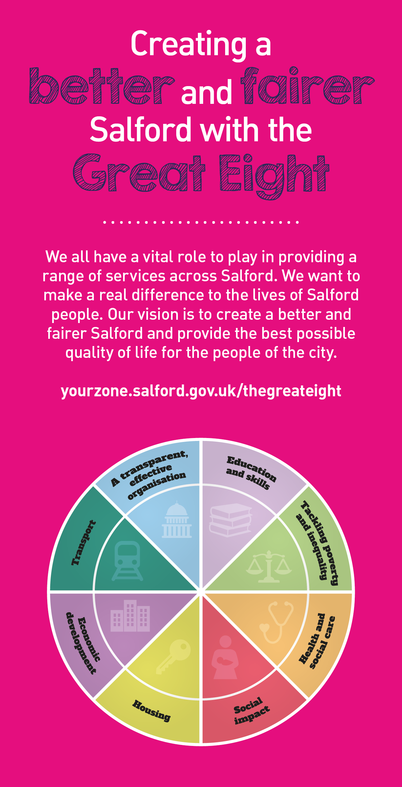
 | Key outcomes
 | - Develop and operate a Public Health framework for the way we work to promote inclusion, equality and diversity. Manage a risk and issues tracking mechanism and proactive resolution and escalation processes.  - Ensure the public health communication and engagement with communities is in line with the Community Impact Assessment plan.  - Contribute insights and appraisal for the public health Equality Impact Assessments, Health Inequality Impact Assessments, and for Building back a better and fairer Salford in the context of COVID-19  - Contribute to an effective risk assessment process to work with diverse communities and settings to prevent Covid-19 outbreaks.  - Contribute to the delivery of the Local Outbreak Management Plan and the specific outbreak management plans for high risk groups in the community.  - Ensure there is an understanding of the response that communities need to undertake, and that links are established to support a swift response to any outbreaks. |  |  |  |  |  | - Develop forward plan for public health work on equality and inclusion to complement the public health team calendar of engagement. Provide proactive and reactive support to the team for the Public Health campaigns.  - Strengthen engagement with identified communities on the wider determinants of health, care, inequalities, and related topics.  - Influence partners, workplaces, community members and groups, to improve the preparation for, and response to, any Covid-19 outbreaks and use specialist knowledge to ensure robust relationships are in place to ensure a comprehensive response  - Promote compliance with the risk assessments for identified communities and settings, and Test and trace activities.  - Promote take up of COVID risk health checks and flu jabs for frontline key workers, volunteers and the BAME communities in Salford.  - Co-ordinate public health contribution to the work undertaken by the council, partners and stakeholders to deliver specific community engagement, and work with communities to co-produce our approach.
 | What we need from you
 | - Specialist knowledge relevant to the role at Masters level or equivalent experience (e.g. public health, behaviour change, social marketing, health improvement, development studies, equality and/or advocacy)  - A proven track record of working in partnership with communities and organisations to assess needs and/or influence their work to tackle health inequalities. This may include experience of working in or with the NHS, local government or VSCE sector on improving health outcomes.  - A sound working understanding of the social and cultural influences on different vulnerable and minority communities in Salford.  - Experience of working in/with minority communities, with thorough understanding and commitment to equality of access and opportunity.  - Proven technical skills and ability in the role with a record of accomplishment for delivering outcomes  - Knowledge and understanding of rights, regulations and good practice in equality, diversity and inclusion relating to the wider determinants of health (housing, employment, education) and health and care services.  - Ability to strengthen community engagement and mobilisation of community partners to raise understanding and awareness of Covid-19 and the local outbreak response.  - Ability to co-produce solutions with partners and communities. |  |  |  |  |  | - Ability to communicate public health priorities and evidence-based initiatives to a variety of audiences using effective and appropriate approaches.  - Ability to engage and work with a wide range of minority community audiences; ensuring you draw on your specialist knowledge and share complex information in an engaging and easy to understand format.  - Ability to engage with internal colleagues; partners and stakeholders to achieve a joined up, effective approach to communicating with minority communities.  - Ability to engage effectively with a range of audiences, including those at a senior level, to influence and shape thinking.  - Ability to work effectively with the Public Health Intelligence function to ensure an evidence led approach which incorporates local and service intelligence alongside national data to inform priorities and activity.  - Ability to prioritise competing demands on resources to deliver identified objectives/outcomes.  - Ability to utilise strong interpersonal skills to network and see the bigger picture, understand links and how the organisation and partners work.  - Ability to work with multiple partner organisations and on several strands of work at any one time using negotiating and persuasive skills.  - To model and demonstrate our values and behaviours.
What we can offer you
Your ongoing professional development and success in your role is important to us, and that is why we provide a variety of learning and development opportunities. Within the sections below you will find development options tailored to you which will enable you to further develop your existing skills and learn new ones at a pace that suits you best. If you are joining us now, your development will form part of ongoing discussions with your manager. If you are an existing employee, you should use your Personal Development Reviews to discuss your development with your manager and create your development journey. It’s important you also take full advantage of any informal learning available to you during the course of your work, including coaching, mentoring and shadowing. Please discuss these options with your line manager.

- Online Learning - Develop your knowledge across a wide range of areas through our Me-Learning platform, with over 200 free courses to choose from. To have the best possible start and comply with current legislation, you must complete the following modules: Welcome to Salford, Health and Safety in the Office, GDPR, Equality Essentials, Safeguarding Children and Adults, and Safer Recruitment. You may also benefit from a variety of courses in categories such as Business Skills, IT and Project Management which are available to learn at your own convenience and pace.  - Developing your digital skills – Our ambition is to provide our workforce with the right level of digital capabilities needed to be successful. Whatever your current digital abilities are, we can provide development ranging from essential workplace skills to specialist workplace skills’. These will be delivered through our Digital Skills Academy using both self-directed and guided learning opportunities to enable you to develop. Additionally, you can access free online courses through the iDea website. |  |  |  |  |  | - Professional Development – Gain role specific skills and time to learn through a wide range of development opportunities. Learn whilst working and get support towards your qualification through an apprenticeship’s standard. Access professional development ranging from entry level to master’s level qualifications. This apprenticeship is relevant to this role, others may be available. Details can be found on www.instituteforapprenticeships.org/apprenticeship-standards/  - Sharing your digital skills – Our goal is to support you to share your digital knowledge with other people. Our Digital Eagles programme has been designed to cover basic digital skills and build your confidence to assist others. By the end of this programme you will join hundreds of staff members who already are digital eagles, and be able to help colleagues, customers, residents, or people in your personal life with all things digital.

Application guidance |  | Our values
We are a values-based organisation so reflecting our values or a values based approach in your evidence will support your application.

The ‘Key outcomes’, ‘What we need from you’ and ‘our leadership behaviours’ sections of the Role Profile are there to give you an understanding of what we would like to see reflected in your application. Don’t give up if you are not able to reflect all of these in your application.

Click here to enter text.

