Job Specification
Job title: | Quality Performance Officer
Service: | Peoples Directorate: Provider Management and Market Development
Grade: | G8
Reporting to: | Lead Market Oversight Manager and Lead External Provider Managers

Your job
Quality Performance Officers work across the whole health and social care economy including; domiciliary care, residential care, nursing care, day opportunities and housing with support / supported living for people with a learning disability. They are key to ensuring that the local health and social care market is diverse, nurtured, challenged and supported with a positive customer experience where quality is the driving force behind all interactions. The Quality Performance Officer will be part of an experienced team that nurtures, supports and challenges the quality of the local social care market through established relationships based on trust and transparency whilst holding a different conversation with people in receipt of services and their families to understand their aspirations, expectations and experiences of services.

You will work as part of the Provider Management and Market Development Team within Adult Social Care and Health to support and influence the continuous development of a robust approach to market oversight and quality assurance in line with the Care Act 2014. You will be required to implement this with a diverse portfolio of internal and external providers. As a Quality Performance Officer you will ensure that the approach is focused around strengthening a wide range of relationships with not only service providers but other health and social care teams and professionals whilst engaging in a different conversation with people in receipt of services and their families and friends.

The Council is committed to complying with the European General Data Protection Regulations (GDPR) and meeting the requirements of the Information Commissioner’s office (regulating data protection compliance in the UK). It is your responsibility to ensure that the work you undertake is compliant with the General Data Protection Regulations.

In this job you will
Within the first 12 - 18 months you will:

- Promote an asset based approach with providers and lead a consistent approach to the Wigan Deal for Providers and Customers within 9 months.
- Build trusting relationships with a portfolio of service providers which nurtures innovation and continuous improvement to achieve greater experiences and outcomes for people in receipt of services within 9 months.
- Within 9 months streamline and integrate quality assurance and market oversight functions, working in partnership with all stakeholders including the CCG and CQC where possible.
- Address poor performance promptly and effectively using evidence based quality assessments and a supportive service improvement process.
- Support the Lead Market Oversight Manager and Lead External Provider Managers to proactively manage the impact of provider failure on service users, taking responsibility and accountability for ensuring continuity of care and support on an ongoing basis.
- Ensure that safeguards are in place to protect vulnerable people and that the application of safeguarding policies and procedures is robust.
- Assess the quality of services across the market, measured against locally agreed quality standards.
- Contribute to the review, development and implementation of quality standards and ensure that these are met by providers of health and social care services in Wigan.
- Support the Lead Market Oversight Manager and Lead External Provider Managers to facilitate a continual programme of provider engagement forums.
- Support all aspects of the commissioning cycle including contributing to the development of service specification and supporting the payment process.
- Ensure that through proactive engagement with the market that the Council is meeting its duties in regards to achieving a comprehensive oversight as detailed within the Care Act 2014.
- Ensure you operate within GDPR guidelines by regularly reviewing data held and destroying information in line with retention schedules.

In this job you will need
You must be able to demonstrate the following essential requirements:

- Experience of quality assurance and contract monitoring of the health and social care market.
- A good knowledge and understanding of relevant legislation, best practice guidance and key national policy drivers in health and social care.
- A good understanding of the external market in Wigan and the importance of the market oversight and quality assurance function.
- A good understanding of safeguarding policies and procedures.
- A good understanding of effective performance management tools, policies and procedures.
- The ability to work across the entirety of the health and social care economy in Wigan including residential and nursing homes, domiciliary care and housing with support.
- Excellent interpersonal skills with and ability to develop trusting relationships to mitigate risks in relation to business failure.
- The ability to work on own initiative, evaluate and exercise sound judgement before reaching decisions over a broad area of activity.
- The ability to multi task working on a variety of different work streams and delivering outcomes in short timescales.
- A focus on the outcomes that individuals in receipt of services want to achieve and a commitment to these needs identified through having a different conversation.

Our culture
For us, it’s not just about all we achieve as an organisation, but how we do it. Therefore, all employees are expected to display our Be Wigan behaviours.

Be Positive… take pride in all that you do

Be Accountable… be responsible for making things better

Be Courageous… be open to doing things differently

Individuals with line management responsibilities are also expected to …
Inspire…lead by example and help others to see the big picture

Care… show genuine concern for people as individuals and value their contributions

Engage… I connect with others both within and beyond the organisation

Staff Deal
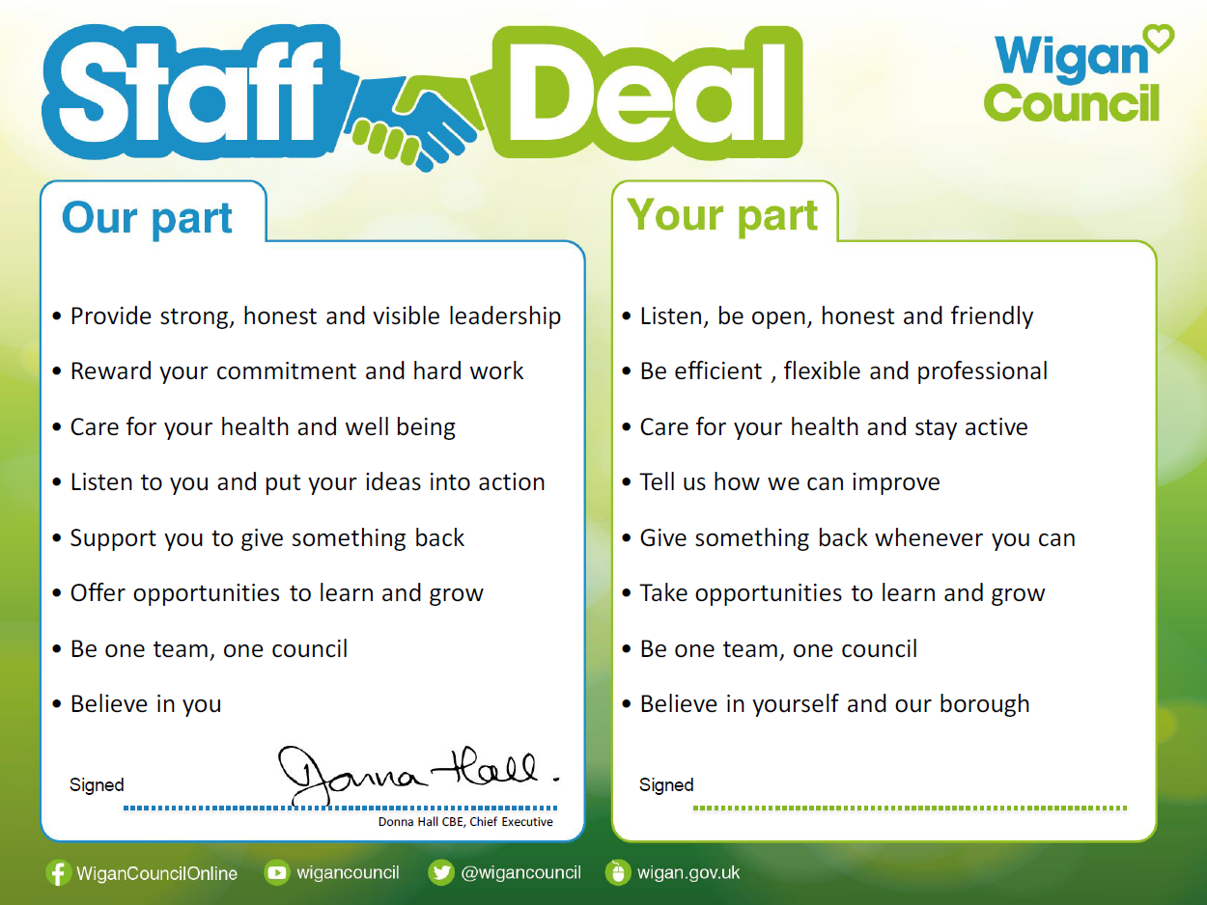
Our Staff Deal is an informal agreement with all staff. It outlines what you can expect from us, and in return what we expect from you

