Workforce Development Officer
Team: | Workforce Development
Service: | People & Workforce Development
Salary & Grade/Band/Pay Range:  Job ID:  Professional Grade Category: | Grade F SCP 17-22 Salary range £28,770 - £31,364  J65  n/a
Responsible to: | Workforce Development Manager
Contract Basis: | Permanent
Hours Per Week: | 36 hours per week
Working Pattern: | Monday to Friday (flexible / hybrid working)
Location: | Main office Base / Home-working
Probationary Period: | 12 months
Criminal records Check required: | n/a
Politically Restricted Post: | No

What’s the post, and what are we looking for?

This role will support the delivery of key People Plan objectives to support the effective management, growth and development of the workforce to support the corporate priorities. This role will enable a range of comprehensive workforce development interventions as identified within the workforce development plan. It will also establish and support the delivery of a range of training programmes and interventions that meet the needs and expectations of identified job roles, teams, services and Elected Members.

Main Duties and Responsibilities include:
This list is not exhaustive, and is an indicator of the key duties and responsibilities that the post holder will have, as opposed to a task list.

- Design and implement corporate training initiatives as set out in the Workforce Development Plan and People Plan available to the whole workforce, Elected Members, schools and partners.

- Design, deliver and facilitate training sessions and focus groups with the workforce and partners when necessary.

- Promote, design and create e-learning for the workforce, including the development of bespoke modules to fit the organisation’s own requirements.

- To support and deliver on the organisation’s employee engagement strategy.

- To work with services to design and deliver bespoke learning and development interventions.

- To work in partnership with identified training providers to ensure quality and content of delivery.

- To develop evaluation and quality assurance procedures for the collection of workforce data to aid analysis of workforce training needs.

- To support the organisation and delivery of sessions and events, both bespoke and large scale.

- To participate in team development as required by the service.

- To develop and review workforce development processes to improve service delivery and contribute to an improved employee experience.

- Undertake research, interpret workforce data to support workforce decisions and reporting requirements e.g. equality and diversity metrics, HR and workforce metrics.

- Support the development of a values based culture organisation that can deliver a better and fairer place for everyone.

- To take responsibility for own learning and development, keeping up to date on all employment related legislation and organisational development best practice and actively sharing knowledge with others

- To contribute to the continual improvement of the Service, including identifying opportunities and supporting activities to ensure we have an appropriately skilled workforce and an inclusive culture and ethos that enables all to do their best whilst enabling good health and wellbeing

- Any other duties that are commensurate with the post and level of responsibility.

The duties may vary from time to time without changing the nature of the post or the level of responsibility, and the post holder may also be required to carry out any other duties appropriate to the grading of the post.

About you

Your essential qualifications

- Level 3 qualification i.e. A Levels, NVQ3, advanced apprenticeship, L3 diploma
- Working towards a Human Resources Qualification (or willingness to undertake) i.e. CIPD certification / diploma

Your essential skills, knowledge and experience

- Experience of designing and delivering learning and development sessions
- Experience of facilitating focus groups and bespoke team sessions
- Experience of delivering training to a variety of employee groups at different levels across the organisation
- Experience of supporting large scale events
- Demonstrates an ability to carry out research and understand more complex issues
- Identifies key issues and relationships and makes systematic and rational judgements based on relevant information
- Develops and uses project management techniques
- Thinks ahead to anticipate problems and opportunities
- Assertive and able to influence others
- Able to listen and understand information
- Able to negotiate and consult others
- Speaks and writes clearly and fluently to both individuals and groups
- Evaluates a variety of solutions before taking decisions/action
- Demonstrates readiness to make decisions and takes action to implement decisions
- Works hard to identify, understand and meet customer needs
- Understands the impact of service delivery for customers
- Works cooperatively, effectively and sensitively as part of the team
- Actively promotes equity and seeks to redress inequity and discrimination
- Generates creative solutions to work problems
- Shows willingness to question traditional assumptions
- Supports others in developing creative solutions to problems
- Models and demonstrates our STRIVE values and leadership behaviours

If you have the following experience or qualifications – then that’s great!

- Relevant formal or informal training for trainers/facilitation skills
- Experience of working with Elected Members
- Experience of working in a HR/OD Team and/or public sector environment
- Member of the CIPD
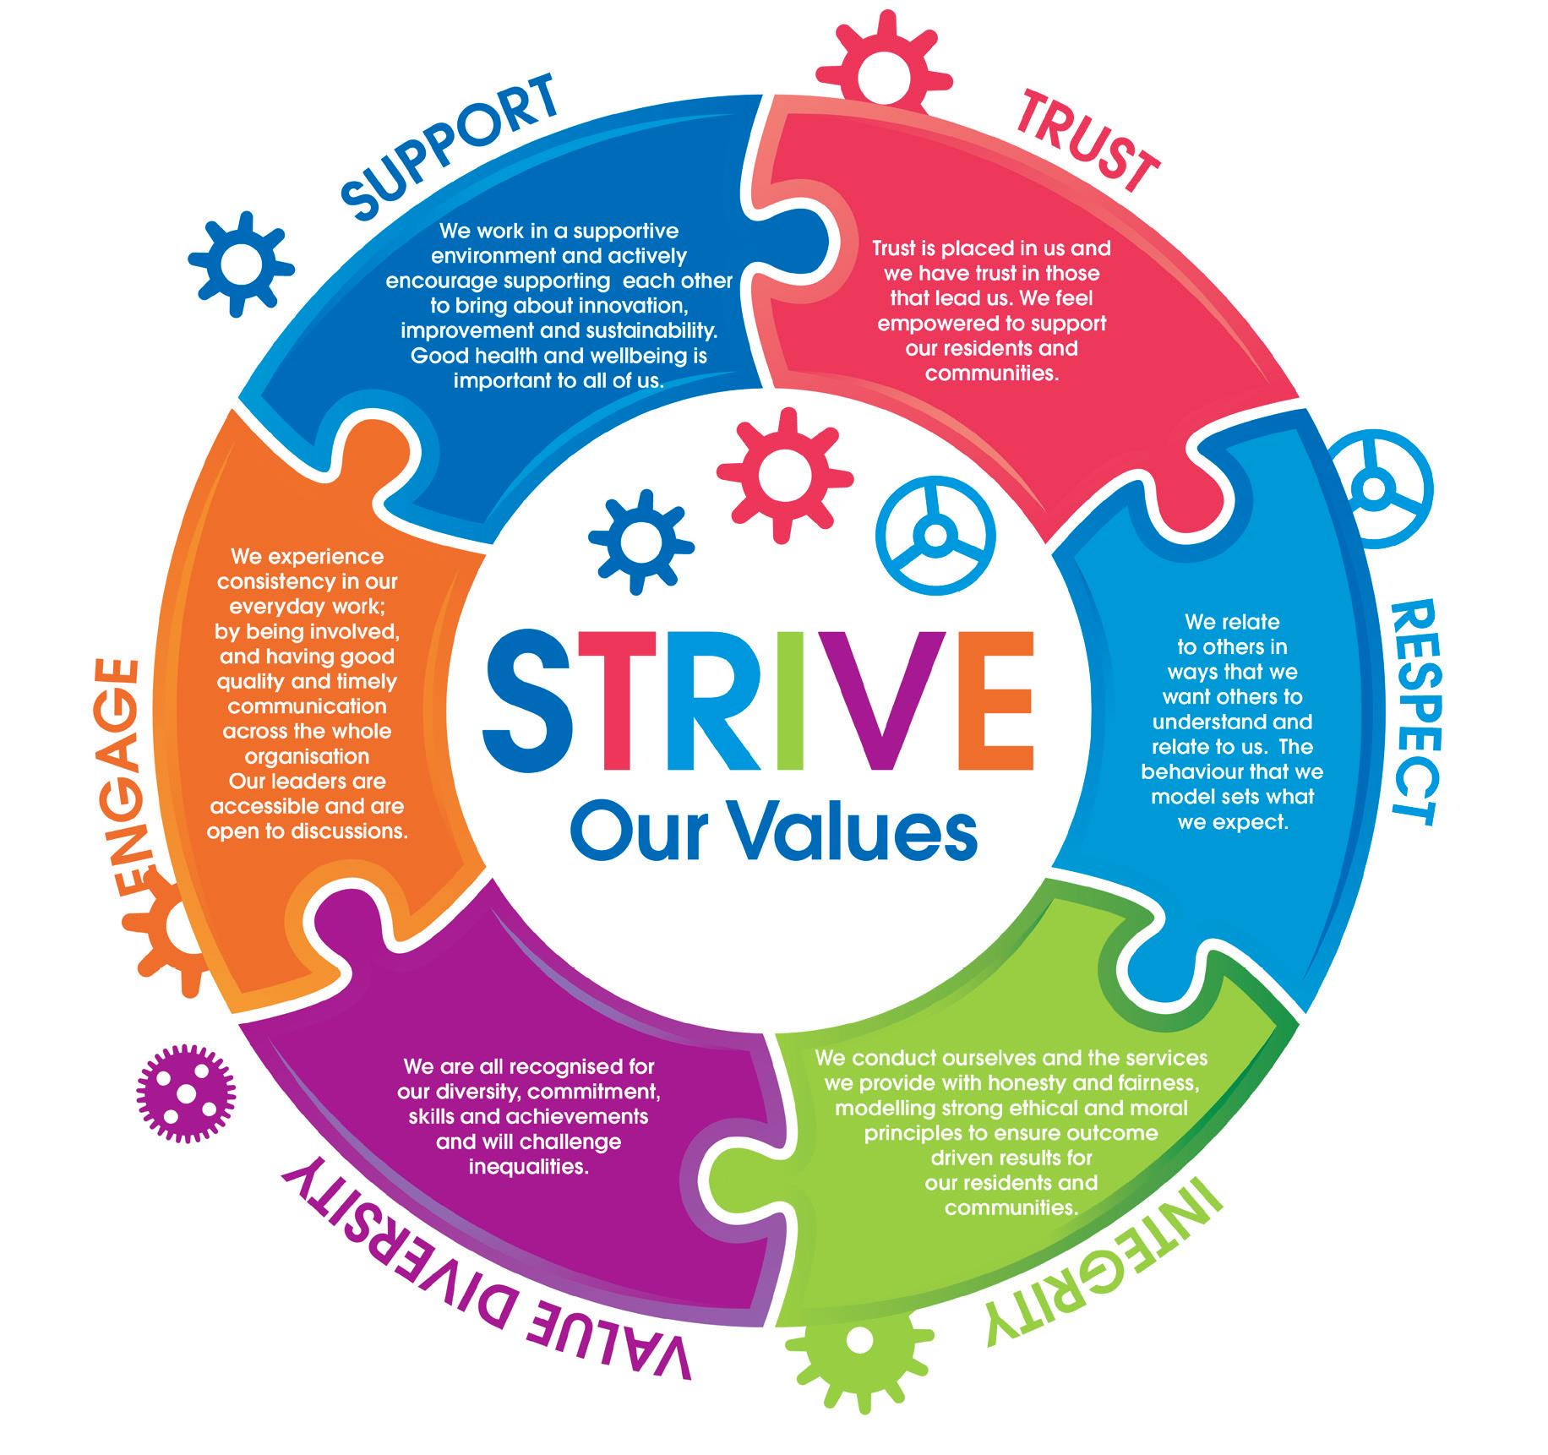
What can you expect from us?
- A fair salary and benefits
- Opportunities for good health and wellbeing
- Help you to grow, develop and to do your best
- Enable you to be creative and innovative
- Fully involve you in changes that affect you and your work
- Listen, and act on your ideas and feedback

Our employees’ skills, experience and knowledge are essential to our success along with their happiness, commitment, enthusiasm and motivation to be the best they can be.
Our STRIVE values underpin our practice and behaviours and are at the heart of everything that we do:

As well as making a difference to your community and working for one of the highest performing organisation’s in the country, here are some other reasons we think you should consider a career with us:
You will have an induction that will help you to understand what to expect once you start, how the organisation works and how your post contributes towards the Corporate Plan ‘Our People Our Place Our Plan’ aims and aspirations for the area.

The plan is structured by life course – Starting Well, Living Well and Ageing Well, underpinned by the idea of ensuring that Tameside & Glossop is a Great Place, and has a Vibrant Economy. Tameside Council has a genuine commitment to equality of opportunity for its employees and citizens.
A comprehensive workforce development programme, including our ILM Assured STRIVE Leadership & Management Development Programme, as well as an Aspiring Leaders Programme.
Up to 30 days leave per year depending on pay grade, in addition to statutory bank holidays. We also operate a Holiday Purchase scheme.
The commitment to improving the work-life balance of employees with a number of supportive procedures promoting, various types of flexible working. Along with, many family friendly policies in place, including generous schemes covering maternity, paternity, shared parental and adoption leave.
Tameside Council employees can join the Local Government Pension Scheme (LGPS). More information about GMPF and LGPS pensions can be found at www.gmpf.org.uk. Teachers can join the Teachers’ Pension Scheme. More information on this scheme can be found by visiting www.teacherspensions.co.uk.
Tameside Council offers a range of salary sacrifice schemes, such as a Cycle to Work Scheme and Car Lease Scheme (subject to eligibility), plus a number of other staff benefits including discounts at local shops, restaurants, health and fitness clubs and much more.

Working together, we are proud to work for Tameside

