Job specification
Job title: | Business Support Services Officer
Service: | Business Support Services –  Start Well and Targeted
Grade:  Salary Range: | G4  £16,822 – £19,008
Reporting to: | Senior BSS Officer

Your job
You will ensure the delivery of a high quality and effective administrative service to support Start Well and Targeted Services colleagues working with children, young people and families across the borough.

You will provide day to day administration support to assist with the achievement of the team’s functions through delivering a high standard of customer care to service users, colleagues and other professionals.

In this job you will
On an on-going basis you will:

- Provide effective administrative support to the team, handling calls and messages, supporting a wide variety of professionals across the service.
- Work within a designated team, providing the appropriate professional support to team members.
- Maintaining accurate records, handling highly sensitive information in line with confidentiality and data protection requirements.
- Act as first point of contact for enquiries from customers, providing advice to managers and employees and signposting to other team members/Directorates as appropriate.
- Respond to routine and ad hoc requests for information from line management, internal and external sources in a timely, responsive manner.
- Contribute to the effective implementation of the team’s delivery plan.
- Provide feedback and suggestions to improve office efficiency.
- Ensure deadlines are met and work is prioritised.
- Support the agile working process, new ways of working and efficiency within the team.

In this job you will need
You must be able to demonstrate the following essential requirements:

- Office experience and an NVQ 2 in Administration or the ability to demonstrate a similar level of knowledge, skills and experience.
- Be highly organised, with the ability to undertake tasks accurately, with attention to detail.
- Experience using a range of Office IT packages, case management and record management systems.
- Have excellent interpersonal skills and be experienced working with a range of staff, service users, other local authorises and wider partners.
- Possess the ability to present information clearly within agreed corporate templates.
- Have the ability to collate information and prepare good quality data that is easily understood by others.
- Have experience in supporting the induction and training of new staff members within the team.
- Have experience in supporting management in HR, Finance and Information Governance tasks.
- Demonstrate a commitment to and evidence of continuous professional development.

Our culture
For us, it’s not just about all we achieve as an organisation, but how we do it. Therefore, all employees are expected to display our Be Wigan behaviours.
Be Positive… take pride in all that you do

Be Accountable… be responsible for making things better

Be Courageous… be open to doing things differently

Individuals with line management responsibilities are also expected to …
Inspire…lead by example and help others to see the big picture

Care… show genuine concern for people as individuals and value their contributions

Engage… I connect with others both within and beyond the organisation

Staff Deal
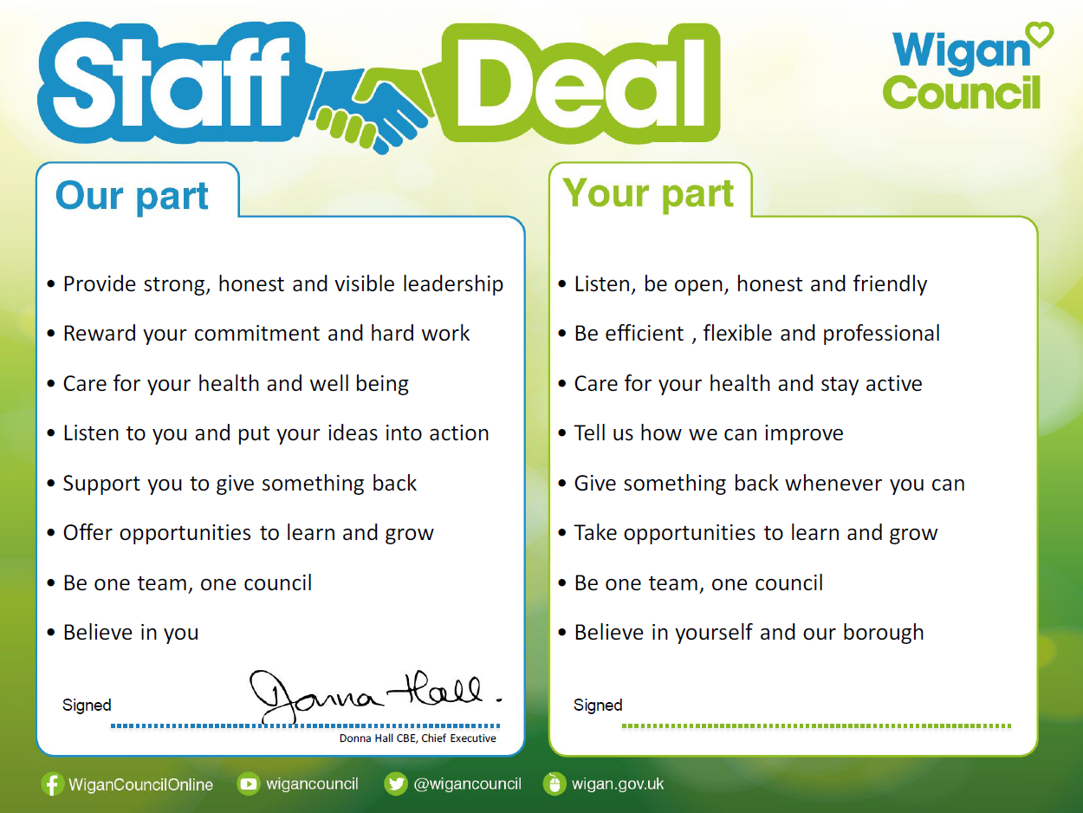
Our Staff Deal is an informal agreement with all staff. It outlines what you can expect from us, and in return what we expect from you

