Job specification
Job title: | Leisure For All Assistant
Service: | Leisure for All
Grade:  Salary Range: | G5  £18,334 - £21,530 (pro-rata)
Reporting to: | Schemes Co-ordinator

Your job
You will work within a caring and enthusiastic team providing short term breaks for Children and Young People with disabilities and complex health needs in order to provide respite to their parents or carers.

You will work evenings and weekends during term time and take part in daytime activities during school holidays.

You will support children and young people to experience enjoyable leisure activities, such as Lego Therapy, arts, crafts, visits to local parks and community venues, for example, SPACE Sensory Centre also encouraging peer interaction and friendship outside of a home or school environment.

In this job you will
On an on-going basis you will:

- Provide hands on care for young people; including but not limited to; personal care, support with feeding and supporting communication needs and programmes.
- Contribute to and follow activity plans within the group and support children & young people to enjoy and achieve through safe, creative and meaningful activities.
- Read and follow requirements from All About Me documents, Care Plans, medical plans and Risk Assessments.
- Communicate effectively with parents or carers to ensure that the service continues to meet needs and expectations.
- Ensure the completion and provision of appropriate paperwork.
- Attend and participate in meetings and supervisions as needed and give feedback as appropriate to managers regarding any important information from parents or carers and a change to risk assessments, care plans or medical information for the child or young person.
- Work within all policies and procedures as laid out by the Leisure for All Service and Wigan Council.
- Work with the team to ensure that all the children and young people are adequately safeguarded.
- Treat children and young people and their families or carers with respect and dignity.
- Follow confidentiality procedures.
- Have empathy towards the issues faced by parents and carers and the disabled children & young people they support and their need for short breaks.

In this job you will need
You must be able to demonstrate the following essential requirements:

- Be numerate and literate.
- Experience of basic administration such as the completion of diary sheets and/or handover sheets.
- A willingness to work towards a relevant childcare qualification and to undertake mandatory training as required.
- Ability to work under your own initiative and as part of a team.
- Willingness to work flexibly to suit the needs of the service.
- Experience of supporting children & young people.
- Experience of supporting children & young people with disabilities.
- Awareness and understanding of child care legislation.

Our culture
For us, it’s not just about all we achieve as an organisation, but how we do it. Therefore, all employees are expected to display our Be Wigan behaviours.
Be Positive… take pride in all that you do

Be Accountable… be responsible for making things better

Be Courageous… be open to doing things differently

Individuals with line management responsibilities are also expected to …
Inspire…lead by example and help others to see the big picture

Care… show genuine concern for people as individuals and value their contributions

Engage… I connect with others both within and beyond the organisation

Staff Deal
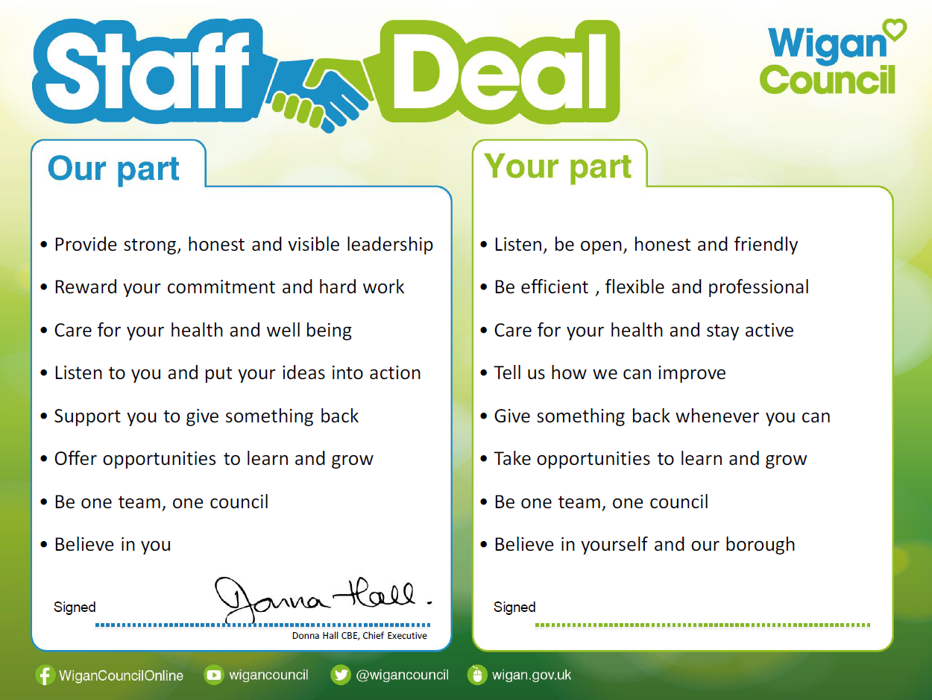
Our Staff Deal is an informal agreement with all staff. It outlines what you can expect from us, and in return what we expect from you

