Central HR Officer
Candidate Pack

Dear Candidate,
Thank you for your interest in this exciting new position to work within the central team at Oak Learning Partnership Trust.
Our Trust is a recently established group of schools currently comprising of a primary, secondary and special school all located in Bury, Greater Manchester. As a Trust we are passionate about transforming children ’s lives and their communities through the delivery of a well-balanced, rounded education, providing individual support in schools which are happy places within which staff and young people thrive. We are passionate about inclusion; this is at the heart of our ethos and is a consistent focus. In all our schools we endeavour to leave no child behind.
We understand that we can only achieve our vision by recruiting the right people and providing
them with the support, training and time they need in order to allow them to flourish and be the best they can be. Whatever role an individual undertakes within our organisation, be that
supporting or teaching, they are contributing to our collective aim of transforming lives. We have high expectations for our staff, we invest heavily in them ensuring they feel valued and their well-being is always considered. We understand that if staff feel valued and if the impact they are having is recognised, they can perform at their best.
Our schools work closely with one another: they collaborate, support each other and share collective systems across both educational and business provisions. But it’s also important to us that each school has individuality and freedom to be innovative. What we do insist on is clarity and consistency from our leaders and always making sure common sense is at the heart of decision making.
I joined the Trust in September 2021 and I’m excited to lead the trust into the next part of its journey. We are laying strong foundations for growing the Trust and with this, will come multiple development opportunities for our staff. We are committed to making a difference on a wider scale, whilst continuing to build on our current strengths. Above all we will continue to have a strong moral purpose, provide a truly inclusive education and embed our core values of Aspiration, Resilience, and Integrity in everything we do.
If you’re excited about joining Oak LP, your values are aligned with ours and you feel like you can make a difference please contact recruitment@oaklp.co.uk directly for any additional information about the role.
James Franklin-Smith
CEO of Oak Learning Partnership

“Every day is
different, with
opportunities to learn
new skills and work
together to find solutions.
It’s a great place to work
with a fantastic team of
dedicated staff.”
Member of the Pastoral
Team at Elms Bank School
within the Oak Learning
Partnership

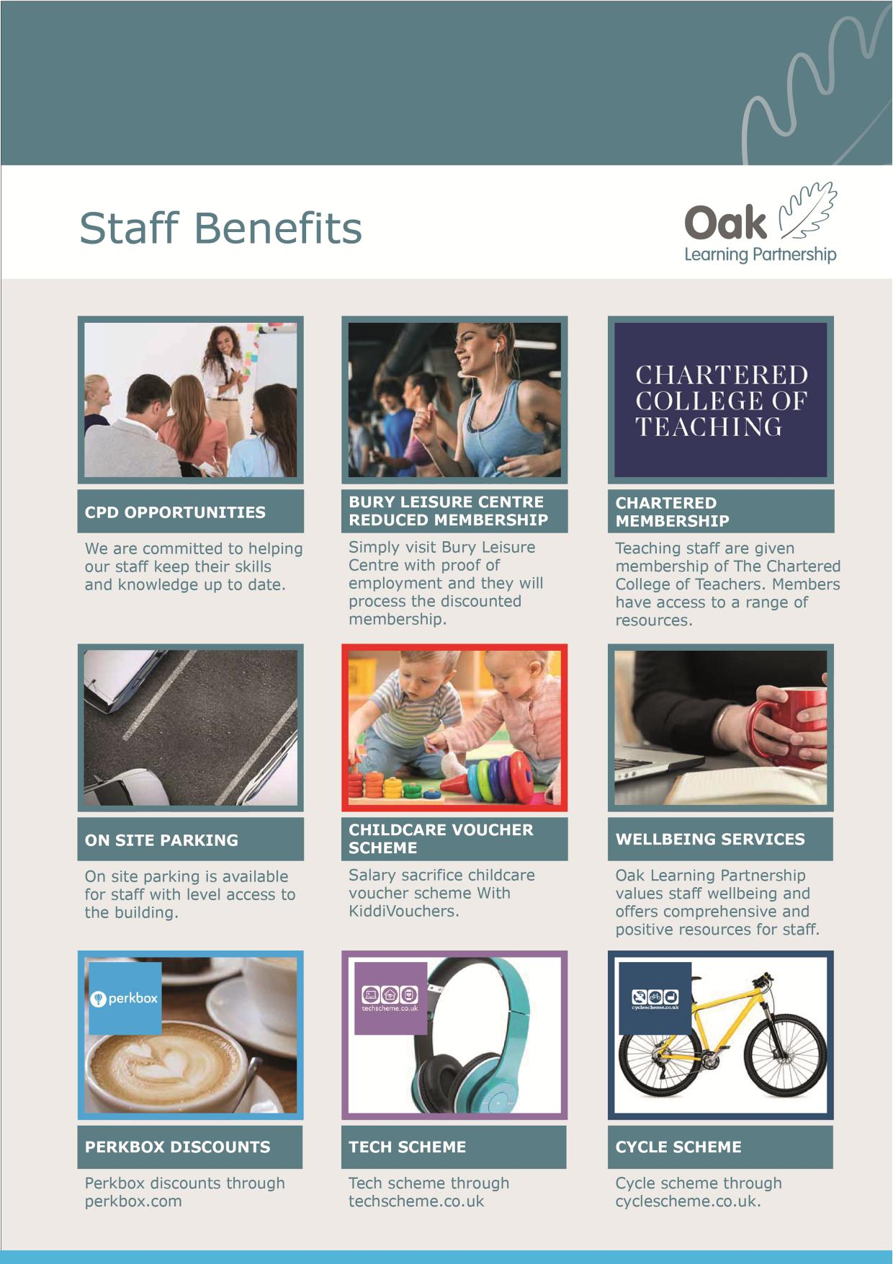
At Oak Learning Partnership, we value our staff highly and recognise their contribution with a series of benefits and incentives.
Find out more on our website:
https://oaklp.co.uk/working-for-oaklp/staff-benefits

“I really enjoy
working with the Oak
Learning Partnership. I
feel supported in my role and
I am valued and encouraged to
reach my full potential by leaders who
believe in me. I have a wealth of
support that I can access from the
central and executive leadership team
and their values are evident in raising
outcomes for children
whilst empowering staff to make, and
be, the difference.”
Member of the admin team
at Unsworth Primary within
Oak Learning
Partnership

Central HR Officer
Salary: Grade 8, SCP 12 - 17, actual salary £19,812 - £21,873
Hours: 37 hours per week, term time only plus 10 days
Required for as soon as possible
We are pleased to announce that due to the planned growth of our trust we are seeking to appoint a dedicated, reliable and highly-motivated HR Officer who possesses excellent communication skills and will work well within our existing central team.
This role will be based in the central team office and the successful candidate will work in conjunction with the HR Manager in providing a confidential and proactive HR administrative support to the schools across the trust.
Whilst applications are encouraged from candidates with previous experience of working within the school environment, we would be willing to provide training in this area for someone whom we believe would bring relevant skills and experience from a different sector.
This post is particularly suitable for a person who has experience of HR software and other admin systems. The successful candidate must have the ability to work with tact, sensitivity and confidence, and would be expected to demonstrate that they have knowledge and experience of various software packages such as Microsoft Word and Excel and other IT systems.
You will be part of an excellent team and will be given extensive support to develop to your full potential both in this role and beyond.

Closing Date: 9.00am, Monday 3rd January 2022

Applicants must have relevant qualifications and experience, please ensure that you meet the person specification before applying.
How to Apply
We are committed to equality of opportunity for all staff and applications from individuals are encouraged regardless of age, disability, sex, gender reassignment, sexual orientation, pregnancy and maternity, race, religion or belief and marriage and civil partnerships.
Appointment is subject to a satisfactory enhanced disclosure from the Disclosure and Barring Service and references. The school is committed to safeguarding and promoting the welfare of children and young people and expects all staff to share this commitment.
Please do not send CVs. Applications should be sent to:
Miss Kristie Bloomfield, CFO at recruitment@oaklp.co.uk

“Our Trust is a
really supportive
and friendly place to
work. Whilst crossing
from site to site I get a
strong feeling that we are
a Trust of schools working
with and for each other.”
Member of our Estates and Facilities staff at a trust school

Thank you
Oak Learning Partnership Trust
Ripon Avenue
Whitefield
Manchester
M45 8PJ
0161 766 1597
enquiries@oaklp.co.uk www.oaklp.co.uk

