Job Summary
Waste Service Officer
Service: |  | Waste Services | Grade: | G5 |  | Salary: | £18,152 to £21,317
Reporting to: |  | Operational and Technical Manager | Location: | Makerfield Depot |  | Hours: | 37 hours

Your job
Waste Services has embarked on a Waste Modernisation project; its aim is to transform delivery across all aspects of the service. This role is a 12 month secondment opportunity to support the Waste Services team during the project period. Your role will be to assist in the efficient and effective provision of business services within the Waste Group, including Environmental, Education and Enforcement Team, Waste Collection, Cleansing and Waste Management.

You will |  | Our culture
As part of your role, on an ongoing basis, you will  √ assist in the planning and implementation of all waste and recycling collections and street cleansing programmes and related services to ensure optimum effectiveness and efficiency  √assist in the implementation, application, maintenance and training of technology used by the service  √be responsible for all data capture, ensuring systems are kept up to date and the reporting of results  √be responsible for the production and presentation of management reports  √support the procurement, implementation and monitoring of all waste contracts  √Assist in the investigation and response to complaints and enquiries  √Assist in ensuring that the Waste Group meets its statutory duties and obligations in the provision of the full range of the services provided |  | For us, it’s not just about all we achieve as an organisation, but how we do it. Therefore, all employees are expected to display our Be Wigan behaviours.  Be Positive… take pride in all that you do  Be Accountable… be responsible for making things better  Be Courageous… be open to doing things differently  In addition to these, our managers are expected to display our Be Wigan behaviours.  Inspire…lead by example and help others to see the big picture  Care… show genuine concern for people as individuals and value their contributions  Engage… I connect with others both within and beyond the organisation

Our ideal candidate |  | Staff Deal
Our ideal candidate will have  - Experience of working within a waste, recycling or cleansing service or similar multi-agency working environment  - Experience of data collection and able to produce quality reports  - Ability to analyse data and make meaningful conclusions and suggest recommendations  - Knowledge and experience of use of IT systems and new technologies to support business delivery  - The ability to make decisions and to break down problems  - The ability to deliver innovative solutions to the benefit of the service  - Good interpersonal and communication skills  - Good administrative skills, keeping accurate and timely records  - Ability to meet deadlines, whilst working under pressure with minimal supervision and on own initiative |  | 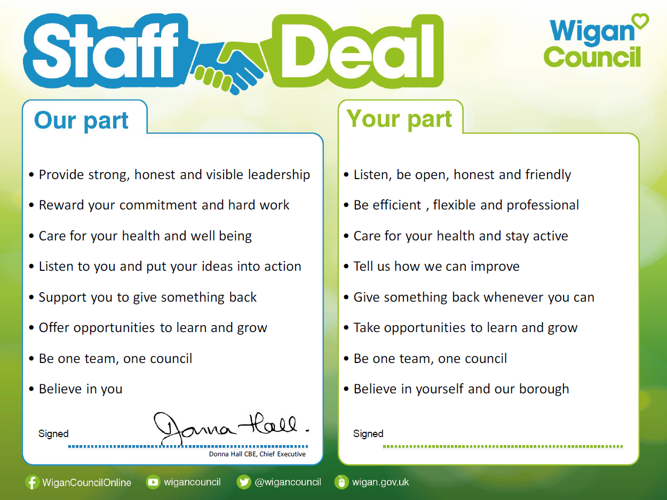  Our Staff Deal is an informal agreement with all staff. It outlines what you can expect from us, and in return what we expect from you

