Complex Case Officer - secondary schools
Service: |  | School Admissions | Grade: | 3B | Salary: |  |  | £22,845-£25,077
Reporting to: |  | School Admissions Manager | Location: | Unity House | Hours: |  |  | 36 hours Term time only plus 2 weeks
About the role |  |  |  |  |  |  | Our priorities
- You will be responsible for the development and operational delivery of the in year fair access process and managed move process for secondary schools  - You will ensure the in year fair access process is clearly planned and articulated, well communicated, monitored and regularly reviewed, and that all partners are engaged in the process.  - You will ensure a consistent approach to managed moves between schools, offering advice and quality assuring the process.  - You will assume responsibility for the placement of complex cases and ensure the speedy and efficient identification of a suitable school place.  - You will advocate for children and young people and their parents/carers to ensure their voice is heard during the managed move process  - You will support education provision for young people at, or at risk of, educational neglect  - You will promote engagement and participation of all partners in the in year fair access process and the managed move process through offering advice, guidance and support.  - You will manage complex operational relationships with schools to secure appropriate school places for pupils using the fair access route, particularly where these schools are their own admission authority.  - You will provide challenge to schools and other educational providers to maximise outcomes for young people with complex needs to ensure equality of access.  - You will work in a muti agency approach to ensure appropriate and timely placements of vulnerable children.  - You will evaluate and scrutinise data on complex or in year fair access cases and managed moves to understand performance and inform future development. |  |  |  |  |  |  | 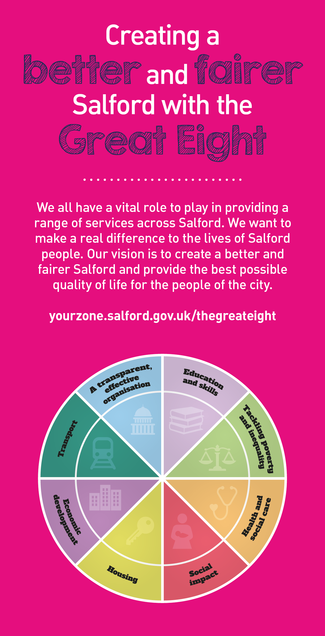
 | Key outcomes
- Statutory duties of the local authority with regard to in year fair access are fulfilled in order to ensure that all formal legal requirements are discharged and all locally agreed operational procedures are maintained
- Timely operational delivery of the Salford in year fair access process for all secondary aged pupils
- A compliant in year fair access processes and managed move processes that are of high quality, exhibit effective practice and perform well to ensure placement of vulnerable children
- Maximise efficiency through review and development of systems and processes, information management and policy
- Senior and exective leaders are well informed on strategic policy development for in year and managed move processes.
- Assessment to identify complex cases is quick and efficient and enables a multi-agency approch to the speedy identification of a suitable school placement
- High quality managed move referrals are appropriate, inclusive and based on the needs of an individual young person
- Relationships with young people and their parents/carers are productive and set high expectations for the young person, taking into account their views and advocating on their behalf
- SMART targets set high expectations for a young person's move to a new school and evidence based assessments are used to monitor success alongside qualitative data
- The social, emotional and mental health of young people is promoted alongside their academic attainment when securing school placements for them
- Managed moves are applied consistently, effectively and successfully across schools within the local authority and with neighbouring local authorities
- The re-integration of pupils back into mainstream schools is managed and supported resulting in successful reintegrations
- Obstacles to school placements for complex cases are overcome by multi-agency working that establishes the required support to aid the transition and induction process
- Complex operational relationships with schools are managed well in order to secure appropriate places in schools for in year fair access pupils
- Maximised outcomes and equality of access to school places for young people with complex needs is achieved through challenge to schools and education providers
- Regular evaluation and scrutiny of data and information on complex cases results in high performance and informed service improvement
- Advice, guidance, support and good communication practices engage all partners in the in year fair access process
- Good practice is disseminated effectively and implemented across schools
- Sensitive and effective dealing of, sometimes difficult and challenging, telephone and written enquiries and complaints
- Personal professional practice is reviewed regularly and training undertaken where development is required

What we need from you |  | Our values
- Proven technical skills and ability in the role with a record of accomplishment for delivering outcomes
- Professional credibility through proven relevant experience
- Models and demonstrates our values
- Knowledge of the Education system and relevant legislations, regulations and statutory responsibilities
- Proven ability to challenge schools, educational establishments or other bodies, whilst applying negotiation skills to achieve desired outcomes
- Experience of working directly with young people, especially those who may have associated learning difficulties, with an undestanding of IEPs, IBPS and SMART target setting
- Experience of working with senior leaders and executives, especially in schools, with the ability to establish and manage good working relationships with colleagues at all levels
- A flexible approach to work and a high level of reliability, initiative and creativity with a solution-focused approach to working in challenging situations
- Good interpersonal skills, with the ability to work independently and in a team situation
- Understanding of / experience in assessing pupils’ individual needs and supporting them in a mainstream environment.
- An understanding of child development and learning
- Interpretation and analysis of data skills
- Full driving licence and vehicle available for transporting parents/carers and young people to and from educational establishments, other locations and for general business use.
- Deal with confidential information discreetly with in the requirements of GDPR
- Commitment to a customer focussed approach ,when dealing with members of the public
- Established written and verbal communication skills appropriately and sensitively applied and adapted to a variety of audiences
- Proven experience of working with people in highly charged and/or emotional situations
- Systematic approach to planning and prioritising competing demands, whilst working accurately to tight deadlines
- Commitment to and understanding of inclusion, diversity and equal opportunities

Application guidance

We are a values based organisation so reflecting our values or a values based approach in your evidence will support your application.

The ‘Key outcomes’, ‘What we need from you’ and ‘our leadership behaviours’ sections of the Role Profile are there to give you an understanding of what we would like to see reflected in your application. Don’t give up if you are not able to reflect all of these in your application.

