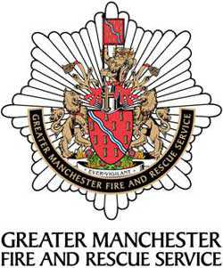

GREATER MANCHESTER FIRE & RESCUE SERVICE
IST Transferable Skills and Qualifications

FIRE SERVICE CAREER
Which F&R Service? | Primary Contract?  (WT/On Call/  Retained) | Length of Service | WT recruits course completed  Y/N | Length of recruits’ course

CURRENT/ EXPIRED FIRE SERVICE QUALIFICATIONS
Qualification / Course | Awarding Body | Date passed | Expired  Yes/No | Date Expired | Desire to do/ continue  Yes/No
Driving Licence
EFAD
EFAD refresher
Hydraulic Platform
Turntable Ladder
Aerial Ladder Platform
Moffat
Telehandler
Fork Lift
Trauma Tech
TT Refresher
TRU
Chainsaw
Confined Space Operator
Confined Space Supervisor
Hot Cutting Operator
Hot Cutting Instructor
Timber Shoring
Advanced Technical Search
USAR
Module 1
Module 2
Technical Rope Rescue
Rescue Boat
Swiftwater Rescue
HVP
Hook Lift
MDU
MDU instructor
DIM
IFE
Other relevant quals:
Operational Breathing apparatus wearer

Do you have any special dietary requirements?
Do you require any specific learning adjustments?

