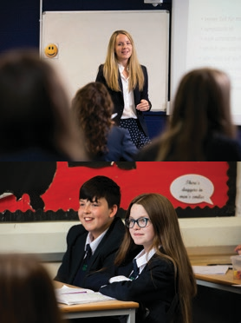
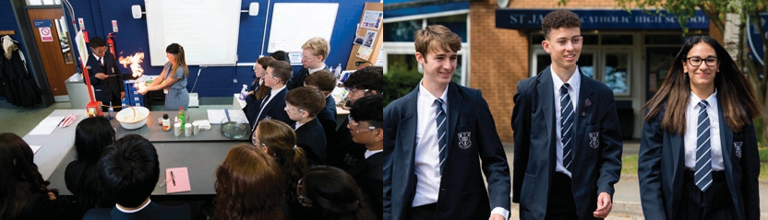

Cover Supervisor
Candidate Information

A message from the Headteacher

Thank you for your interest in St James’ Catholic High School. This is an exciting time to join St James’ as we look to move our school to the next level.

We are a good oversubscribed school (OFSTED 2022) located in Stockport, South of Manchester. Our school is made up of 825 students and 100 staff. St James’ Catholic High School is a thriving Catholic community that places children at the centre of everything we do. The Diocese of Shrewsbury judged our school to be an “Outstanding” Catholic school.

St James’ is a highly academic performing school:

- Impressive positive progress 8 scores for the previous three years

- In 2022, 84% of students achieved at least a grade 5 in English & Maths while 66% of students achieved a grade 5 in these subjects

- 94 grade 9s and 253 grade 8s in 2022 demonstrating exceptional attainment across a wide range of subjects

- Exceptional results in open subjects and the humanities placing us in the top 20% of similar schools nationally

Our school is at the cutting edge of teaching and learning and thrives on providing outstanding opportunities for the young people we serve. All our staff work to provide our young people with the skills, knowledge and understanding in order to achieve their full potential.
Inspired by the example of St James, the purpose of our school is to strive for excellence whilst keeping our Catholic roots at the centre of everything we do. Our three school values of Family, Faith and Excellence are lived out every single day by staff, students and all stakeholders.

The reputation of our school is exceptional within Stockport and across the Shrewsbury Diocese for academic excellence, impeccable pupil conduct and for providing outstanding additional opportunities for our young people. The result is that our young people develop into global Catholic citizens who are proud to profess their faith and who make a positive contribution to society.

At the root of our success is our St James’ community. This is built on strong, positive relationships between all staff, students and parents. Our parents support our school and develop their children at home whilst our dedicated staff are relentless in driving excellence by providing the best educational experiences and opportunities for our students. Underpinning this excellence are our unique values, Catholic ethos and our mission. We are inspired and driven by the Gospel where we are told: ‘With God all things are possible’ (Matthew 19:26).

If you would like to find out more about our school and community, or would like to arrange a visit please contact Kirsty Bowers, PA to the Headteacher on 0161 482 6900 or at headteacherpa@stjamescheadle.co.uk

Anthony Pontifex
Headteacher

Job Advertisement

Cover Supervisor
Full time 30 hours per week (term time only) Scale 4: £22,369 - £24,054 pro rata. Actual salary £14,414-£15,499

The St James’ Catholic High School Mission:

To ensure everyone within our school family achieves their full potential, to encourage learning and development through faith,
and to strive for excellence

Applications are welcome regardless of the personal faith of the applicant, providing they are supportive of the school’s Catholic ethos

St James’ Catholic High School is a popular and oversubscribed 11-16 mixed comprehensive Catholic
High School which was judged by OFSTED to be a “Good” school in April 2022

The Diocese of Shrewsbury judged our school to be an “Outstanding” Catholic school

The governors of the school wish to appoint an outstanding, dynamic and highly motivated Cover Supervisor

Please note a current CES application form (version 14) and a Model Rehabilitation of Offenders act 1974
– Disclosure form must be completed for this post – CVs will not be accepted. Forms can be emailed to

headteacherpa@stjamescheadle.co.uk

St James’ Catholic High School is an equal opportunity employer which is “Positive about Disabled People”. Whilst all applicants will be judged on merit alone, we particularly welcome applications from groups currently under-represented in the workforce, who meet the person specification for the post

St James’ Catholic High School is committed to safeguarding and promoting the welfare of children and applicants must be willing to undergo child protection screening appropriate to the post, including checks with past employers and the Disclosure & Barring Service

Job Description

Cover Supervisor

School Mission Statement

St James’ Catholic High School aims to ensure everyone within our school family achieves their full potential,
to encourage learning and development through faith, and to strive for excellence.

Purpose

To work under the guidance of teachers and/or members of the school leadership team and within an agreed system of supervision. To support individuals and groups of pupils to enable access to learning. This could include those requiring detailed and specialist knowledge in particular areas. To supervise whole classes during the absence of the teacher. The main focus of such cover will be to respond to questions, assist pupils to undertake set activities and stay on task and manage behaviour.

Key Responsibilities

- To register and record student attendance using Sims Lesson Monitor
- To instruct students regarding the work left by the teacher
- To provide students with the necessary resources for their learning
- To enable orderly entrance and exit of classrooms
- To promote the inclusion and acceptance of all pupils within the classroom
- To create a calm and purposeful environment in which pupils can complete work set by the classroom teacher and engender high expectations
- To follow school systems and procedures on behaviour management
- To report back as appropriate using school’s referral procedures on the behaviours of pupils during the class and any issues arising
- To manage resources effectively and ensure classrooms are left tidy and ready for the next lesson
- To collect any completed work after the lesson and return it to the appropriate teacher
- To liaise with teacher(s) about cover work
- To be aware of particular pupils’ specific needs as identified in IEPs and on the medical needs register
- To support pupils in using basic ICT as directed
- Support the curriculum when supervising classes in the absence of a teacher
- Be aware of, and comply with, all school policies and procedures
- Contribute to the overall ethos, work and aims of the school
- Recognise own strengths and areas of expertise and use these to advise and support others
Whilst every effort has been made to explain the main duties and responsibilities of the post, each individual task undertaken may not be identified.

It is not a comprehensive statement of procedures and tasks, but sets out the main expectations of the school in relation to the post holder’s professional responsibilities and duties.

This post is subject to Enhanced DBS disclosure.

Whilst every effort has been made to explain the main duties and responsibilities of the post, each individual task may not be identified.

The post holder will be expected to comply with all reasonable requests from the Headteacher to undertake work of a similar level that is not specified in their job description.

Person Specification

Cover Supervisor

 | Status of Criteria |  | Method of Assessment
Job Requirements | Essential | Desirable | Application | Interview/task
Training and Qualification
Good standard of education to at least GCSE standard or equivalent; at least GCSE Grade C or equivalent in English or Maths | 🗸 |  | 🗸
Experience
Experience of working in a school environment | 🗸 |  | 🗸
Ability to make sound judgements and prioritise multiple demands | 🗸 |  | 🗸 | 🗸
Ability to act on own initiative, dealing with any unexpected problems that arise | 🗸 |  | 🗸 | 🗸
Professional Knowledge
Knowledge of, and commitment to, relevant school policies including Safeguarding/Child Protection and Health and Safety |  | 🗸 | 🗸 | 🗸
Personal skills and qualities
Supportive of the ethos of a Catholic School | 🗸 |  | 🗸 | 🗸
Ability to maintain confidentiality and to be able to deal with matters with discretion and sensitivity | 🗸 |  | 🗸 | 🗸
Willingness to accept the demands and challenges of the post and respond in a flexible and approachable manner | 🗸 |  | 🗸 | 🗸
Able to work under pressure and manage own workload and commitments through excellent time management skills | 🗸 |  | 🗸 | 🗸
Good interpersonal skills and able to communicate effectively with a range of people | 🗸 |  | 🗸 | 🗸

Contact

Kirsty Bowers
PA to the Headteacher

0161 482 6900
headteacherpa@stjamescheadle.co.uk

www.stjamescheadle.co.uk
St James’ Catholic High School St James’ Way
Cheadle Hulme Cheadle Cheshire
SK8 6PZ

A560
WYTHENSHAWE

M60

CHEADLE
GATLEY

M56

HEALD GREEN

A34

CHEADLE HULME

HALE BARNS

BRAMHALL

Manchester Airport

B5094

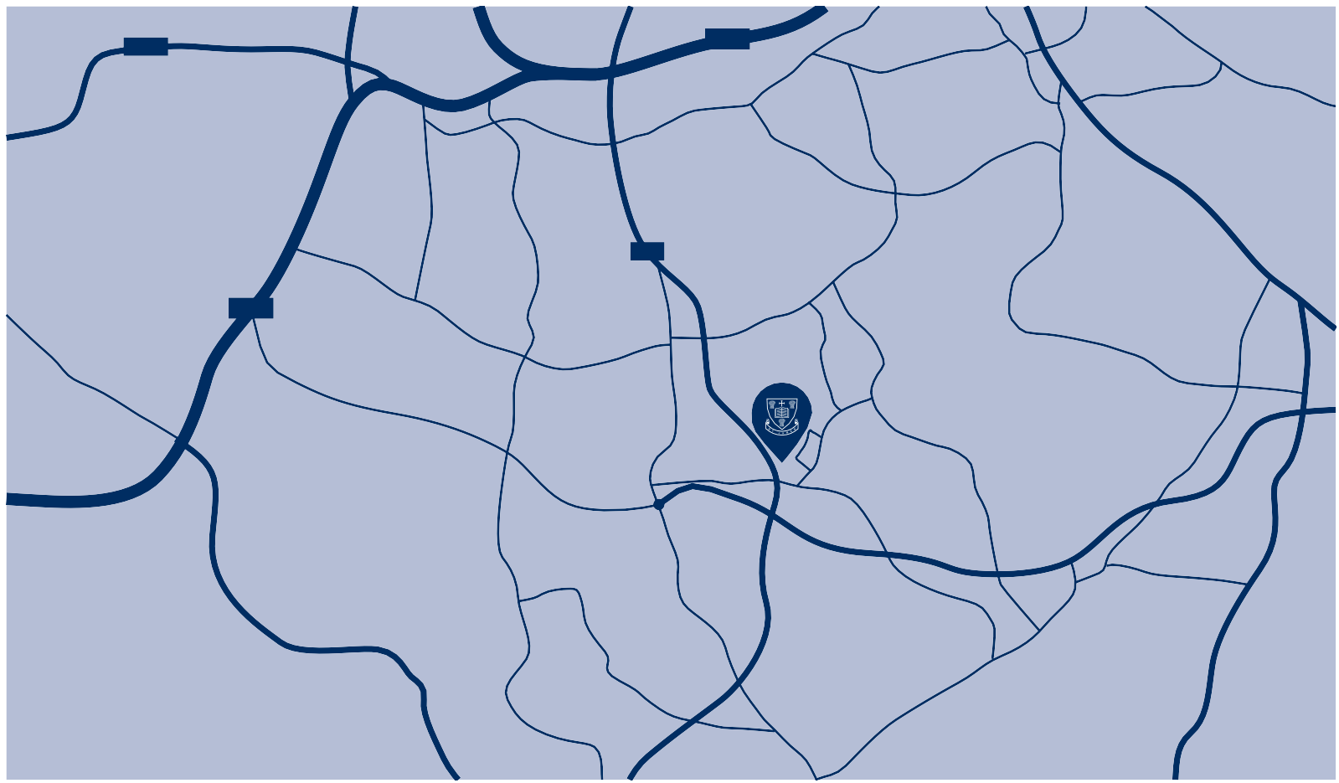
HANDFORTH
STYAL

MORLEY GREEN

WILMSLOW

With God all things are possible
Matthew 19:26

