Human Resources & Organisational Development
Service Reform
Salford City Council, Salford Civic Centre
Chorley Road, Swinton, Salford, M27 5BN
Phone 0161 607 7178
Email samantha.betts@salford.gov.uk
Web www.salford.gov.uk

December 2019
Welcome to Salford from the Assistant Director, Human Resources & Organisational Development

Dear candidate,

I am delighted to be writing this letter inviting you to consider joining our team. Our vision for our city is for a better and fairer Salford for everyone underpinned by our organisational mission ‘to create the best quality of life for the people of Salford.’ You will be joining us at an exciting time for Human Resources & Organisational Development as we are about to embark upon the next phase of our digital journey transforming the way we do things through digital.

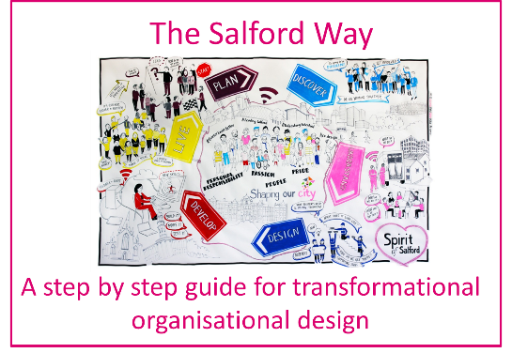
Salford is going through a period of significant growth and change and you will be joining us as we continue with our ambitious programme of transformation. HR and OD are positioned at the heart of this, leading change through our innovative organisational development methodology which underpins our approach to service design with stakeholder engagement and co-design at the heart. People focussed and values based that’s the Spirit of Salford. We are developing a culture that encourages innovation, flexibility, learning, and empowerment; that ‘gives permission’ to all employees to make decisions that are in the best interests of our residents; one that creates the environment where everyone feels inspired and empowered to lead positive change.

The HR and OD function is structured around key roles of Strategic HR & OD Manager, HR & OD Manager, Senior HR & OD Business Partner leading our talent and resourcing offer, HR & OD Business Partners, and HR & OD Consultants. Another core area of the service is the Payroll, Pensions & HR team which delivers a comprehensive operational HR, payroll, pensions and employee benefits offer to the council, schools and other organisations. Combined, we provide a comprehensive professional HR & OD service across all council services, schools and other external organisations and key partners.

Professional development of the team is therefore of utmost importance to ensure that we have the right skills, knowledge and experience required to remain at the forefront of innovative practice and deliver a high impact HR & OD offer to the varied range of organisations and customers we work with. Your natural curiosity will be supported by access to development opportunities provided both internally within the function and as a wider development programme across the whole of the team. I would be delighted to offer the opportunity to undertake a level 3/5 apprenticeship in leadership to support your development.

The Spirit of Salford is tangible and our values of pride, passion, people and personal responsibility capture this spirit and expectations of the city and they inform the way we operate. The values have been developed to underpin the way we work they influence our choices, behaviours, how we make decisions and transform services. Our values describe the personal qualities every employee is expected to demonstrate when carrying out their role. Putting the values in to practice across the whole organisation creates a supportive environment which allows us ‘to be the best we can be’. These values are central to the way we communicate about the council and the way in which we behave with colleagues, customers and partners.

We are delighted that Salford made an exclusive shortlist in the MJ Achievement Awards in 2017 and went on to win two MJ Achievement Awards in 2018 for Delivering Better Outcomes and its Senior Leadership Team. The council was also the overall DL100 Winner 2018 (Digital Leaders) and Digital Council of the Year. Salford was also a finalist in the Greater Manchester Sports Awards for active workplace of the year 2019.

If you want to be part of the Spirit of Salford; connect with our values; are interested in working with a committed and enthusiastic team and can provide the professional expertise required I look forward to welcoming you to the team.

Yours sincerely

Sam

WINNERS

