Content

Welcome: Headteacher | Page 2
School Mission and Vision | Page 3
Letter from our children | Page 4
Recruitment Process | Page 5

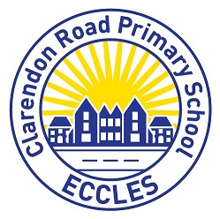

Dear Applicant,
Thank you for expressing an interest in the role of Deputy Headteacher at Clarendon Road Primary School.
Having worked at the school for over five years now, and recently being appointed as Headteacher, I have a very clear idea about the journey our school is on and where we want it to take us.
Our staff team, supported by our Governors, constantly strive to give each of our pupils the most positive and successful educational experience they can have in order to prepare them for the next stage of their education. We want our school to be at the heart of the local community in helping all of its children to achieve the highest standards they can.
We believe that this is best achieved when our pupils are:
- Happy in what they are doing.
- Proud of themselves and their achievements.
- Immersed in their learning.
- Supported through partnerships between home and school.
- Consulted about what they want their learning to look like.
During the last Ofsted visit in June 2016, Clarendon Road was judged to be a good school. We have continued to build on these strong foundations, developing our curriculum so it is diverse, reflects the needs of our pupils and provides them with the skills and knowledge they need to take into their future education. We believe continuous improvement is vital to ensuring our children receive the high quality of education they are entitled to.
We are seeking an aspirational Deputy Headteacher with the same beliefs, who can work closely with myself to support our team and pupils; to build on recent successes; and achieve our core objective of ensuring every pupil leaves us ready for the next stage of their education.
Our new Deputy Headteacher will join a dedicated, professional and driven team with the support of parents who seek the very best for their children. Effective support and encouragement will also be provided by the Headteacher and Governors.
If you feel you have what it takes, we would love to meet you and show you around our school.

Kind regards
Rachel Gallagher
Headteacher

Our Mission
Our mission is to be a school community where people value themselves and others, where human diversity and effort are celebrated, the environment respected and a lifelong love of learning is fostered.

Our Vision
A unique school where all individuals are committed to working with a shared ethos. During their journey at CRPS, children feel safe and welcome, enabling them to develop essential skills for the future.
Excellent leadership identifies and provides supportive, personalised staff and pupil development embedded in a positive, cohesive working environment for the whole team so that everyone is a leader of learning.
Consistently passionate teaching enables every child to progress and attain their full potential through a wide range of pivotal learning opportunities, visits and extracurricular activities.
Staff, children, parents, governors and the wider community work together to achieve shared goals and excellent outcomes for all. All children and their families are welcomed and supported to engage with learning.
A school where all children are supportive and friendly toward their peers and show respect towards all adults. Children strive to achieve the school’s core values through the Spirit of School system.
A school with a reputation for celebrating its diversity and with a proud culture of modern British values.

Our Values

 |  | Passion
 | Loyalty |  | Dignity
Trust |  | Honesty |  | Respect

To our new Deputy Head Teacher,

At Clarendon Road Primary School, we are passionate about learning and love to think up new ideas. We take pride in our work and love to take on new challenges. We are happy, we are proud and we shine in everything that we do!
We have three different councils within the school. These are the: School Council, Eco Council and Sports Council. The School Council helps to make the school a better place and listens to everyone’s ideas. The Eco Council helps to make the school environmentally friendly and spread the ‘Eco Code’. The Sports Council helps to organise events and think of new ideas for after school clubs.
We also have Arrival Ambassadors who welcome new children into our school to make them feel welcome and comfortable. Playground leaders are also included in our family – they kindly take care of EYFS and KS1 at lunchtime.
We are very passionate about sport and we love to get involved with the different sporting competitions. We are very creative and really enjoy art week, where we look at different artists and recreate their work.
At Clarendon Road, we love to take on new challenges and enjoy being pushed. From Nursery, all the way up to Year Six, we use our learning in new and exciting situations. We enjoy the lessons that our teachers plan for us and we put in our full efforts throughout each lesson.
Do you think that Clarendon Road is the school for you? If so, we would love for you to join our family!
Yours sincerely,
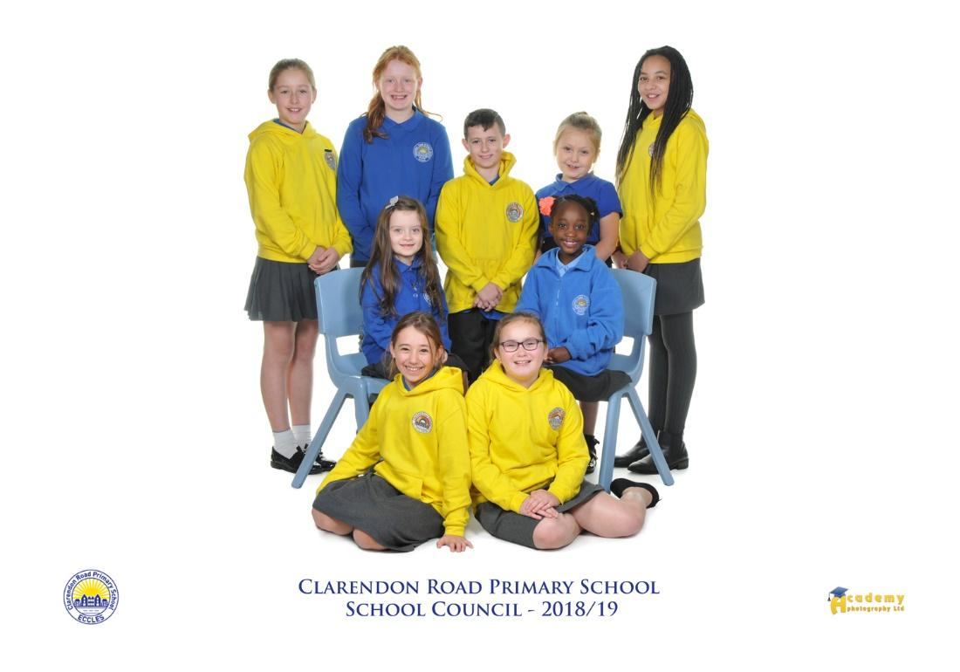
The School Council

Recruitment Process
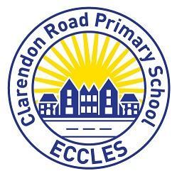
If you would like to apply for this post, you should ensure that you address each of the selection criteria and provide supporting evidence of how you meet the criteria through reference to work or other relevant experience, when completing your form.
To apply, please click on the following link: www.greater.jobs

School Visit Opportunities
Please contact the school office on 0161 789 4469/ clarendonroad.primaryschool@salford.gov.uk to arrange a visit.
Preferred visit times: Friday 22nd March/Wednesday 27th March.

Closing date for applications: 29th March 2019 by 12.00pm
Interview dates: 24th/25th April 2019

