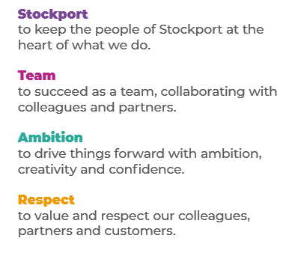
Job Profile and Working for Stockport Council
Our Council
Our employees are our greatest asset. We’re proud of the way we provide vital frontline services every day and work together, as one team.
Our 4 core values as shown above, run through everything that we do, and we aim to stay true to them regardless of the challenges that we may face.
To support our values, we have policies, guidance and procedures around health, safety and welfare, customer care, emergency planning and security that all our colleagues are adhering and working to.
We also pride ourselves on our commitment to wellbeing and inclusivity of our colleagues and residents.
You can find out more about working for Stockport Council and some of the benefits that we offer our employees at https://greater.jobs/locations/stockport/

Role: |  | Information Governance Apprentice
Service Area: |  | Data Service
Directorate: |  | Corporate and Support Services
Salary Grade: |  | Level 3 Apprentice - £8.91 PH
About the Job

Main Purpose of the Job
Main Purpose of the Job
Working within the dynamic and specialised Information Governance (IG) Team, you will provide administrative support and oversee the fulfilment of information requests on behalf of the organisation under various forms of legislation including:
- UK General Data Protection Regulation
- Data Protection Act 2018
- Freedom of Information Act 2000
- Environmental Information Regulations 2004
The IG Team is also responsible for the management of personal data breach incidents in addition to providing advice, guidance, and training to internal and external stakeholders, including our traded service partners operating within the local health, social care, and education sectors to ensure compliance with information law.
Key Responsibilities
- Monitoring the team email inboxes and responding to or escalating queries to Senior Officers
- Answering telephone calls and providing advice on Data Protection and Freedom of Information queries
- Logging new requests for access to information using both dedicated software and Windows based systems
- Locating and retrieving electronic and paper records to compile responses to requests
- Help deliver training sessions to colleagues across the council and our traded service partners to promote awareness of information law best practice.
- To work positively and inclusively with colleagues and customers so that the Council provides a workplace to deliver a service that does not discriminate against people on the grounds of their age, disability, gender reassignment, marriage, civil partnership, pregnancy, maternity, race, religion, belief, sex, or sexual orientation.
- To fulfil personal requirements, where appropriate, with regards to Council policies and procedures, standards of attendance, health, safety and welfare, customer care, emergency, evacuation, security and promotion of the Council’s priorities.

Additional Information
The responsibilities set out in this document, in the advert and any additional information are intended to provide a flavour of the work you will carry out. It is not possible to include everything you will be asked to undertake, and we expect all colleagues to work flexibly according to business needs and to enhance your own development. Your skills, abilities and training needs will be taken into account and discussed with you when any significant changes to your role are needed. In line with our flexible approach you may be required to work from home for a proportion of your time or from any of the Council's sites across the borough.
The Council is an inclusive employer and holds the Disability Confident and Armed Forces Covenant accreditations. If you have a disability, we will support you by implementing reasonable adjustments to enable you to perform your role.

About You
Please use your application to tell us how well you meet the criteria listed below as these are the key skills, experience, technical expertise and qualifications needed to be successful in the role. We will then use all the information you provide in your application to help us decide whether you are shortlisted for interview. Any interview questions or additional assessments such as tests or presentations may also be broadly based on these criteria:
- You will be a highly organised individual who is able to demonstrate experience of managing and prioritising conflicting workloads in a fast-paced environment.
- You will have a good attention to detail
- You will have excellent communication skills and be a team player
- You will have a hardworking and positive attitude
- You will work to the Council’s values and behaviours by:
- Keeping the people of Stockport at the heart of what we do
- Succeeding as a team, collaborating with colleagues and partners
- Driving things forward with ambition, creativity and confidence
- Showing value and respect to our colleagues, partners and customers.

