Candidate Ref No (for office use only)

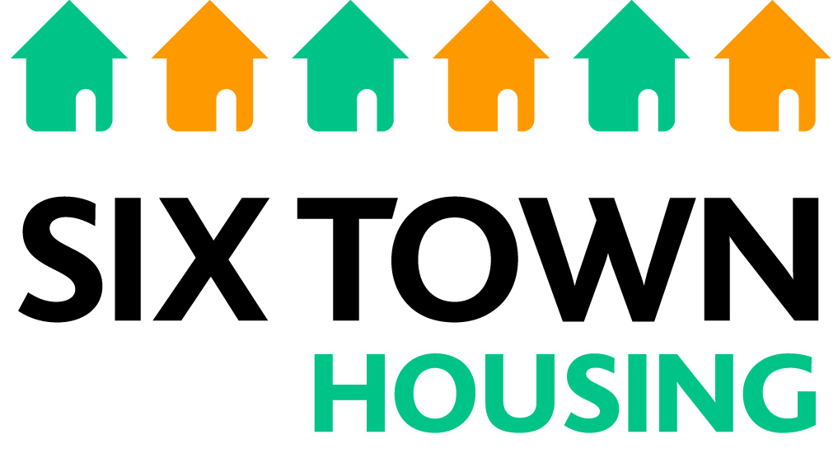
APPLICATION FOR EMPLOYMENT
SECTION A

Name: _______________________ Position Applied for: ______________________

EQUAL OPPORTUNITIES MONITORING
The information in this section will be treated in strict confidence. The results will be used to produce statistical information about recruitment and selection and employment. They will help us to take action to prevent discrimination in accordance with the Equality Act 2010.

Section A of the application will be detached and kept separately before the short listing stage. PLEASE DO NOT PUT YOUR NAME OR ANY IDENTIFIER ON INDIVIDUAL PAGES OR IN THE HEADER OR FOOTER OF YOUR APPLICATION DOCUMENT UNLESS ASKED TO DO SO IN A PARTICULAR SECTION.

In all the following sections, please tick the appropriate box or supply additional information as indicated.

- Gender
I am: Male Female Prefer not to say

2. Transgender
Do you live and work full time in the gender role opposite to that assigned at birth?

Yes No

3. Marital Status
Single Divorced Separated Prefer not to say
Partner Widowed Married or civil partnership

4. Nationality
I am: British Other, please write in ………………………………………

5. Language/s spoken What is your first language?
English Other, please write in ……………………………………..
Other languages spoken, please write in ………………………………………….

6. Religion or Belief Do you follow a religion or belief?
Christianity Buddhism Hinduism Islam
Judaism Sikhism None Prefer not to say

Other, please write in ……………………………………………………………….

7. Sexual Orientation Please indicate your sexual orientation
Heterosexual Bisexual
Lesbian/Gay Woman/Gay Man Prefer not to say

8. Age – please state your age………………………………………..

9. Caring responsibilities in your personal life
Is there anyone that relies on you to provide personal care and attention AND you supply this on a daily basis?
Yes No
If yes, please indicate the circumstances:
Children Sick or disabled child (up to 18 years)
Elderly relative Sick or disabled adult

10. Disability
For the purpose of defining disability we rely on the guidance of the Equality Act 2010. A disabled person is someone who has a physical or mental impairment, which has a substantial and long term (i.e. has lasted or will last over 12 months) adverse affect on his/her ability to carry out normal day to day activities. People with HIV, cancer or multiple sclerosis are protected by the Act from the point of diagnosis. People with some visual impairments are automatically deemed to be disabled.
Do you consider yourself to be a disabled person? Yes No

TYPE OF IMPAIRMENT: - If you answered yes to the question above, how would you define your disability?
Physical Disability (e.g. using a wheelchair to get around or having difficulty using
your arms)
Learning Disability (e.g. Downs Syndrome or dyslexia)
Mental Health condition (e.g. depression or schizophrenia)
Head injury of other cognitive impairment (e.g. autism)
Visual disability
Hearing disability
Musculoskeletal disability
Cardio-vascular disability (e.g. chronic heart disease)
Other long standing illness or health conditions (e.g. back conditions/injury, diabetes, cancer, HIV, or epilepsy. Please state: ______________________________

11. Ethnic Origin
Please tick the box that you believe best describes your ethnic origin. Your ethnic origin is not related to your nationality, place of birth or citizenship. It describes your culture and broad ethnic group. UK citizens can belong to any of the groups indicated below.
White Mixed
British White and Black Caribbean
Irish White and Black African
Traveller of Irish heritage White and Asian
Gypsy/Roma Any other mixed background
Any other white background Please write in …………………
Please write in …………………….

Asian or Asian British Black or Black British
Indian Black Caribbean
Pakistani Black African
Bangladeshi Black British
Any other Asian background Any other Black background
Please write in …………………… Please write in ………………..

Chinese or other ethnic group Unknown
Chinese Unknown/prefer not to say
Other ethnic group
Please write in …………………….

