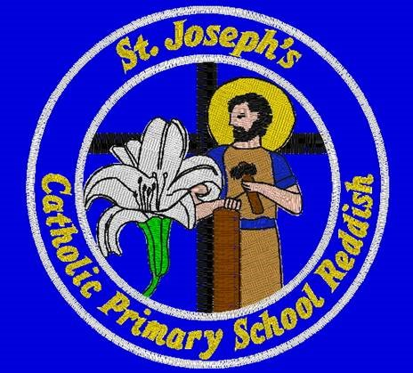

St Joseph’s Catholic Primary School Reddish

Job Description
Teaching Assistant Level A

The main purpose of the job:

To provide support to teaching staff in the Early Years setting

Main Duties and Responsibilities

- To support, assist and supervise children under the direction of the teacher
- to prepare materials and equipment for classroom activities
- to undertake basic first aid duties and attend to sick children

Key Areas

Assisting children in completing tasks and activities
      - Ensuring that classroom activities are prepared eg setting up activities and clearing away activities
      - Assisting with supervision during playtime and educational visits.
      - Attending to sick children including changing soiled clothing and maintaining hygiene standards

