Dear Applicant,
Nurture – Respect - Achieve
Welcome to Lark Hill!
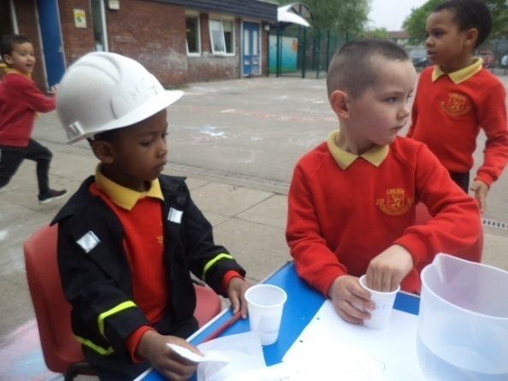
Lark Hill Community Primary School is a fantastic place to be. We are a rapidly growing and changing inner city primary school who place working with our community at the heart of everything we do.
Our children are amazing! They are characters who come together to make our school a vibrant community. Laughter is never far away and we value kindness and humour to help us achieve trusting relationships with all of our children.
Our children do have some challenges. Roughly 1/3 of our school are on the Special needs register, 1/3 have English as an additional language and we have an unusually high number children who have safeguarding issues in their lives.
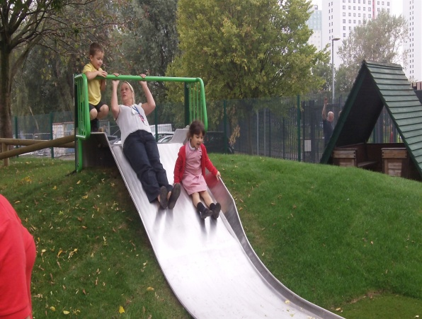
The community we serve is diverse and has changed dramatically over the last three years. Our school is placed in an area of high social deprivation and whilst this brings challenges to our community it also makes us extremely supportive and caring. We have an increasing amount of children who have English as an additional language and this is changing the culture of the school making us rich and vibrant with 23 languages being spoken and children coming from many different countries around the world.
We are a rapidly expanding school having increased our roll from 260 to 580 in the last two years. We now have 580 children and this is continuing to rise. We are in the process of having a new junior building added to our site and over the last 4 years we have had major internal building work completed which has given us 8 classrooms and a new Nursery. We have also just had major work completed on the EYFS outdoor play area.
This work has transformed our school.

We have a dedicated, hard working team led by our Head Teacher who joined us in Sept 2011 and our two Deputy Head Teachers. We are supportive yet challenging and have placed good teaching at the heart of what we do. We have a clear vision for our future. We are working on our new curriculum which brings together literacy and enterprise through topic work. We have strong community links and plan to use these to support our curriculum work and to produce an exciting and engaging curriculum that has enjoyment at its heart.
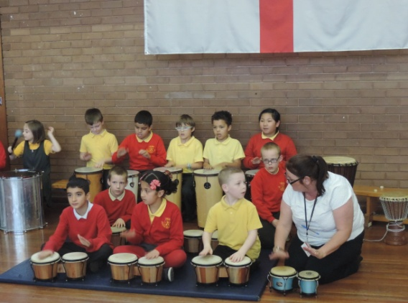
In October 2013, Ofsted visited the School and recognised the School as a good School. We were delighted with the outcome and have continued to build on our strengths and have strong systems in place for curriculum and assessment.
We are committed to high standards and believe that all our children should leave our school being successful readers, writers and mathematicians. This will help ensure they have the best possible start to their lives.
Our journey to be an outstanding school with high standards of achievement is in its infancy and the road ahead will undoubtedly have many challenges. For this reason, it is vital that not only do we select the candidates, but the candidates select Lark Hill. We are looking for people who share our vision and understand the hard work needed to realise this. We are first and foremost looking to appoint a candidate who will embrace our values: Nurture – Respect – Achieve.
A key area of our school improvement plan addresses our commitment to continual professional development for all staff. You will receive a personalised development plan, supported by senior teachers. Coaching for improving and developing teaching and learning plays a vial role within our school. We place great emphasis on our staff as learners and we embrace opportunities to support each other with our development. We also recognise the importance of career development and will look to develop opportunities for whole school responsibility.

The Post
Due to our expanding School roll we are keen to appoint an intervention class teacher to support our staff team. This teacher would be required to teach small groups across Key Stage 2, including support Year 6 in achieving the expected standard. We would like to appoint someone four days a week, however we are flexible in agreeing those days with the successful candidate.
We have developed and worked hard on our approach to teaching over the last year. We have a great practical curriculum that aims to not only excite and motivate, it delivers great learning opportunities that children remember. We have high expectations of all our community and offer staff the chance to learn and grow in a supportive environment. We offer a full induction package that includes support from our coaching four teaching and learning team along with personalised learning plans to support you with the next stage of your career.
Procedures for filling out your application : When completing the online application form, we ask that you write your supporting information in the form of a statement rather than bullet point the specification criteria. In this statement you need to provide supporting information referencing content of the job description and the person specification but please also outline your philosophy of education- what principles and values do you hold closely when teaching. We would also like to hear about your own views and teaching style and also any subject specialisms you would be interested in supporting.
We hope to see you soon!
Andrew Earl

Headteacher

