Enjoy, Care, Achieve
Application for the post of:

Science Teacher
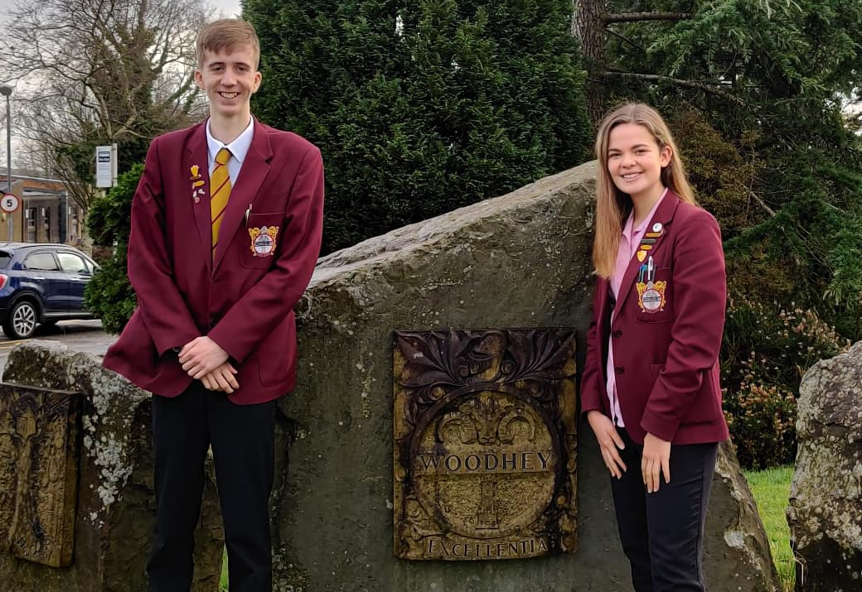
Salary— MPS/UPS

Closing date: Monday 27 April 2020 (noon)

Healthy Schools

April 2020

Dear Applicant

Welcome to Woodhey High School and thank you for expressing an interest in the post of Science Teacher.

This is a high-achieving, inclusive, community school which continues to strive for sustained improvement in all areas.
We are therefore seeking to appoint a passionate and inspirational individual who will play an important role in the future development of the Science Faculty at Woodhey. This post offers an excellent opportunity for a talented teacher to gain experience in a successful faculty. Science is one of our most successful faculties at GCSE.

We are looking for effective inter-personal and communication skills, evidence of excellent teaching ability and a
desire to work through a team approach. Equally important will be a set of values which matches our own and a
constructive attitude to externally imposed change. We shall be delighted to consider your application if you decide to apply and wish you the best of luck if you choose to do so.

If any candidate wishes to discuss the post on an informal basis they may contact us by phone (01706 825215). Please note that our interview processes will be different, in the light of the Covid-19 Lockdown.

Yours faithfully

Brian Roadnight
Headteacher

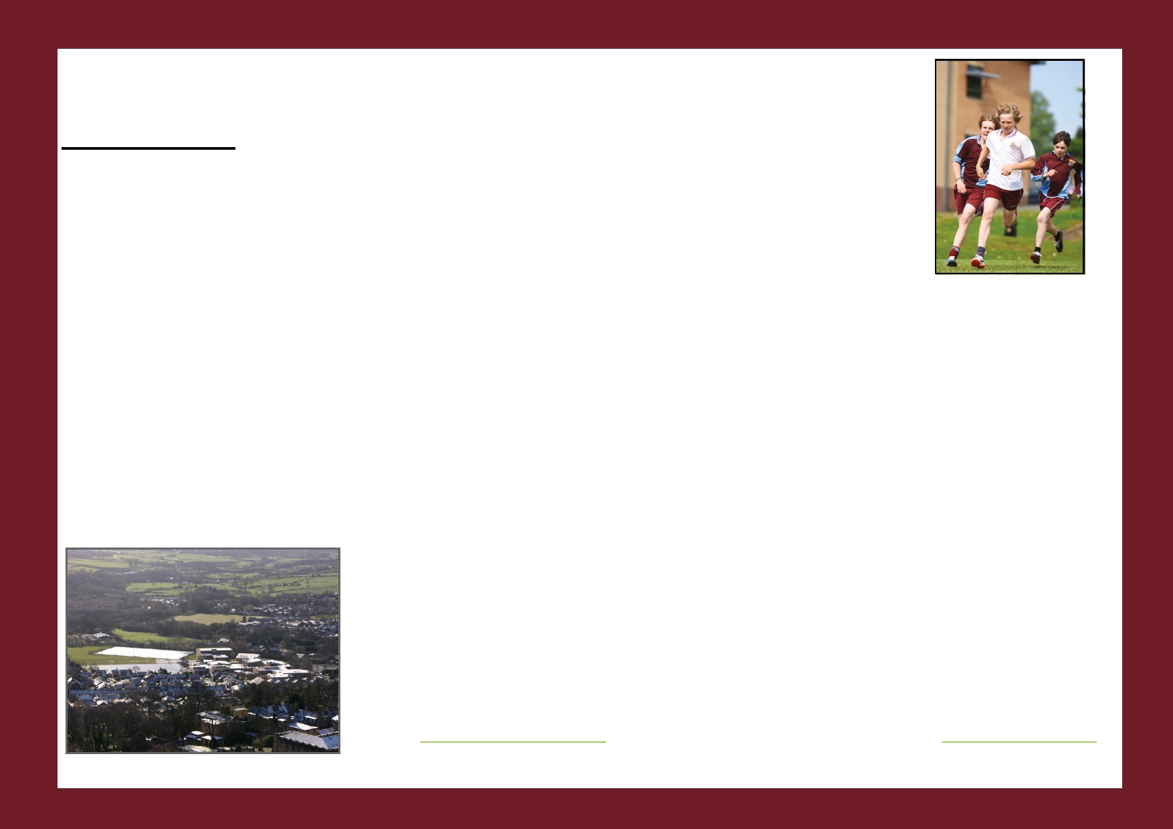
Application for the post of:
Salary:
Appointment Process
By Fri 3/04/20
Mon 27/04/20
Wed 29/04/20

Week beginning 4/5/20
Science Teacher
Fri 15/05/20
MPS/UPS

Local Authority Jobs Website & School Website
DFE, TES

Closing date for applications (12 noon)

Shortlisting (am)

Professional interviews will take place. The format of these interviews will depend on the country’s position regarding COVID-19 Lockdown and will be communicated nearer the time. It is likely that interviews will be conducted individually and not necessarily face to face.

Final date beyond which applicants can assume that their application has been unsuccessful on this occasion if they have not been contacted. We wish you well for the future if this is the case.

The successful candidate will be expected to take up the position from 1 September 2020.

All unsuccessful shortlisted candidates will be offered a debriefing session.

Please find with this information:
1. Job description.
2. Person specification.
3. Information about the school.
4. Application Form.

Further details about the school and a copy of our latest Ofsted Report (Nov 2017) are available on the school
website www.woodhey.bury.sch.uk. For information about Ramsbottom please visit www.Ramsbottom.net.

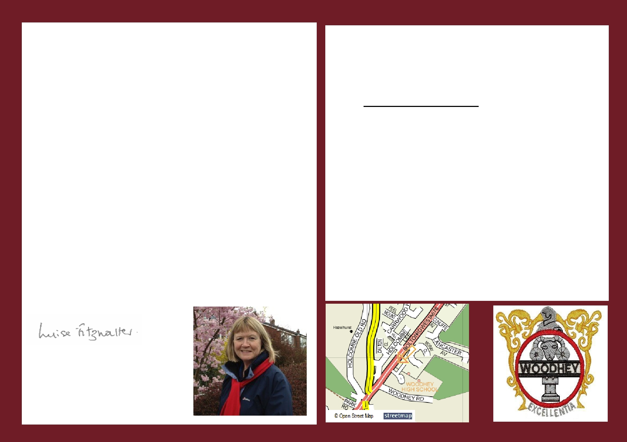
April 2020

Dear Applicant

Thank you for expressing an interest in the post of Science Teacher at Woodhey High School in Ramsbottom.

The Governors wish to appoint an outstanding candidate to teach in this highly successful and popular faculty with effect from 1 September 2020. We are looking for a dedicated and inspirational teacher who will build on the school's success and continue to raise standards of achievement in this subject.

Woodhey is a high achieving and inclusive 11-16 community comprehensive school and was a Specialist Science College. It also has an Enhanced Provision Unit for pupils on the autistic spectrum. We are committed to providing a secure and caring learning environment for all our pupils and we ask our pupils to achieve, care and enjoy. Our aim is to develop highly-educated, well-rounded, considerate and confident young people who are willing and able to contribute to society.
There are currently 1119 pupils on the school roll.
Ramsbottom has become more of a residential area than an industrial town. The town
does have some thriving small industries and is a popular shopping centre for the surrounding area. A strong sense of community values still exists in Ramsbottom, but many residents now commute to Greater Manchester, Merseyside, West Yorkshire and
Lancashire because of the superb access to the nearby motorway network.
We obviously want the right person for our school and you will want the right school in
which to work - so we have tried to include as much information as possible for your consideration. We shall be delighted to consider your application if you decide to apply
and wish you the best of luck if you choose to do so.
I look forward to receiving your application.
Yours faithfully
APPLICATION DETAILS

Please complete the enclosed application form, together with a letter of application (no more 1,500 words).

Application forms and details are available on the school's
website www.woodhey.bury.sch.uk. in the section "About us".

Applications should be sent by email (woodhey@bury.gov.uk) or
post to the school to arrive by:
Monday 27 April 2020 (noon)

Your application must address the person specification and outline your experience, values and vision for the future at Woodhey. You may enclose a curriculum vitae if you wish but this will only be considered alongside a fully completed application form and letter.

We look forward to receiving your application.
If you have not heard from us by Friday 15 May 2020 please assume that you have not been successful on this occasion. May we thank you in advance for your application and wish you well for the future.

Luise Fitzwalter
Chair of Governors

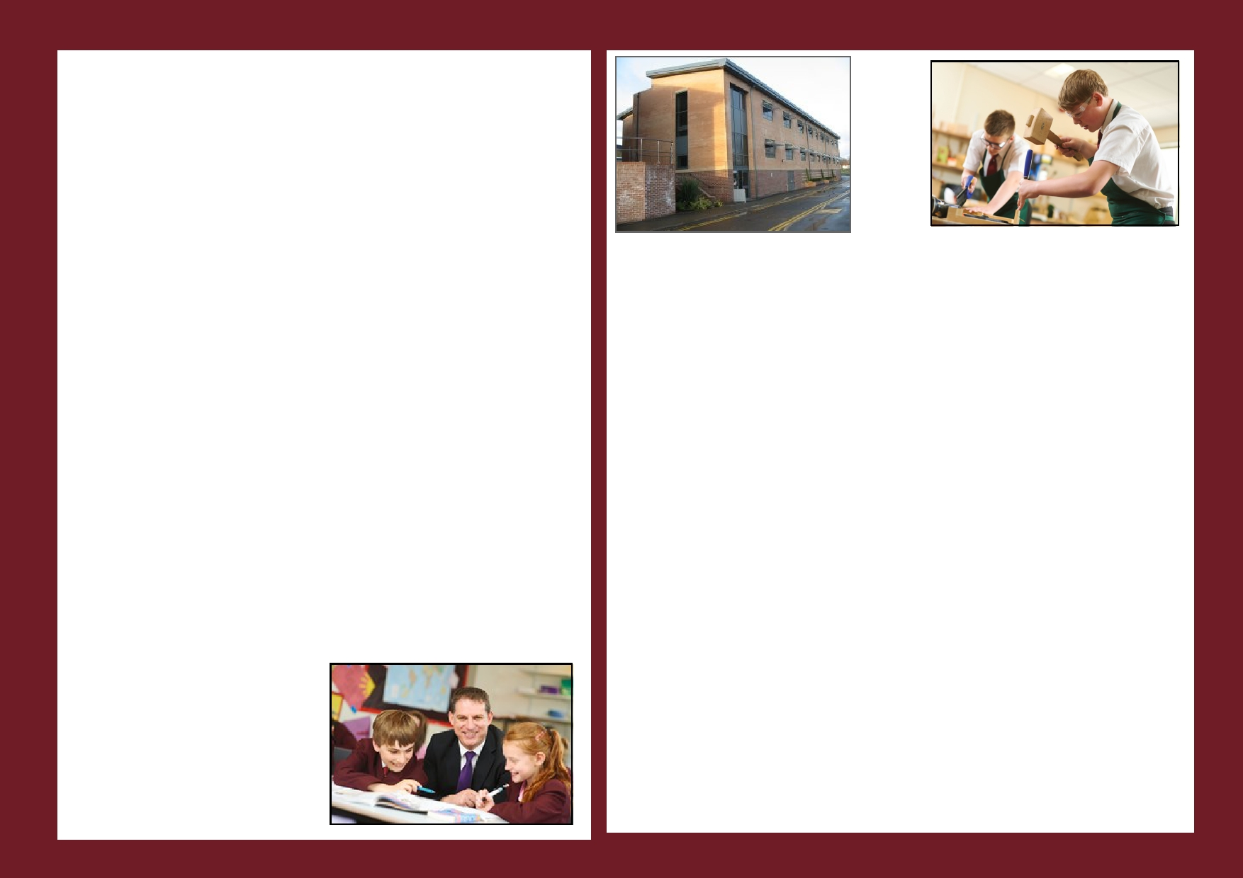
SCIENCE FACULTY INFORMATION
Woodhey High School has an experienced and successful Science Faculty that consistently achieves results well above the national average. The faculty currently consists of 7 full-time Teachers, 4 part-time Teachers, 1 Assistant Headteacher and two Technicians.
At KS3 we use ‘Science Works’ text books with modified schemes of work and pupils are taught in sets according to ability. Science is allocated 6 hours per fortnight in Years 7 & 8 with an additional hour in Year 9. During Year 8 Woodhey pupils can take an option for taking Triple Sciences and are allocated 10 hours per fortnight during Year 9. Woodhey’s Science curriculum is available at http://www.woodhey.bury.sch.uk/Curriculum/ The successful candidate will teach all three disciplines at KS3.
At KS4 the majority of pupils currently study AQA Trilogy, studied in Year 10, and Year 11. The number taking the 3 Separate Sciences has generally been about one quarter of the cohort in recent years.
The department has an extensive range of worksheets and software to aid teaching. There are 8 laboratories, one classroom and at KS4 we have access to a computer suite. All laboratories are situated around a central preparation room. The majority of lessons are taught in the laboratories.
Faculty staff are practically minded, constantly seeking to encourage an interest in an enjoyment of science through exciting and dynamic teaching, thus leading to a good understanding of the subjects at all levels.
Members of the faculty each assume responsibility within their subject area to help contribute to the effective running of the Science team. Staff are encouraged to voice their opinions and share their ideas in order to move the faculty forward in line with new developments.
As Head of Faculty, I am looking for a well-qualified, committed and enthusiastic teacher who will need to be hard-working. Due to the current specialisms of our staff, Chemistry and Physics specialists would be preferred but ultimately we want to appoint the best teacher. The successful candidate will be expected to contribute fully to the team, offering new ideas and approaches to teaching, and show a willingness to take on responsibility. In return you will receive a great deal of support, gain valuable experience teaching very responsive pupils, and learn from extremely hard-working colleagues. The successful candidate will be expected to teach confidently across the subject at KS3 and at KS4.

I hope the information supplied has encouraged you to apply. If you feel that Woodhey provides the opportunity for you, I wish you well and look forward to receiving your application.

D Careless
Head of Faculty

Information regarding the
Job Description
and
Person Specification
for this position can be found
within the separate
documents attached with this
advertisement

