Health Improvement Worker
Service: |  | Health Improvement Service | Grade: | 2C |  |  | Salary: |  |  |  | £22,183 – 24,491
Reporting to: |  | Health Improvement Officer | Location: | Civic Centre |  |  | Hours: |  |  |  | 36
About the role |  |  |  |  |  |  |  |  |  | Our priorities
- Support the Health Improvement Service in improving health and reducing inequalities by engaging with communities to implement local health improvement action plans through the delivery of health projects in neighbourhoods.  - Deliver and co-ordinate community-based health improvement initiatives.  - Promote and raise awareness of healthy lifestyles and signpost people to health promoting activities.  - Produce project plans for group projects and lead groups on a range of topics including carrying out evaluation of sessions.  - Signpost to other staff/agencies for higher levels of support.  - Support the Senior Community Development Worker in developing and delivering local community development initiatives.  - Communicate effectively with a wide range of people including senior managers, frontline staff, local people and outside agencies like health services and voluntary sector agencies.  - Contribute to the delivery of local publicity and conducts local surveys and research through their established links in the community.  - Work with other partners as required by Health Improvement Officer  - Collect data as requested to inform and develop good practice, and to report performance  - Focus on geographical areas of deprivation, aspiring to deliver equity of services and focussing work across diverse communities |  |  |  |  |  |  |  |  |  | 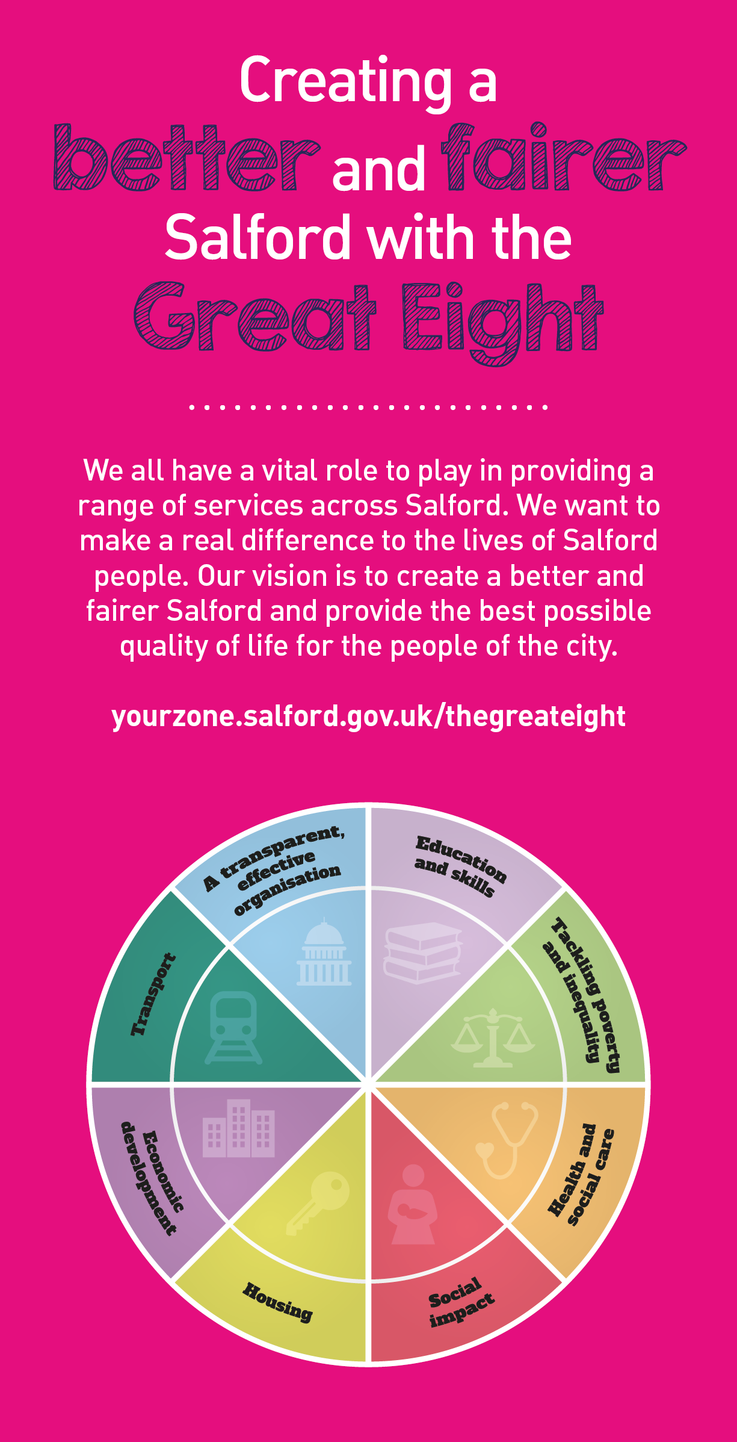
 | Key outcomes
 | - Create appropriate partnerships to take forward and deliver health projects and initiatives.  - Work to mainstream health improvement activities and ensure sustainability  - Produce marketing and communications materials in line with policies, including the use of social media  - Deliver a range of health related projects in suitable formats including smoking cessation and the issuing of Nicotine Replacement Therapy following completion of training. |  |  |  |  | - Delivers NHS Health Checks in line with agreed processes and procedures with the necessary support being provided by more experienced staff.  - Deliver and co-ordinate a programme of neighbourhood based health improvement intervations, courses and programmes as required.  - Keep accurate records and contribute to team reports by providing data and information as required.
 | What we need from you
 | - Proven technical skills and ability in the role with a record of accomplishment for delivering outcomes  - Professional credibility through proven relevant experience  - Models and demonstrates our values and leadership behaviours  - Knowledge and understanding of the wider determinants of health, and public health principles and policies.  - A flexible and positive attitude, there will be a requirement to travel around, to regularly work weekends and evenings, and to workin an environment of change.  - Passionate and committed to reducing health inequality.  - To understand and be able to apply the principles of community involvement, participation and development.  - A stong commitment to team working and the ability to manage and diffuse conflict.  - Good written and verbal communication skills |  |  |  |  | - Ability to empathise with, and motivate others  - Ability to work on initiative, prioritise work and work in an environment of change  - Experience of working with and within a variety of communities  - Experience of delivering health improvement initiatives  - Experience of Undertaking evaluation and using evidence  - Ability to work with people at all levels, capabilities and attitudes  - Computer skills including knowledge of Internet, Intranet, email and Microsoft Office applications
Application Guidance |  |  |  |  |  |  |  |  | Our values
We are a values-based organisation so reflecting our values or a values-based approach in your evidence will support your application.

The ‘Key outcomes’, ‘What we need from you’ and ‘our leadership behaviours’ sections of the Role Profile are there to give you an understanding of what we would like to see reflected in your application. Don’t give up if you are not able to reflect all of these in your application.

For more information please contact:
Angela Eden
Health Improvement Manager
Angela.eden@salford.gov.uk
07799115451

