Partnerships Support Officer (fixed term 18 months)
Service: | Policy and Partnerships Team | Grade: | 2B |  |  | Salary: | £19,945 to £21,589
Reporting to: | Prevent and Cohesion Lead | Location: | Unity House |  |  | Hours: | 36 hours per week
About the role |  |  |  |  | Our priorities
- To provide effective administrative and business support that contributes to the work of the Policy and Partnership Team and across community safety, emergency planning and safety advisory group structures.
- To arrange meetings, book facilities/equipment, prepare agendas, attend meetings and produce and distribute high quality minutes within agreed timescales.
- To assist officers in the co-ordination of multi-agency delivery plans to achieve community safety, emergency planning and safety advisory objectives.
- To co-ordinate the council’s emergency planning officer rota to ensure adequate staffing levels are maintained.
- To assist emergency planning on call officers to participate in training exercises as required.
- To contribute to the delivery of a broad range of projects relating to key council and partnership priorities.
- To work with partners and third sector organisations to provide a seamless administrative and business support service.
- To organise, support and attend promotional events and training sessions as required.
- To assist in raising the profile and awareness of equality issues through supporting delivery of equality and cohesion related initiatives.
- To assist officers within the team to carry out policy research so that Salford is able to benefit from new ideas and innovations.
- To undertake such additional duties commensurate with the level of the post.
- To carry out all duties with full regard to Salford City Council’s Equal Opportunities and Health & Safety policies.
- To contribute and demonstrate a commitment to Salford City Council’s Community Safety Strategy.
- To treat all information in accordance with Salford City Council’s policies on confidentiality and Data Protection.

 |  |  |  |  | 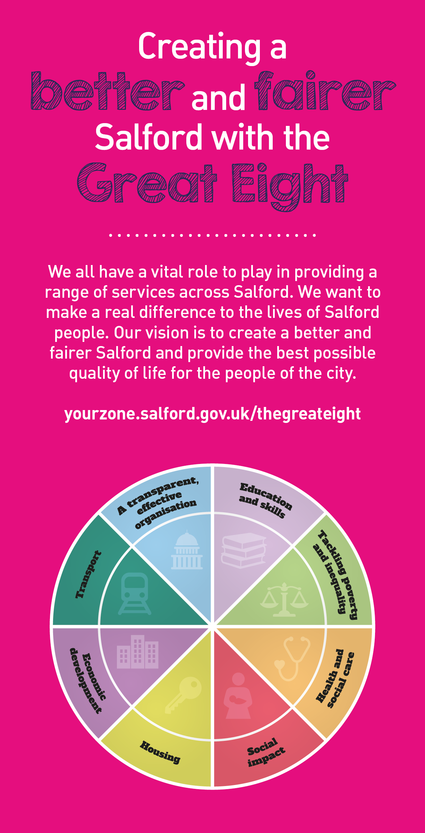

Key outcomes
Provision of high quality administrative and business support for the Policy and Partnership and Community Safety teams. |  | Ensures the City Council takes fully regard of its equalities duties in the development in the delivery of its business.
Play a key role in building and maintaining strong links with communities of interest to improve community cohesion and foster positive relations in support of the council’s public sector equality duty. |  | Play a key role in protecting and maintaining public safety through administration of the council’s emergency planning processes
Play a key role in maintaining effective relationships with a wide range of partners across the city including the Police, Fire Service, Clinical Commissioning Group and other key stakeholders represented on community safety partnership. |  | Personally embraces the Council’s values of Pride, Passion, People and Personal Responsibility, and embodies these values in everything you do. Embeds these values throughout the team.
What we need from you
Demonstrates initiative, confidence and personal responsibility for action. |  | Good communicator who communicates with clarity and enthusiasm and is able to create rapport and build trust and confidence
Good interpersonal and time management skills with the ability to work with diverse stakeholders |  | Ability to work with confidential and sensitive data
Ability to ensure reliable, accurate and timely information is available at all times to inform decision making. |  | Ability to work flexibly and attend evening meetings as required
Determined and consistently persists with actions to achieve outcomes. |  | Models and demonstrates our values and leadership behaviours.
Demonstrates respect and caring for others, treating everyone fairly; listening and acting on the things people say. |  | Excellent Microsoft Office skills (Word, Excel and Outlook).

Application Guidance |  | Our values
We are a values based organisation so reflecting our values or values based approach in your evidence will support your application.

The ‘Key outcomes’, ‘What we need from you’ and ‘our leadership behaviours’ sections of the Role Profile are there to give you an understanding of what we would like to see reflected in your application.

Don’t give up if you are not able to reflect all of these in your application.

