The MioCare Group
The MioCare Group comprises three companies. The MioCare Group CIC is the parent organisation with two subsidiary delivery organisations, Oldham Care and Support and MioCare Services. The group was established in October 2013 by Oldham Council with the overarching aim of making sure the people of Oldham can continue to access excellent social care and support services when they need them. The MioCare Group is a fully signed up and active member of the Oldham Cares Health and Social Care Alliance.
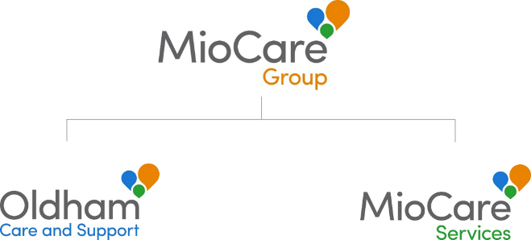

The MioCare Group is owned by Oldham Council and has a common Board which governs all the companies in the group. The Board comprises four shareholder representatives, all of whom are elected members (Councillors), nominated by the Council, three independent non-executives and the Managing Director. The Council have also appointed the Director of Adult Social Services to act as the shareholder’s advisor to the Board.
Oldham Care and Support (OCS) – OCS comprises largely of the services which were provided inhouse by Oldham Council prior to the companies being established. The company currently employs circa 350 staff, the majority of which are care and support workers. A service level agreement is in place for OCS to provide a range of services on behalf of Oldham Council.
MioCare Services (MSL) – MSL was a start-up company in 2013 which uses a social business approach to operating in the market in a way in which the previous in-house service was unable to. Employing circa 100 staff, MSL has been successful in entering into the Extra Care market and delivers a (non-commissioned) learning disability day service.
Our mission is to support people to get the most out of life in a way that helps people to become more independent or keep, or get back, their independence. Our primary client groups:
• Older and frail people
• People with a complex learning disability, including challenging behaviour
• People with mental health support needs
Please see www.miocare.co.uk for more information.

