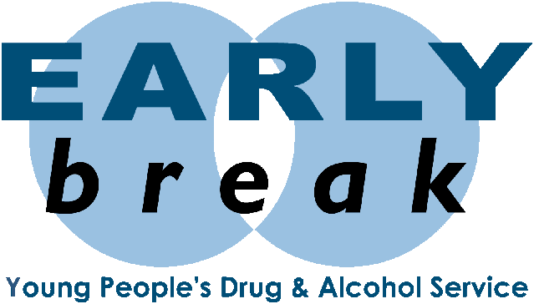
18 April 2017

Dear Colleague

Thank you for your interest in the role of Team Leader at Early Break.

Please find attached a role outline which gives you more information about the post, including key deliverables, competencies and required knowledge, skills and experience, all of which should form the basis of your application. The application should demonstrate your suitability for this role.

The closing date for applications for this role is Friday 12 May 2017 at 12 noon. Please return your completed application forms, together with a covering letter to:

Clare Healey
Early Break
Annara House
7-11 Bury Road
Radcliffe
Manchester
M26 2UG

Or by email to chealey@earlybreak.co.uk

Interviews will take place on Wednesday 24 May 2017 and you will be advised by phone and follow up letter of an interview time only if you have been successful.

If you have any further questions regarding this process please speak to Clare Healey on 0161 723 3880 or email chealey@earlybreak.co.uk in the first instance.

Yours sincerely

J Day

J Day
Area Manager

Employment Opportunity

Team Leader

EB Salary Points Range 33 – 35, (£27,751-£29,132 per annum)
Part time - 4 days week, permanent contract (pro rata £22,200 per annum)

You will:
- Contribute to the maintenance of an ethos in which all workers, clients and all in contact with Early Break and its partner agencies are valued and shown respect
- Support the Managers in the delivery of the Service ensuring targets are met and workers supported in their practice
- Undertake case reviews and allocation of cases alongside Senior Managers
- To support on the recruitment and management of volunteers in service
- To assist in the preparation of funding bids, as appropriate and as required
- Manage a small caseload and function as a key worker for young service users with complex primary drug and related healthcare needs, as required and where need dictates
- To promote the service digital media and lead by example to the workforce
- Be prepared to work evenings and/or occasional weekends as required by the role
- To contribute to the wider work of the charity and its entrepreneurial development
- Be a reflective practitioner in the role

Application pack available for downloading from www.earlybreak.co.uk

Closing date for applications: Friday 12 May 2017 at 12 noon

Interview date: Wednesday 24 May 2017

Early Break is committed to safeguarding children and vulnerable adults. It is the Company’s policy only to offer employment, or volunteering experiences to those who have a satisfactory and enhanced Disclosure and Barring Certificate (DBS).
At all times the Company reserves the right to refuse employment, or a volunteering role, within the Service, if it is not satisfied with issues that have been disclosed.

