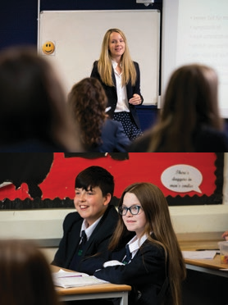
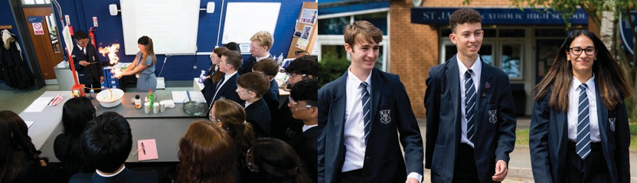

Learning Support Assistant

Candidate Information

A message from the Headteacher

Thank you for your interest in St James’ Catholic High School. This is an exciting time to join St James’ as we look to move our school to the next level.

We are a good oversubscribed school (OFSTED 2022) located in Stockport, South of Manchester. Our school is made up of 825 students and 100 staff. St James’ Catholic High School
is a thriving Catholic community that places children at the centre of everything we do. The Diocese of Shrewsbury judged our school to be an “Outstanding” Catholic school.

St James’ is a highly academic performing school:

- Impressive positive progress 8 scores for the previous three years

- In 2022, 84% of students achieved at least a grade 5 in English & Maths while 66% of students achieved a grade 5 in these subjects

- 94 grade 9s and 253 grade 8s in 2022 demonstrating exceptional attainment across a wide range of subjects

- Exceptional results in open subjects and the humanities placing us in the top 20% of similar schools nationally

Our school is at the cutting edge of teaching and learning and thrives on providing outstanding opportunities for the young people we serve. All our staff work to provide our young people with the skills, knowledge and understanding in order to achieve their full potential.

Inspired by the example of St James, the purpose of our school is ‘To educate and develop global Catholic citizens’. Our three school values of Family, Faith and Excellence are lived out every single day by staff, students and all stakeholders.

The reputation of our school is exceptional within Stockport and across the Shrewsbury Diocese for academic excellence, impeccable pupil conduct and for providing outstanding additional opportunities for our young people. The result is that our young people develop into global Catholic citizens who are proud to profess their faith and who make a positive contribution to society.

At the root of our success is our St James’ community. This is built on strong, positive relationships between all staff, students and parents. Our parents support our school and develop their children at home whilst our dedicated staff are relentless in driving excellence by providing the best educational experiences and opportunities for our students.
Underpinning this excellence are our unique values, Catholic ethos and our mission. We are inspired and driven by the Gospel where we are told: ‘With God all things are possible’ (Matthew 19:26).

If you would like to find out more about our school and community, please contact Kirsty Bowers,
PA to the Headteacher on 0161 482 6900 or at headteacherpa@stjamescheadle.co.uk

Anthony Pontifex
Headteacher

Job Advertisement

Learning Support Assistant
28 hours per week, term time only pro rata. Permanent. Scale 4 £22,369- 24,054 (Actual Salary £14,414 - £15,499)

The St James’ Catholic High School Mission:

To ensure everyone within our school family achieves their full potential, to encourage learning and development through faith,
and to strive for excellence

Applications are welcome regardless of the personal faith of the applicant, providing they are supportive of the school’s Catholic ethos.

St James’ Catholic High School is a popular and oversubscribed 11-16 mixed comprehensive Catholic High School which was judged by OFSTED to be a “Good” school in April 2022

The Diocese of Shrewsbury judged our school to be an “Outstanding” Catholic school

The governors of the school wish to appoint a Learning Support Assistant

Please note a current CES application form (version 14) and a Model Rehabilitation of Offenders act 1974
– Disclosure form must be completed for this post – CVs will not be accepted. Forms can be emailed to

headteacherpa@stjamescheadle.co.uk

St James’ Catholic High School is an equal opportunity employer which is “Positive about Disabled People”. Whilst all applicants will be judged on merit alone, we particularly welcome applications from groups currently under-represented in the workforce, who meet the person specification for the post

St James’ Catholic High School is committed to safeguarding and promoting the welfare of children and applicants must be willing to undergo child protection screening appropriate to the post, including checks with past employers and the Disclosure & Barring Service

Job Description | Responsible to: SENCO

Learning Support Assistant

School Mission Statement

St James’ Catholic High School aims to ensure everyone within our school family achieves their full potential,
to encourage learning and development through faith, and to strive for excellence

Main responsibilities of the post

To assist in providing a learning environment that enables all pupils to access the curriculum and learn to the best of their ability.

General - The Learning Support Assistant will:

- Have an understanding of the broad range of Special Educational Needs (specific learning difficulties, complex learning difficulties, moderate learning difficulties, autistic spectrum disorder, emotional behavioural, mental health & social communication difficulties, ADHD) with reference to how this affects pupils’ learning
- Work under the guidance of teaching / senior staff to implement agreed work programmes
- Provide support for teaching staff across the school in an appropriate learning environment
- Assist with the integration of pupils with special educational needs and/ or disabilities, supporting a small group or on
an individual basis within the classroom or on a withdrawal basis
- Be an integral part of the school, working in close partnership with all staff
- To liaise sensitively and effectively with parents/carers as agreed with the teacher and participate in feedback sessions or meetings as directed

Pupils - The Learning Support Assistant should:

- Assist with the teaching of pupils; whole class, small groups and individuals as directed
- Help pupils to access learning activities through specialist support
- Provide feedback to pupils in relation to progress and achievement
- Monitor and evaluate pupils’ responses to learning activities through observation and planned recording of achievement against pre-determined learning objectives
- Encourage pupils to interact and work co-operatively with others and engage all pupils in activities
- Be aware of and support difference and ensure all pupils have equal access to opportunities to learn and develop
- Implement local and national learning strategies e.g. literacy, numeracy, and make effective use of opportunities provided by other learning activities to support the development of relevant skills

Staff - The Learning Support Assistant should:

- Assist the teacher in curriculum planning, management & preparation of resources
- Be responsible for keeping and updating records as agreed with the teacher, contributing to reviews of systems/records as requested
- Undertake marking of pupils’ work and accurately record achievement/progress
- Implement agreed learning activities/teaching programmes, adjusting activities according to pupil responses/needs
- Implement local and national learning strategies e.g. literacy, numeracy, early years and make effective use of opportunities provided by other learning activities to support the development of relevant skills
- Support the use of ICT in learning activities and develop pupils’ competence and independence in its use

Specific Responsibilities of the Learning Support Assistant at St James’ Catholic High School

- To work with the department and all staff in the promoting of inclusion of young people with special educational needs and/or disabilities
- To support the learning of pupils with SEND
- To be empathetic, highly supportive and understanding of the needs of individual pupils
- To help pupils to access learning activities through specialist support
- Administer and assess routine tests and invigilate exams/ tests
- Be responsible for keeping and updating your own records in relation to your continued professional development
- To attend training and development sessions
- To work alongside the teacher to ensure that students achieve learning aims
- To provide general clerical/admin support e.g. administer coursework, produce worksheets for agreed activities etc
- To support charity work within school
- To help to develop and maintain Individual Educational Plans (IEPs)
- To be a presence in the classroom, where required
- To attend SEND Departmental meetings

Whilst every effort has been made to explain the main duties and responsibilities of the post, each individual task may not be identified.

The post holder will be expected to comply with all reasonable requests from the Headteacher to undertake work of a similar level that is not specified in their job description

Person Specification

Learning Support Assistant

 | Status of Criteria |  | Method of Assessment
Job Requirements | Essential | Desirable | Application | Interview/task
Training and Qualification
Level 2 or equivalent qualification in English/Literacy and Mathematics/Numeracy | 🗸 |  | 🗸
First Aid qualification |  | 🗸 | 🗸
Experience
Experience of working as a Teaching Assistant |  | 🗸 | 🗸 | 🗸
Experience of working with young people within a school environment |  | 🗸 | 🗸 | 🗸
Experience of working as part of a team | 🗸 |  | 🗸
Professional Knowledge
Demonstrate knowledge and understanding of working with young people with special needs and /or disabilities | 🗸 |  | 🗸 | 🗸
Ability to relate to and inspire young people | 🗸 |  | 🗸
Personal skills and qualities
Ability to communicate effectively both orally and in writing | 🗸 |  | 🗸 | 🗸
Commitment to appropriate professional development | 🗸 |  |  | 🗸
Sense of humour | 🗸 |  | 🗸
Commitment to safeguarding and protecting the welfare of children and young people | 🗸 |  | 🗸 | 🗸
Willingness to accept the demands and challenges of the post and respond in a flexible and approachable manner | 🗸 |  |  | 🗸
Commitment to health and safety | 🗸 |  |  | 🗸
Ability to relate well to children and adults | 🗸 |  |  | 🗸
Ability to work under pressure to prioritise and meet deadlines | 🗸 |  | 🗸 | 🗸
Have excellent professional relationships with different groups of people | 🗸 |  |  | 🗸
Practising Catholic |  | 🗸 |  | 🗸

Contact

Kirsty Bowers
PA to the Headteacher

0161 482 6900
headteacherpa@stjamescheadle.co.uk

www.stjamescheadle.co.uk
St James’ Catholic High School St James’ Way
Cheadle Hulme Cheadle Cheshire
SK8 6PZ

A560
WYTHENSHAWE

M60

CHEADLE
GATLEY

M56

HEALD GREEN

A34

CHEADLE HULME

HALE BARNS

BRAMHALL

Manchester Airport

B5094

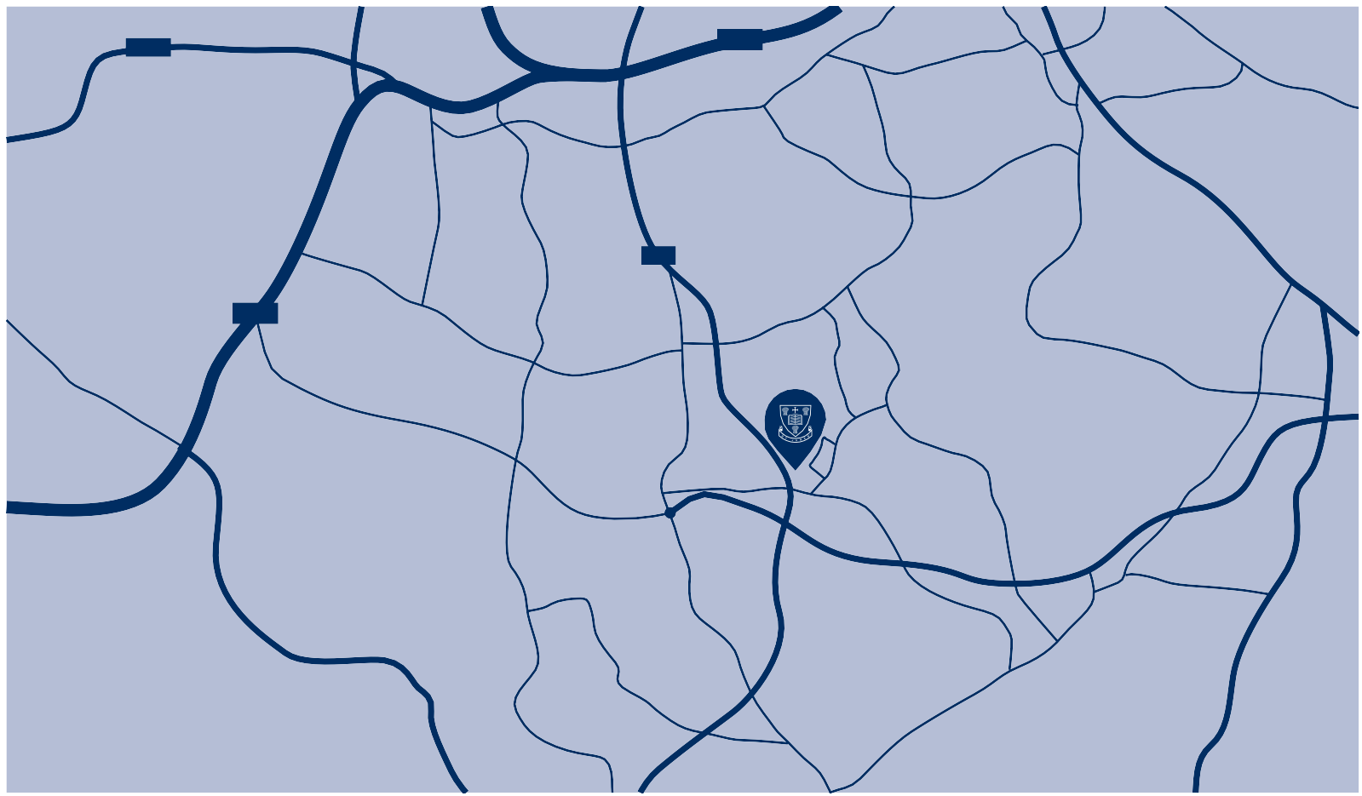
HANDFORTH
STYAL

MORLEY GREEN

WILMSLOW

With God all things are possible
Matthew 19:26

