Human Resources & Orgnisational Development Business Partner
Service: | Human Resources and Organisational Development | Grade: | 4A | Salary: |  |  | £32,878 - £35,934
Reporting to: | Strategic HR and OD Manager | Location: | Civic Centre, Swinton | Hours: |  |  | 36
About the role |  |  |  |  |  | Our priorities
- Contribute to the development of the corporate workforce strategy and, working closely with the Strategic HR & OD Managers, ensure that it is embedded within service directorates.  - Position the role of HR Business Partner as an integral part of our HR & OD function through the development of effective working relationships and immersion in services - influencing, and challenging management teams on the development and delivery of their people plans in support of the achievement of the service area outcomes and workforce strategies.  - Support service directorates to identify and develop a response to a wide range of workforce related matters including strategic workforce planning, skills shortages, succession planning, and future proofing the workforce.  - Working with senior managers, providing innovative organisational development and learning solutions, workforce plans and strategies to achieve appropriate service outcomes.  - Work with service areas to establish and introduce systems that identify employees with high potential, support the development of career pathways for key roles, succession planning and self-development tools.  - Through the provision of appropriate organisational development and learning tools and knowledge enable managers to effectively manage their people e.g. leading change, performance and talent management, career management, health and wellbeing and absence management.  - Provide transformational advice on change management initiatives including: consideration of organisational and service redesign; job role design; alternative delivery models in order to improve service delivery.  - Using insight and analysis to inform workforce strategies and plans to mitigate people risks.  - Work collaboratively to provide specialist advice, information, support and challenge which supports the delivery of service outcomes whilst also safeguarding the organisation and delivering our priorities.  - Work with managers to build capacity and capability for managing employee relations issues and improve the effectiveness of both employee engagement and consultation.  - Embed a performance management culture within directorates as a means of improving organisational performance through people. |  |  |  |  |  | 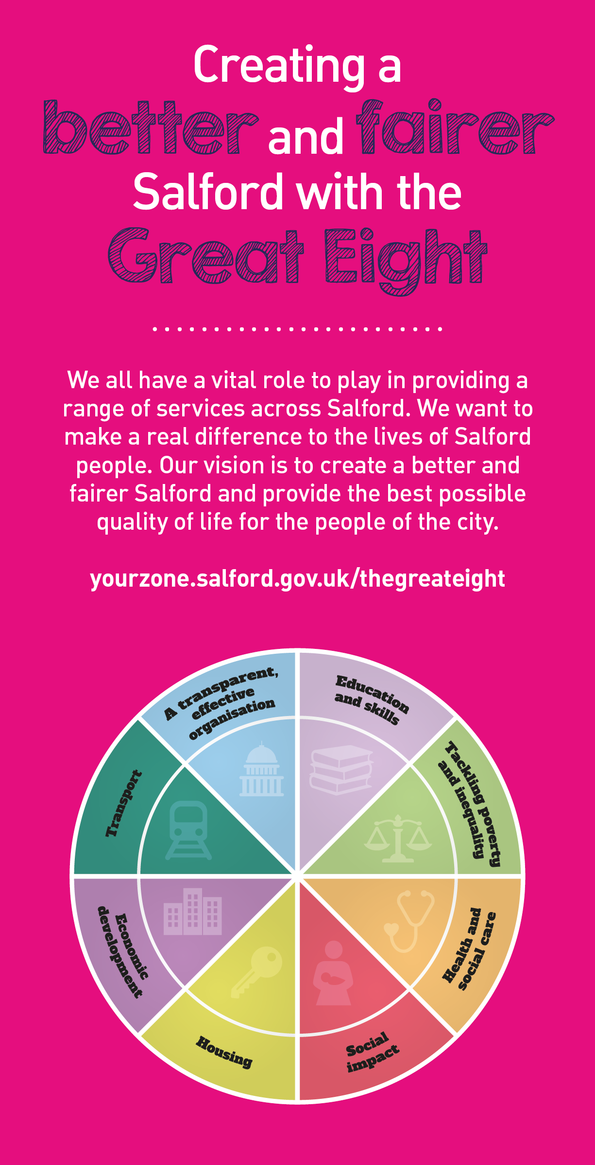

Key outcomes
- Play a key role in the research, design, development and implementation of organisational and workforce development, talent management and workforce planning initiatives in support of the workforce and talent strategies.  - Work with the service areas to establish and introduce systems that identify employees with high potential, identify and develop programmes that meet development potential.  - Work with the service areas to establish workforce planning approaches, create career pathways and programmes for ‘growing our own’.  - Reduce employee relations episodes through effective application of policies and procedures, coaching managers to be effective people managers.  - Play a key role on the development and implementation of high impact talent management approaches that ensure the organisation is attracting, recruiting, developing and retaining talent - developing & cementing our ‘brand’ as an exemplar employer. |  | - Maximise the opportunities the apprenticeship levy brings for re-skilling and up-skilling our workforce ensuring that talent management and workforce planning initiatives are underpinned by entry and advanced apprenticeships.  - Play a key role in the research, design, development and implementation of employee engagement and culture development approaches that ‘leads the way to make Salford a great place to work’.  - Using insights produce and relay effective management information to develop solutions and inform management decisions and actions.  - Support our transformation programme by leading best practice co design methodology and workforce development approaches to support service redesign.  - Play a key role in developing a values based positive permission culture organisation that can deliver a better and fairer Salford for everyone.
What we need from you
- Achiever - proven technical skills and ability in the role of expert employee relations, organisational and workforce development practitioner bringing innovative best practice approaches.  - Assured - demonstrates initiative, confidence and personal responsibility for action.  - Credible - professional credibility through proven experience across the HR field – organisational design, employee relations, organisational and workforce development.  - Curious - understands the bigger picture and broader context and is able to translate to a local setting.  - Determined - tenacious and consistently persists with actions to achieve outcomes.  - Diplomat - open to the views of others - able to constructively challenge and be challenged.  - Evidence Seeker - demonstrates analytical skills using data insight to inform workforce strategies and plans.  - Techically Proficient  - Demonstrates a sound knowledge across the range of HR & OD functions including organisational development; employee engagement; workforce wellbeing; employee relations; learning and development; pay and reward; policy development etc. |  | - Leader - leads people/projects, with an ability to motivate, engage and develop people to deliver shared outcomes.  - Optimist - remains positive under challenging circumstances.  - People Person - skilled communicator who communicates with clarity, conviction and enthusiasm and is able to demonstrate integrity, create rapport and build trust and confidence.  - Solutions Seeker - understands the local context and able to identify outcomes focussed solutions to meet needs.  - Story Teller - ability to translate complex ideas and information into meaningful and ‘user-friendly’ information; ‘tells the story’ to bring people along and ensure all audiences understand the key messages.  - Resource Weaver - brings together multi faceted activities to improve performance and/or resolve business critical issues.  - Values Based - models and demonstrates our values and leadership behaviours.  - Technically Proficient  - Knowledge and understanding of employment legislation and the overarching workforce legal framework, including expertise in recognised HR & OD policy practice.  - Hold or be working towards CIPD qualification (Level 5)

Our leadership behaviours |  | Our values
As a values-based leader you will:  - Model the values and embed them in the way your team delivers services  - Hold people accountable for delivering the values  - Respect and care for others, treating everyone fairly, recognising the importance of ensuring equality of opportunity for all, and listening and acting on the things people say  - Be honest, taking responsibility for your actions and decisions  - Use resources that you are trusted with wisely |  | To lead and develop people you will:  - Listen to understand, not to defend  - Give people the freedom to use their initiative  - Provide opportunities for people to discuss and solve problems and issues  - Regularly provide coaching and support to others to help them achieve their objectives and potential  - Appreciate and build on people’s strengths  - Motivate, engage, encourage and inspire others in order to be the best they can be
To create a performance and development culture you will:  - Be visible, inject pace, vigour and purpose  - Expect high standards; mediocrity is not acceptable  - Take an evidence and whole system approach in making decisions  - Maximise technology and models to deliver quicker, easier, better services  - Have a digital mindset, fully utilising digital systems and solutions to deliver services differently  - Set context and challenging goals that will motivate people to take ownership, maximise performance, and develop |  | To build and communicate a vision for the future you will:  - Be optimistic and ambitious for the city and its people, helping others to understand the need to transform public services  - Build strong collaborative relationships to find creative ways to make services more sustainable and flexible  - Recognise and values the strengths of people and places, taking a strengths-based approach to make the most of opportunities  - Support people through change, in undertaking new things, and taking risks  - Take a place and whole system approach in designing, delivering and leading services  - Ensure an inclusive approach with the aim of reflecting the increasing diversity of Salford

What we can offer you
Your ongoing professional development and success in your role is important to us, and that is why we provide a variety of learning and development opportunities. Within the sections below you will find development options tailored to you which will enable you to further develop your existing skills and learn new ones at a pace that suits you best. If you are joining us now, your development will form part of ongoing discussions with your manager. If you are an existing employee, you should use your Personal Development Reviews to discuss your development with your manager and create your development journey. It’s important you also take full advantage of any informal learning available to you during the course of your work.
- Online Learning - Develop your knowledge across a wide range of areas through our Me-Learning platform, with over 200 free courses to choose from. To have the best possible start and comply with current legislation, you must complete the following modules: Welcome to Salford, Health and Safety in Office, Equality Essentials, GDPR, Safeguarding Children and Adults, and Safer Recruitment. You may also benefit from a variety of courses in categories such as Business Skills, IT and Project Management, Leadership and Management which are available to learn at your own convenience and pace.  - Developing your digital skills – Our ambition is to provide our workforce with the right level of digital capabilities needed to be successful. Whatever your current digital abilities are, we can provide development ranging from essential workplace skills to specialist workplace skills’. These will be delivered through our Digital Skills Academy using both self-directed and guided learning opportunities to enable you to develop. Additionally, you can access free online courses through the iDea website.  - Sharing your digital skills – Our goal is to support you to share your digital knowledge with other people. Our Digital Eagles programme has been designed to cover basic digital skills and build your confidence to assist others. By the end of this programme you will join hundreds of staff members who already are digital eagles, and be able to help colleagues, customers, residents, or people in your personal life with all things digital. | - Developing your leadership skills – We want to equip our leaders with the knowledge, skills and behaviours outlined in our #LeadingSalford programme. Our aim is to support you to lead highly engaged, motivated teams in today’s rapidly changing environment. This will be achieved through our core Master Classes: Breakthrough Conversations, Engage for Success, Values to Action, and Coaching for Performance and Potential. The Master Classes are designed to help you meet the expectations that we have of our Salford leaders. In addition to the core Master Classes, we also provide courses such as Management Essentials, Health and Wellbeing at Work, Strengths-Based Conversations, and Financial Skills for Non-Financial Managers.

Application guidance

We are a values based organisation so reflecting our values or a values based approach in your evidence will support your application.

The ‘Key outcomes’, ‘What we need from you’ and ‘our leadership behaviours’ sections of the Role Profile are there to give you an understanding of what we would like to see reflected in your application. Don’t give up if you are not able to reflect all of these in your application.

