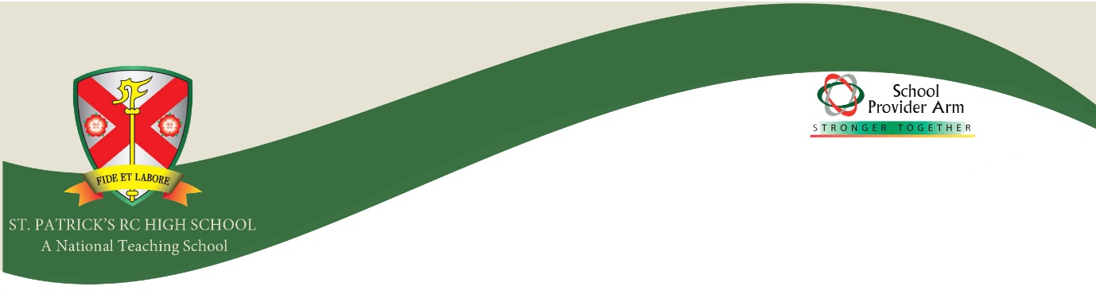

Job Description
Technician- Art, Design and Technology Department
Purpose of the role
To assist in providing practical support to teaching and learning in the art, design and technology department.
Duties and Responsibilities:
1. Core qualities
- Positive attitude to continuous improvement
- Leading by example
- Effective communication skills
- A willingness to embrace change
- Excellent organisational skills

2. Specific responsibilities
- To support the work of the art and design and technology department primarily by ensuring that the resource and materials requirements of the department are effectively met
- To support students and teaching staff when doing practical sessions with supervision, instruction and demonstration
- Prepare materials, equipment and resources for lessons
- Keep all classrooms tidy and organised as well as free from hazards
- Administrative tasks including fling, photocopying and laminating
- To organise any repair and maintenance of equipment, including tool sharpening, ensuring all equipment is maintained in a good working order
- To prepare departmental resources where it is appropriate and cost-effective to do so
- To stock check, order stock, check deliveries and ensure suitable storage and maintain a record of departmental spending
- To ensure that equipment and working areas are kept in a clean, tidy order, specifically after lessons. This includes art rooms, workshops and a kitchen.
- To provide technical support during lessons, including individual or small group pupil support where appropriate
- To produce teaching aids and update displays and visual materials around the department and school
- Maintain health and safety records including work equipment checks, risk assessments, COSHH assessments and site audits
- Develop an infrastructure of facilities of the department
- Support catch-up sessions during lunch or after school
- To have particular regard to health and safety matters in accordance with school policy and statutory requirements
- To check and empty extraction systems on a regular basis
- To undertake such other tasks relevant to the work of the department or the needs of the school as they may arise

General Information and Working Arrangements
- The above duties are not exhaustive and the postholder may be required to undertake tasks, roles and responsibilities as may be reasonably assigned to them by the Head of Department or a member of the Senior Leadership Team.
- To be aware of, and comply with, policies and procedures relating to child protection, health, safety and security, confidentiality and data protection, reporting all concerns to an appropriate person.
- To support the aims of the school and treat all members of the school community with respect and consideration.
- To set a good example to students in terms of appropriate dress, standards of punctuality and attendance.
- To take responsibility for professional development, participating in staff training, including INSET days where required, and the school’s CPD and professional development procedures.
- To take responsibility for the implementation of, and compliance with, policies and procedures relating to child protection, health safety and security, confidentiality and data protection, reporting all concerns to an appropriate person.
Person specification
- Previous experience working with power machining such as lathes, drills and millers in commercial or educational settings
- Confident use of ICT
- Ability to operate and maintain power machinery
- Suitability to work with children
- Proactive and able to work independently as well as a part of a team
- High level of practical and problem solving skills
- Flexible approach and ability to prioritise short and long term tasks
- Excellent organisational skills
- Self-motivated with the ability to multi-task

