Job specification
Job title: | Service Manager - Crisis Intervention and Prevention
Service: | Crisis Intervention and Prevention
Grade: | G14
Reporting to: | Assistant Director Homes

Your job
Wigan Council provides services to those heading towards or in crisis; the Crisis Intervention and Prevention Team helps to stabilise lives and put them back in control.

This post covers a range of services to support those furthest away from this control.

As the Service Manager for Crisis Intervention and Prevention you will oversee and coordinate services in relation to housing support, homelessness, rough sleeping, drugs and alcohol and also minimising reoffending.

Such services are delivered in house, through commissioned providers and also through voluntary and charitable sectors.

You will be responsible for three teams comprising of approximately 50 staff who will be responsible for supporting you with the delivery all of services.

You will work closely with your teams to ensure a positive customer experience which streamlines the pathway for people accessing the service and gets people back in control of their lives in a timely manner.

You will also work closely with colleagues across the Council to exploit efficiencies and options for people needing extra support.

In this job you will
Within the first 12 – 18 months you will::

- Develop and implement appropriate strategies and policies to ensure the effective delivery and running of the service to meet Council aims.
- Take the lead responsibility for the creation of systems, processes and structures to deliver the strategic priorities across all intervention and crisis services.
- Be responsible for the delivery of key outcomes, improvement strategies and Fresh Look reviews to fundamentally review how services are delivered to achieve Council priorities and cost reductions in line with targets set collaboratively with other services.
- Support the Assistant Director by providing technical and professional advice to elected members.
- Develop and maintain effective working relationships across the Council and with other stakeholders that promote the Councils interests.
- Deploy resources in the most effective manner to meet service delivery projects.
- Oversee the review of supported housing services and procedures across all accommodation utilised by the Council.
- Oversee the review of temporary and dispersed accommodation in conjunction with the Service Manager Reform and Policy.
- Review and redesign the early intervention and prevention service and provision in relation to homelessness and rough sleeping.
- Effectively manage devolved budgets
- Represent Wigan in national and regional policy development.

In this job you will need
You must be able to demonstrate the following essential requirements:

- A level 7 qualification in Housing, Management or other relevant field or an equivalent level of skills, knowledge and experience relevant to the role.
- A current member of the Chartered Institute of Housing or other relevant body
- Significant experience of managing crisis services.
- Significant experience of managing change and delivering tangible outcomes
- Experience of developing relationships with partners, external agencies and the voluntary sector.
- Extensive knowledge of best practice, statutory and regulatory requirement and key operational issues relevant to homelessness, drugs, alcohol and offender management.
- Knowledge of the locality plan and integrated working methods and an ability to contribute to achieving both aims
- The ability to reform services in a creative way.
- The ability to lead multi agency partnerships to deliver outcomes and effective working in line with Council priorities
- The ability to identify trends, future needs and assess regulatory changes and adapt the service to accommodate these.
- The ability to manage high level complex budgets.
- Experience of managing diverse service areas and managing competing priorities.
- Excellent written and verbal communication skills across a wide range of audiences
- The ability to lead teams and instil a culture of achievement and high performance throughout the service
- A current valid driving licence or the ability to travel as required using own or public transport in the most effective manner

Our culture
For us, it’s not just about all we achieve as an organisation, but how we do it. Therefore, all employees are expected to display our Be Wigan behaviours.
Be Positive… take pride in all that you do

Be Accountable… be responsible for making things better

Be Courageous… be open to doing things differently

Individuals with line management responsibilities are also expected to …
Inspire…lead by example and help others to see the big picture

Care… show genuine concern for people as individuals and value their contributions

Engage… I connect with others both within and beyond the organisation

Staff Deal
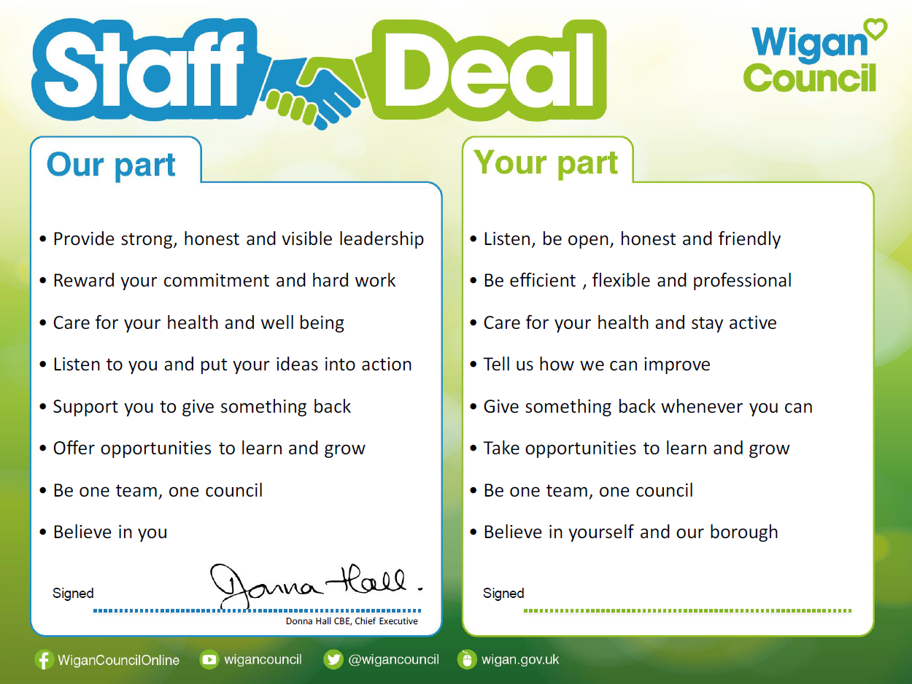
Our Staff Deal is an informal agreement with all staff. It outlines what you can expect from us, and in return what we expect from you

