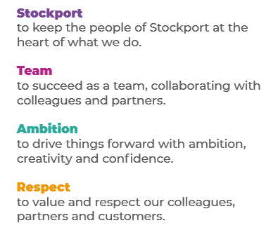
Job Profile and Working for Stockport Council
Our Council
Our employees are our greatest asset. We’re proud of the way we provide vital frontline services every day and work together, as one team.
Our 4 core values as shown above, run through everything that we do, and we aim to stay true to them regardless of the challenges that we may face.
To support our values, we have policies, guidance and procedures around health, safety and welfare, customer care, emergency planning and security that all our colleagues are adhering and working to.
We also pride ourselves on our commitment to wellbeing and inclusivity of our colleagues and residents.
You can find out more about working for Stockport Council and some of the benefits that we offer our employees at https://greater.jobs/locations/stockport/

Role: |  | Junior Quality Analyst
Service Area: |  | IT - Development
Directorate: |  | Corporate and Support Services
Salary Grade: |  | SC6
About the Job

Main Purpose of the Job
To ensure that our ambitious digital plans and solutions are of a high quality, and ready for our customers to use by:
- supporting the development of web-based applications and solutions
- providing hands-on testing
- developing and designing test plans
- automating tests
- supporting the development life cycle, from requirements gathering to delivery
- triaging failures, identifying root-causes and define corrective actions
Key Responsibilities
- being involved in each stage of the software delivery lifecycle to ensure we are meeting our quality goals
- reviewing business requirements and writing test plans
- writing test cases
- working with other members of the team to write story and bug cards
- creating and managing bug reports
- reviewing test coverage and test quality
- hands testing of functional and non-functional requirements
- To work positively and inclusively with colleagues and customers so that the Council provides a workplace to deliver a service that does not discriminate against people on the grounds of their age, disability, gender reassignment, marriage, civil partnership, pregnancy, maternity, race, religion, belief, sex, or sexual orientation.
- To fulfil personal requirements, where appropriate, with regards to Council policies and procedures, standards of attendance, health, safety and welfare, customer care, emergency, evacuation, security and promotion of the Council’s priorities.

Additional Information
The responsibilities set out in this document, in the advert and any additional information are intended to provide a flavour of the work you will carry out. It is not possible to include everything you will be asked to undertake, and we expect all colleagues to work flexibly according to business needs and to enhance your own development. Your skills, abilities and training needs will be taken into account and discussed with you when any significant changes to your role are needed. In line with our flexible approach you may be required to work from home for a proportion of your time or from any of the Council's sites across the borough.
The Council is an inclusive employer and holds the Disability Confident and Armed Forces Covenant accreditations. If you have a disability, we will support you by implementing reasonable adjustments to enable you to perform your role.

About You
Please use your application to tell us how well you meet the criteria listed below as these are the key skills, experience, technical expertise and qualifications needed to be successful in the role. We will then use all the information you provide in your application to help us decide whether you are shortlisted for interview. Any interview questions or additional assessments such as tests or presentations may also be broadly based on these criteria:
- Working to the Council’s values and behaviours by:
- Keeping the people of Stockport at the heart of what we do
- Succeeding as a team, collaborating with colleagues and partners
- Driving things forward with ambition, creativity and confidence
- Showing value and respect to our colleagues, partners and customers.
- a general understanding of software development and the software delivery lifecycle
- passionate about starting a career as a Quality Assurance Analyst
- a proactive, positive ‘can do’ attitude
- a logical approach to working through problems with the confidence to ask questions
- excellent attention to detail
- strong organisational skills
- strong verbal and written communication skills
- effective at building and maintaining professional relationships
- can work independently and use your own initiative to find solutions to problems
- industry related degree (desirable)
- experience working in a software development team (desirable)
- experience working in an agile environment (desirable)
- knowledge of the software development lifecycle (desirable)
- experience of web standards and best practices e.g. accessibility (desirable)
- ISTQB qualification (desirable)
- experience using tools such as Jira and Miro (desirable)
- experience using Github (desirable)
- awareness of continuous integration/delivery/deployment principles and practices (desirable)
- understanding or experience of testing products on multiple platforms/browser and tools (for example BrowserStack)

