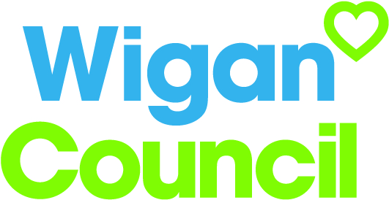
Job specification
Job title: | Panel Administrator
Service: | Together for Adoption
Grade:  Salary Range: | G4  £16,822 - £19,008
Reporting to: | Administration Manager

Your job
You will be responsible for the day to day administration of adoption panel services delivered and commissioned by the Wigan, Warrington, St Helens, Cheshire West & Chester and Halton Regional Adoption Agency, Together for Adoption.

You will work alongside a variety of colleagues at all levels in multiple organisations, helping to plan workloads and ensure a timely turnaround of panel documentation.

You will work with the Panel Adviser to ensure that adoption panel papers are received, collated and sent securely to panel members using a new electronic system.

In this job you will
On an on-going basis you will:
- Be responsible for the coordination of a weekly adoption panel.
- Work in a fast paced, highly rewarding environment, working with a new team to provide administrative support to a weekly adoption panel.
- Respond to routine and ad hoc requests for information from line management and internal and external sources in a timely, responsive manner.
- Support the management team in relation to service delivery, development and change.
- Work to a solution based approach to resolve issues through a commitment to engagement with colleagues at all levels in the Council.
- Anticipate problems and take action to avoid them by exploring different options to find resolution through best use of resources.

In this job you will need
You must be able to demonstrate the following essential requirements:

- NVQ Level 2 in Business Administration or a similar qualification.
- Experience of taking minutes and actions in order to produce accurate records of meetings.
- A high level of organisational skills.
- Experience of agenda planning, arranging and diarising meetings.
- Experience of using electronic record systems and generating and applying management information.
- The ability to use various Microsoft Office packages.
- The ability to present information clearly within agreed templates.
- The ability to collate information and prepare good quality data that is easily understood by others.
- Good interpersonal skills and the ability to work collaboratively with others.
- The ability to deal effectively with emotional demands from people whose personal circumstances may cause them distress.
- Excellent problem solving skills and the ability to work with minimal supervision to meet challenging deadlines.
Our culture
For us, it’s not just about all we achieve as an organisation, but how we do it. Therefore, all employees are expected to display our Be Wigan behaviours.

Be Positive… take pride in all that you do

Be Accountable… be responsible for making things better

Be Courageous… be open to doing things differently

Individuals with line management responsibilities are also expected to …
Inspire…lead by example and help others to see the big picture

Care… show genuine concern for people as individuals and value their contributions

Engage… I connect with others both within and beyond the organisation

Staff Deal
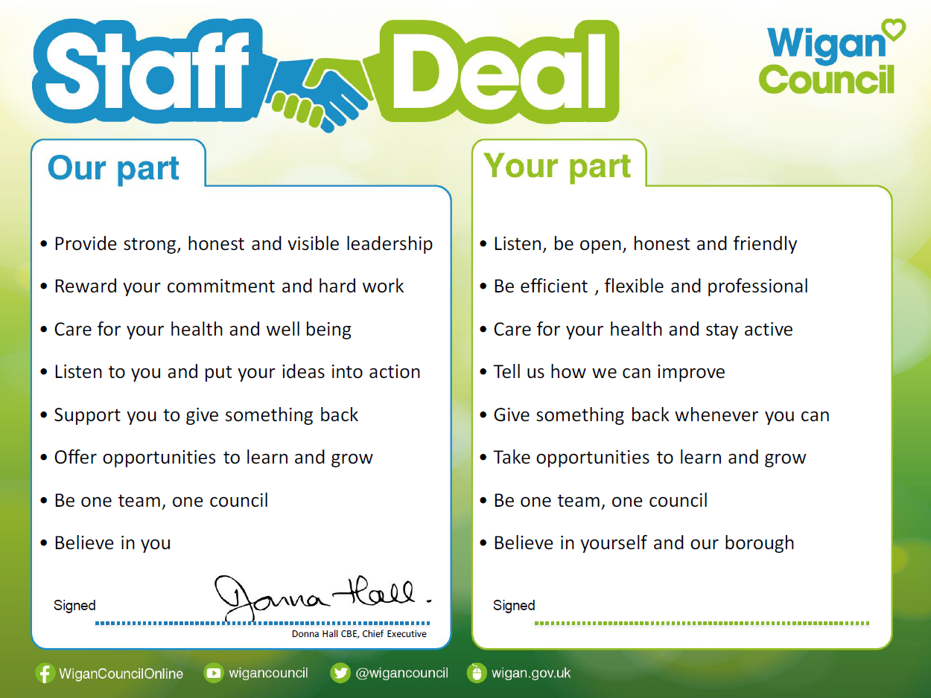
Our Staff Deal is an informal agreement with all staff. It outlines what you can expect from us, and in return what we expect from you

