Assistant Highway Engineer
Service: |  | Highways | Grade: | 3A | Salary: |  |  | £23,866 - £26,470
Reporting to: |  | Principal Engineer | Location: | Swinton Civic Centre | Hours: |  |  | 36
About the role |  |  |  |  |  |  | Our priorities
- Assist in managing and take a significant role to undertake the feasibility studies, conceptual, preliminary and detailed design, procurement and supervision of the construction of a range of civil engineering and highway projects.  - Liaise with Clients, Stakeholders, and the public on projects.  - You will have a working knowledge and understanding of the relevant legislation, standards and procedures. Possess an extensive working knowledge of standard highway and civil engineering specifications, conditions of contract and methods of measurement.  - Deal apprpriately and effectively with external organisations, statutory bodies and clients  - Undertaking feasibility studies including preparing reports, cost estimates, investigating problems, and identifying of options  - Working capability to use AutoCAD software in the preparation of designs and drawings. |  |  |  |  |  |  | 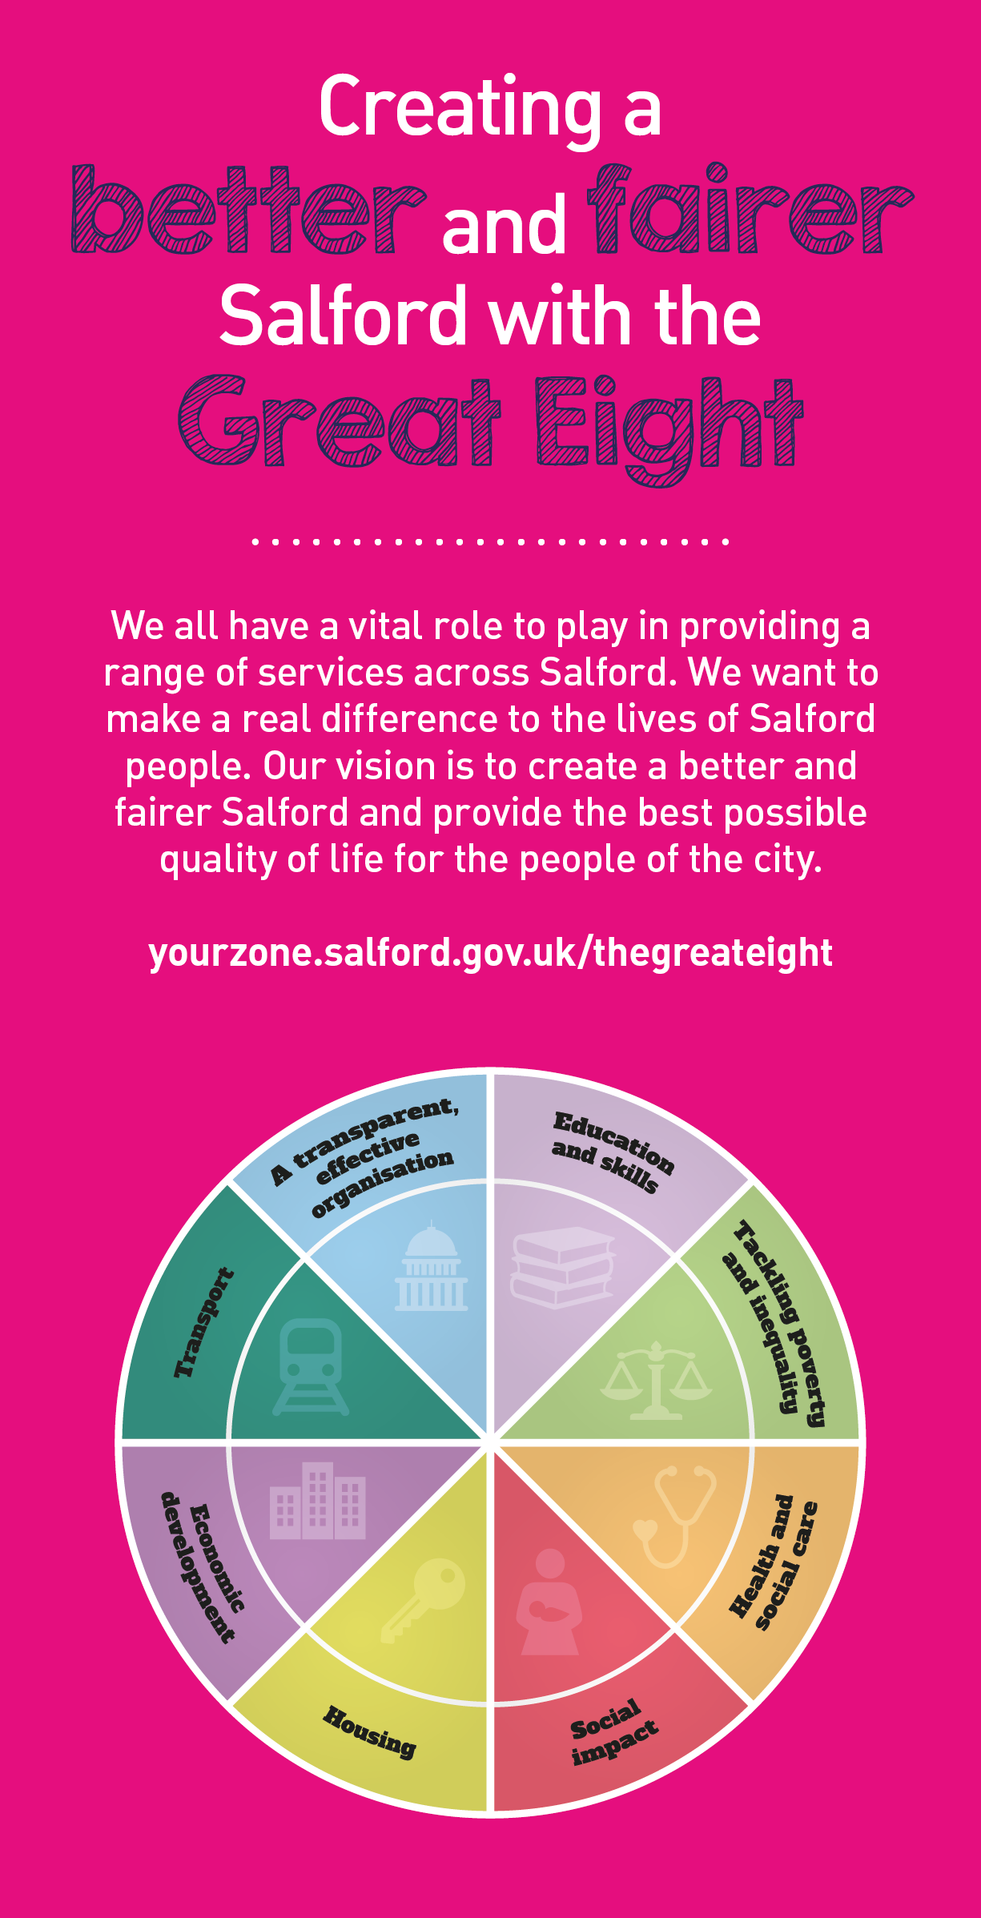
 | Key outcomes
- Arranging the procurement of highway improvement works through competitive tendering. Prepare, manage, report and maintain project cost plans.
- Implement projects to meet the requirements of quality, health and safety, environmental standards, and time to both national and corporate standards.
- Assimilate work that may be assigned to a team of engineers and technicians to deliver a variety of projects covering a range of complexities.
- Preparing schemes for tender using: the NEC3 ECC Forms of Contract; Manual of Contract Documents for Highway Works; Specification for Highway Works and the Standard Method of Measurement.
- Supervision and monitoring of works on site including: making valuations for payment assessments; chairing and managing progress meetings; identification and assessment of additional payments due to variation orders or compensation events; determination of project final accounts and satisfactory completion of the defects period.
- Ensure compliance of the team’s work with a high regard to Health and Safety and the application of the CDM Regulations and other legislation.

What we need from you |  | Our values
- Proven technical skills and ability in the role with a record of accomplishment for delivering outcomes
- Professional credibility through proven relevant experience
- Models and demonstrates our values
- You will possess or be working towards a Bachelors or Masters degree in Civil Engineering or a related subject accredited by the Engineering Council OR possess or be working towards a Higher National Diploma in Civil Engineering or a related subject.
- You will have a minimum of 3 years post qualification experience in the design, implementation and supervision of all aspects, in highway design.
- You will have a working knowledge and understanding of the relevant legislation, standards and procedures.
- You will possess a working knowledge of standard highway and civil engineering specifications, conditions of contract and methods of measurement.
- You will demonstrate initiative, confidence and personal responsibility for action.
- You will be able to understand the bigger picture and broader context and will be able to translate to a local setting. You will understand the local context and will identify outcomes focused solutions.
- You will have analytical skills and will be able to use data insight to inform workforce strategies plans.
- You will be open to the views of others, able to constructively challenge and be challenged, and you will remain positive under challenging circumstances.
- You will be a skilled communicator who communicates with clarity, conviction and enthusiasm and is able to demonstrate integrity, create rapport and build trust and confidence.
- You will be committed to continous professional development and service improvement

Application guidance

We are a values based organisation so reflecting our values or a values based approach in your evidence will support your application.

The ‘Key outcomes’, ‘What we need from you’ and ‘our leadership behaviours’ sections of the Role Profile are there to give you an understanding of what we would like to see reflected in your application. Don’t give up if you are not able to reflect all of these in your application.

