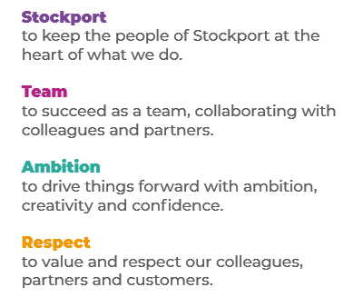
Job Profile and Working for Stockport Council
Our Council
Our employees are our greatest asset. We’re proud of the way we provide vital frontline services every day and work together, as one team.
Our 4 core values as shown above, run through everything that we do, and we aim to stay true to them regardless of the challenges that we may face.
To support our values, we have policies, guidance and procedures around health, safety and welfare, customer care, emergency planning and security that all our colleagues are adhering and working to.
We also pride ourselves on our commitment to wellbeing and inclusivity of our colleagues and residents.
You can find out more about working for Stockport Council and some of the benefits that we offer our employees at https://greater.jobs/locations/stockport/

Role: |  | School Crossing Patrol
Service Area: |  | Public Protection
Directorate: |  | Services to Place
Salary Grade: |  | Scale 1
About the Job

Main Purpose of the Job
To assist children and adults safely across the road at a designated location to and from school. To promote Road Safety on behalf of Stockport Council and act as a representative of the Council.
Key Responsibilities
- To assist and maintain control of children and adults across the road at a designated location.

- To arrive punctually at the designated location and to remain for the specific length of time.

- To wear the issued uniform at all times when on duty and to maintain the uniform in a good clean and tidy condition.

- To report any defects at the crossing location to the School Crossing Patrol Supervisor as soon as possible.

- attend the annual School Crossing Patrol training day.

- Mobile Patrols will be responsible for operating any vacant point throughout the Authority, as required by the School Crossing Patrol Supervisor.

- To work positively and inclusively with colleagues and customers so that the Council provides a workplace to deliver a service that does not discriminate against people on the grounds of their age, disability, gender reassignment, marriage, civil partnership, pregnancy, maternity, race, religion, belief, sex, or sexual orientation.

- To fulfil personal requirements, where appropriate, with regards to Council policies and procedures, standards of attendance, health, safety and welfare, customer care, emergency, evacuation, security and promotion of the Council’s priorities.

Additional Information
The responsibilities set out in this document, in the advert and any additional information are intended to provide a flavour of the work you will carry out. It is not possible to include everything you will be asked to undertake, and we expect all colleagues to work flexibly according to business needs and to enhance your own development. Your skills, abilities and training needs will be taken into account and discussed with you when any significant changes to your role are needed. In line with our flexible approach you may be required to work from home for a proportion of your time or from any of the Council's sites across the borough.
The Council is an inclusive employer and holds the Disability Confident and Armed Forces Covenant accreditations. If you have a disability, we will support you by implementing reasonable adjustments to enable you to perform your role.

About You
Please use your application to tell us how well you meet the criteria listed below as these are the key skills, experience, technical expertise and qualifications needed to be successful in the role. We will then use all the information you provide in your application to help us decide whether you are shortlisted for interview. Any interview questions or additional assessments such as tests or presentations may also be broadly based on these criteria:
- Working to the Council’s values and behaviours by:
- Keeping the people of Stockport at the heart of what we do
- Succeeding as a team, collaborating with colleagues and partners
- Driving things forward with ambition, creativity and confidence
- Showing value and respect to our colleagues, partners and customers.
- Ability to assist children and adults in crossing the road
- Basic knowledge of road safety
- Experience of working with children
- Respectful towards drivers and pedestrians
- A friendly and approachable manner
- Communicating Effectively
- The ability to converse at ease with service users/customers and provide advice in accurate spoken English

