Drainage Engineer
Service: |  | Engineering & Landscape Design | Grade: | 3C |  |  | Salary: |  |  | £30,451 to £32,910
Reporting to: |  | Senior Group Leader, Engineering & Landscape Design | Location: | Civic Centre, Swinton |  |  | Hours: |  |  | 36 per week
About the role |  |  |  |  |  |  |  |  | Our priorities
- You will have knowledge and experience of undertaking the duties of the Lead Local Flood Authority.  - You will have knowledge and experience of responding to planning applications on behalf of the Lead Local Flood Authority, including an understanding of the planning process and knowledge of the NPPF.  - You will have knowledge and experience of working on FCERM projects.  - You will have knowledge of the duties of other risk management authorities.  - You will assist in managing and take a significant role in the undertaking of feasibility studies, conceptual, preliminary and detailed design, procurement and monitoring of the construction of a range of civil engineering and highway projects;  - Responsible for managing the work of Assistant Engineers & Landscape Architects, Technicians, temporary and seconded staff within the team and working with external consultants;  - You will possess;  - or be working towards a Bachelor’s or Master’s degree in Civil Engineering or a related subject accredited by the Engineering Council or possess a Higher National Certificate/Diploma in Civil Engineering or a related subject;  - You will have a minimum of 3 years post qualification experience in the design, implementation and supervision of engineering & landscape design projects;  - You will have a working knowledge and understanding of the relevant legislation (including the Land Drainage Act and The Flood and Water Management Act), standards and procedures. Possess an extensive working knowledge of standard engineering & water industry specifications, conditions of contract and methods of measurement;  - You will be required to liaise with Clients, Stakeholders, and the public on projects;  - You will be able to demonstrate recent experience in the following:  - The ability to deal appropriately and effectively with external organisations, statutory bodies and clients;  - Undertaking feasibility studies including preparing reports, cost estimates, investigating problems, and identifying of options;  - Working knowledge of the relevant legislation and guidelines including the SuDS Manual, Design Manual for Roads and Bridges, British and European Standards, Eurocodes and Codes of Practice;  - Initiative and ingenuity in solving engineering problems;  - Excellent communication skills, both orally and in writing, both at a general and technical level;  - Working capability to use AutoCAD, Causeway Flow & WinDES and GIS software in the preparation of designs and drawings. |  |  |  |  |  |  |  |  | 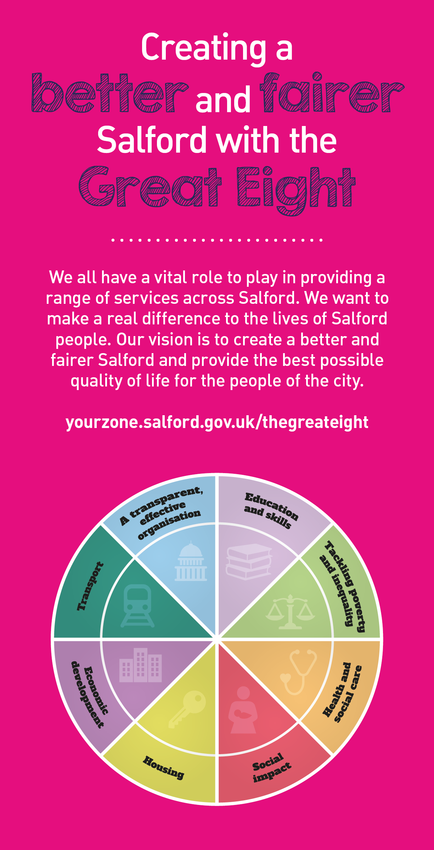
 | Key outcomes
 | - Assist with the technical aspects required for project delivery including feasibility, concept design, detailed design, preparation of tender and contract documentation, invitation of tenders and supervision of construction works on site;  - Contribute to implementing projects to meet the requirements of quality, health & safety, environmental standards, and time to both national and corporate standards;  - Assist with Preparing schemes for tender using: the NEC3 & NEC4 ECC Forms of Contract; Manual of Contract Documents for Highway Works; Specification for Highway Works and the Standard Method of Measurement.  JCT & JCLI forms of contract for landscape works |  |  |  |  | - Ensure compliance of your work with a high regard to Health and Safety and the application of the CDM Regulations and other legislation;  - Abide by the objectives and targets of both the section and the department and follow procedures and practices utilised in all aspects of the work, including computerised and manual systems and the maintenance of relevant records;  - You will require the ability to set and work to personal deadlines and targets to meet the requirements of programmes of work, to meet clients’ needs and to respond to targets set by others.
 | What we need from you
 | - Achiever - proven technical skills and ability in the role  - Assured - demonstrates initiative, confidence and personal responsibility for action  - Credible - professional credibility through proven experience in a highway design environment  - Curious - understands the bigger picture and broader context and is able to translate to a local setting  - Determined - tenacious and consistently persists with actions to achieve outcomes  - Diplomat - open to the views of others - able to constructively challenge and be challenged  - Evidence Seeker - demonstrates analytical skills using data insight to inform workforce strategies and plans |  |  |  |  | - Optimist - remains positive under challenging circumstances.  - People Person - skilled communicator who communicates with clarity, conviction and enthusiasm and is able to demonstrate integrity, create rapport and build trust and confidence.  - Self-development - demonstrates a commitment to continual professional development and continuous service improvement  - Solutions Seeker - understands the local context and able to identify outcomes focussed solutions to meet needs  - Values-based - models and demonstrates our values

Application Guidance |  | Our values
We are a values-based organisation so reflecting our values or a values-based approach in your evidence will support your application.

The ‘Key outcomes’ and ‘What we need from you’ sections of the Role Profile are there to give you an understanding of what we would like to see reflected in your application. Don’t give up if you are not able to reflect all of these in your application.

