ASSISTANT DIRECTOR – INTEGRATED COMMISSIONING
Service: |  | People Directorate | Grade: | Local Scale Band E |  |  | Salary: |  |  |  | £70, 883 - £77, 972 (Full time salary)
Reporting to: |  | Strategic Director People & Director of Commissioning, Salford CCG | Location: | Salford Civic Centre |  |  | Hours: |  |  |  | 18 hours (job share)
About the role |  |  |  |  |  |  |  |  |  | Our priorities
- Leads and manages health and social care commissioning in the context of the Salford Together Integrated Care System.  - Ensures commissioning strategies and plans are in place that reflect local need, priorities and maximise resources. These strategies include Mental Health, Learning Disabilities, Older People, Carers, Housing for Vulnerable Adults and Dementia.  - Contributes to the Service and Financial Plan for Adults in Salford and develops Integrated Commissioning as a cross-cutting activity, linking strategic and financial planning with operational delivery.  - Creates an environment that ensures that people/patients who use services and their carers are at the heart of commissioning, engaging and co-producing with citizens in the wider community to define outcomes which reflect needs, preferences and aspirations of people who will use services in the future.  - Develops and maintains partnership arrangements with stakeholders within and across organisations, with the responsibility for ensuring that changes resulting from the service transformation take account of professional social work issues.  - Develops leading edge outcome based specifications, and consistent performance and quality management.  - Manages the budget for agreed commissioned service, ensuring compliance with contractual arrangements and agreed service specifications and standards.  - Challenges conventional approaches across health and social care to enable greater efficiency, effectiveness through the development of best practices and innovative commissioning and market development.  - Alerts the Strategic Director People (SCC) & Director of Commissioning (CCG) when there is failure or risk of failure, to meeting required professional standards, and advise on action to mitigate this.  - Devises and updates appropriate infrastructures, methodologies and templates to support the commissioning process and cultural change and supporting commissioners to develop and present business cases as required.  - Undertakes strategic and representative activities (e.g. at external meetings) as delegated by the Strategic Director People (SCC) or the Director of Commissioning (CCG). |  |  |  |  |  |  |  |  |  | 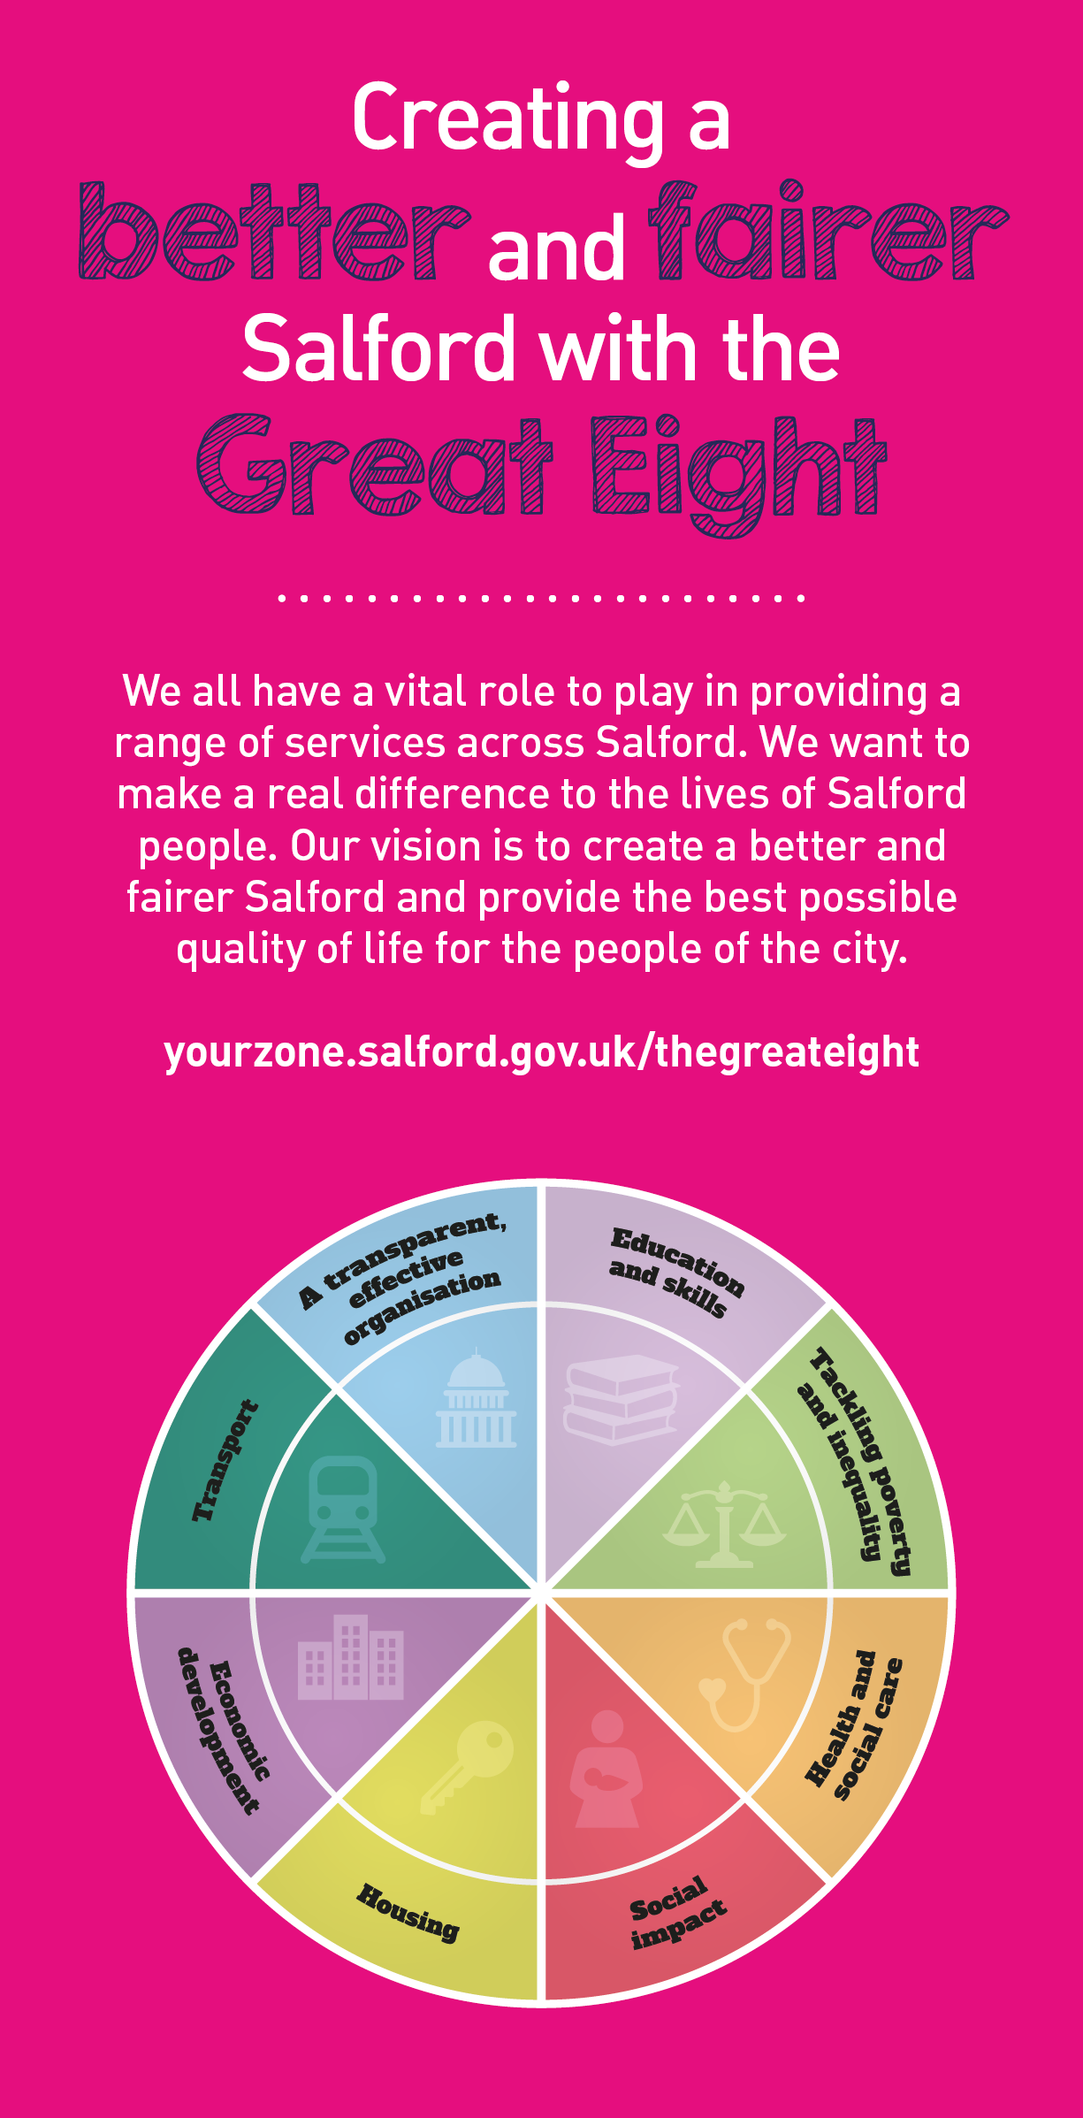
 | Key outcomes
 | - Provides strong professional leadership and strategic responsibility for ensuring high professional standards in all areas of commissioned services.  - Leads a learning culture which inspires staff and provides senior management to employees within the Council and CCG, motivating and supporting them to attain the highest professional standards, skills, knowledge, attributes and competencies required to fulfil their duties  - Leads, builds and manages positive, constructive productive relationships between the Council, the CCG, its partners, and local communities.  - Provides constructive and assertive engagement with commissioned services to ensure Salford has high quality performing services that meet strategic objectives and national targets.  - Alongside the Strategic Director People (SCC) and the Director of Commissioning (CCG) develop an integrated commissioning culture across both organisations. |  |  |  |  | - Ensures active engagement with people/patients in order to promote a culture of learning and coproduction to develop services for the future.  - Communicates a strategic vision for the delivery of health and social care services across mental health and adult social care, pertaining to specific service user groups  - Explores and implement innovative solutions and new ways of working to improve the offer and outcomes to the Salford public  - Fully engages in relevant workstreams across Greater Manchester which relate to adult social care and mental health commissioning.  - Ensures Salford meets our statutory responsibilities (e.g. Care Act) and commissioning expectations (e.g NHS Long Term Plan)
 | What we need from you
 | - Proven technical skills and ability in the role with a record of accomplishment for delivering outcomes  - Professional credibility through proven relevant experience  - Models and demonstrates our values and leadership behaviours  - Masters level degree or equivalent level of experience  - Evidence of continued professional development  - A proven track record of senior social care, leadership underpinned by an understanding of the NHS, social care and their infrastructure  - High level of managerial competence with the ability to lead and manage change in a complex and dynamic organisational environment.  - A proven track record of strategy and policy development impacting positively on the modernisation of professional practice.  - Evidence of experience in building effective networks at senior levels and using these to make improvements  - Knowledge of the care sector and ability to implement integrated models of care  - Knowledge of the safeguarding agenda |  |  |  |  | - Knowledge of the requirements of professional leadership and ability to implement systems and processes that maintain them  - Knowledge of the independence agenda and ability to implement and sustain services which deliver it  - Resilient with an innovative approach and ability to inspire and enthuse others as well as hold to account  - The intellect and interpersonal skills to command the respect of senior practitioners and managers, Elected Members and Clinical Commissioners  - Evidence of holding to a clear strategy and set of values while responding appropriately to short-term challenges and priorities  - Personal attributes including emotional intelligence, communication skills’ resilience, determination and an energising, innovative and improving spirit combined with operational and financial rigour and discipline and holding to account for performance  - Flexibility to respond to changing conditions while remaining clear – sighted on service strategies and objective  - Ability to travel within the requirements of the post  - Demonstrable evidence of creating and fostering a culture of openness, honesty, integrity and inclusiveness.
Our leadership behaviours |  |  |  |  |  |  |  |  | Our values
As a values-based leader you will:  - Model the values and embed them in the way your team delivers services  - Hold people accountable for delivering the values  - Respect and care for others, treating everyone fairly, recognising the importance of ensuring equality of opportunity for all, and listening and acting on the things people say  - Be honest, taking responsibility for your actions and decisions  - Use resources that you are trusted with wisely |  | To lead and develop people you will:  - Listen to understand, not to defend  - Give people the freedom to use their initiative  - Provide opportunities for people to discuss and solve problems and issues  - Regularly provide coaching and support to others to help them achieve their objectives and potential  - Appreciate and build on people’s strengths  - Motivate, engage, encourage and inspire others in order to be the best they can be
To create a performance and development culture you will:  - Be visible, inject pace, vigour and purpose  - Expect high standards; mediocrity is not acceptable  - Take an evidence and whole system approach in making decisions  - Maximise technology and models to deliver quicker, easier, better services  - Have a digital mindset, fully utilising digital systems and solutions to deliver services differently  - Set context and challenging goals that will motivate people to take ownership, maximise performance, and develop |  | To build and communicate a vision for the future you will:  - Be optimistic and ambitious for the city and its people, helping others to understand the need to transform public services  - Build strong collaborative relationships to find creative ways to make services more sustainable and flexible  - Recognise and values the strengths of people and places, taking a strengths-based approach to make the most of opportunities  - Support people through change, in undertaking new things, and taking risks  - Take a place and whole system approach in designing, delivering and leading services  - Ensure an inclusive approach with the aim of reflecting the increasing diversity of Salford

Application guidance

We are a values based organisation so reflecting our values or a values based approach in your evidence will support your application.

The ‘Key outcomes’, ‘What we need from you’ and ‘our leadership behaviours’ sections of the Role Profile are there to give you an understanding of what we would like to see reflected in your application. Don’t give up if you are not able to reflect all of these in your application.

Click here to enter text.

