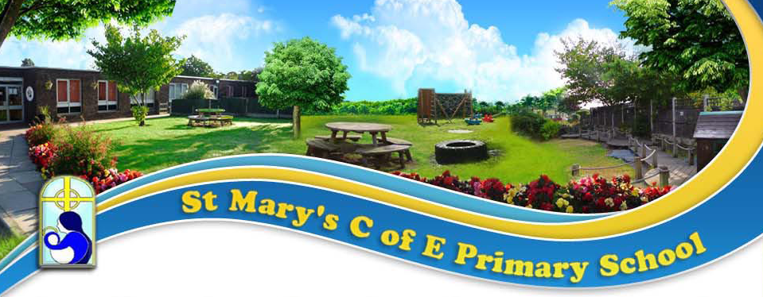

Higher Level Teaching Assistant - Person Specification

 |  | Essential |  | Desirable
Qualifications & Experience
Education | • | Good standard of education – Maths, English & Science GCSE Grade C or above or equivalent
Experience | • | Experience of delivering whole class teaching having achieved the Professional Standards for Higher Level Teaching Assistants.
Professional Knowledge
Safeguarding | • | Thorough knowledge and understanding of safeguarding children.
Teaching,  Learning &  Assessment | • | Contribute to planning and curriculum delivery  to ensure that they are highly effective practitioners. | • | Experience of delivering phonics via Read, Write, Inc and the Year One statutory assessment.
Professional Skills |  | Essential |  | Desirable
Ethos | • | A holistic approach to the well-being and education of pupils. | • | Experience of working in a faith school.
 | • | The ability to challenge and engage children in their learning through creative opportunities, with high levels of expectations of all learners.
Curriculum | • | Ability to think creatively to deliver learning | • | An understanding of Emotionally Friendly Schools
Computing | • | A working knowledge of desktop PCs, Ipads and school networks in order to support staff with smooth curriculum delivery

Professional Attributes
Relationships | • | Ability and willingness to work collaboratively and supportively within the school team.
 | • | Able to inspire confidence and respect amongst colleagues and the school community.
 | • | Builds effective and professional working relationships with parents, staff, Governors and the wider community.
Attitude | • | Is committed to their own professional development.
 | • | Is a creative thinker, who strives to embed innovative practice and strategies to improve learning for pupils.
 | • | Consistently reflects the highest levels of professionalism as a role model at all times and demonstrates the school’s aims and values at all times.

