Advanced Social Worker
Service: |  | People | Grade: | 4C |  |  |  | Salary: |  |  | £39,880 - £42,821
Reporting to: |  | Practice Manager | Location: | Various |  |  |  | Hours: |  |  | 36 hours per week
About the role |  |  |  |  |  |  |  |  |  | Our priorities
- You will effectively manage a limited caseload of complex cases in accordance with statutory responsibilities. These will include child in need; child protection, Looked After Children, Public Law Outline and court proceedings cases. You will deploy these responsibilities in accordance with national and local policies and procedures to secure positive outcomes for children.  - You will have responsibility for the supervision of qualified social work staff and trainees and contribute to the development of other staff including other social workers.  - You will build effective relationships with children, young people and their families enabling full participation in assessment, planning, review and decision making.  - You will manage safeguarding risk effectively including child protection, working within a multi-agency environment, providing a professional social work service. You will secure access to services, negotiating and challenging other professionals and organisations to provide the help required.  - You will support the practice manager in managing the duty service.  - You will actively contribute to the allocation of cases  - You will work in accordance with national and local policies and procedures, and use the law, regulatory and statutory guidance to inform practice decisions. |  |  |  |  |  |  |  |  |  | 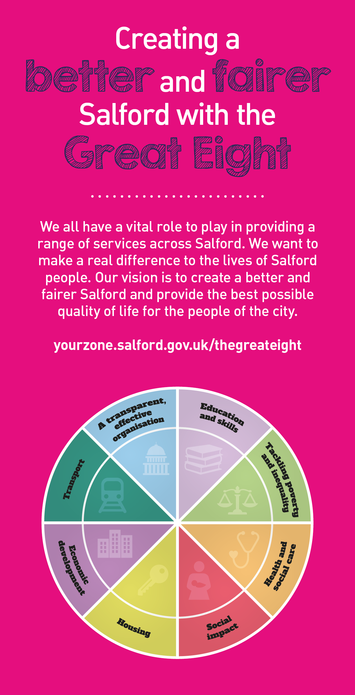
 | Key outcomes
 | Take an active role in team and service development. This will include supervising staff and leading in the development of policies, procedures and training activities.  - You will work to the highest standard in line with the Council’s Employee Code of Conduct, and other relevant policies.  - You will be responsible for and committed to safeguarding and promoting the welfare of children and young people and for ensuring that they are protected from harm.  - Ability to contribute to the development of positive and supportive team working relationships.  - You will assist with the learning of others through reflective supervision and contribute to the development of best practice in Social Work.  - You will be aware of and apply Salford’s values at all times. |  |  |  |  |  | - Ability to motivate, engage and develop people to deliver shared outcomes.  - You will take responsibility for your own continuing professional development and support the development of others.  - You will maintain timely and accurate recording of work undertaken in client information systems, having regard to the GDPR and associated policies.  - Through personal example, open commitment and clear action, you will ensure diversity is positively valued, resulting in equal access and treatment in employment, service delivery and communications.  - To undertake such additional duties as are reasonably commensurate with the level of the post and deputise on behalf of the Practice Manager as required.
 | What we need from you
 | - Possession of a recognised Social Work qualification and current registration with Social Work England.  - Substantial experience of working with children and/ or complex safeguarding. Personal and professional commitment to ensure positive outcomes for children in Salford  - Ability to motivate, engage and develop people to deliver shared outcomes  - Be able to demonstrate experience of mentoring / supervision of less experienced staff/ students.  - Ability to communicate equally, appropriately and effectively with a wide range of individuals and groups across all sectors and levels of society.  - You must clearly evidence your ability to develop effective relationships with partner agencies and effective engagement skills to work with their carer’s, families and partner agencies  - Ability to organise own time effectively, prioritising, preparing in advance and setting realistic timescales. Ability to maintain focus and objectivity under pressure.  . |  |  |  |  |  | - Ability to contribute to the development of positive and supportive team working relationships.  - Be able to demonstrate evidence of excellent assessment practice using analytical skills  - Ability to respond to immediate problems of a complex nature with associated risk factors and deliver immediate solutions sometimes under pressure  - Ability to think creatively and take an active role in team and service development. Personal commitment to supervision, reflective practice and self-development.  - Willingness to flexibly work outside of office hours as required by the needs of the service. You will also contribute to the team duty service on a rota basis with their team members  - Ability to use IT systems to retrieve, record and update information and willingness to learn to use new systems  - Ability to travel across Salford and Greater Manchester area either through use of a vehicle insured for business use or using public transport
What we can offer you
Your ongoing professional development and success in your role is important to us, and that is why we provide a variety of learning and development opportunities. Within the sections below you will find development options tailored to you which will enable you to further develop your existing skills and learn new ones at a pace that suits you best. If you are joining us now, your development will form part of ongoing discussions with your manager. If you are an existing employee, you should use your Personal Development Reviews to discuss your career options with your manager and create your development journey. It’s important you also take full advantage of any informal learning available to you during the course of your work, including coaching, mentoring and shadowing. Please discuss these options with your line manager.

- Online Learning - Develop your knowledge across a wide range of areas through our Me-Learning platform, with over 200 free courses to choose from. To have the best possible start and comply with current legislation, you must complete the following modules: Welcome to Salford, Health and Safety in Office, Equality Essentials, GDPR, and Safeguarding Children and Adults. You may also benefit from a variety of courses in categories such as Business Skills, IT and Project Management, Leadership and Management which are available to learn at your own convenience and pace.  - Developing your digital skills – Our ambition is to provide our workforce with the right level of digital capabilities needed to be successful. Whatever your current digital abilities are, we can provide development ranging from essential workplace skills to specialist workplace skills’. These will be delivered through our Digital Skills Academy using both self-directed and guided learning opportunities to enable you to develop. Additionally, you can access free online courses through the iDea website.  - Sharing your digital skills – Our goal is to support you to share your digital knowledge with other people. Our Digital Eagles programme has been designed to cover basic digital skills and build your confidence to assist others. By the end of this programme you will join hundreds of staff members who already are digital eagles, and be able to help colleagues, customers, residents, or people in your personal life with all things digital. |  |  |  |  |  | - Developing your leadership skills – We want to equip our leaders with the knowledge, skills and behaviours outlined in our #LeadingSalford programme. Our aim is to support you to lead highly engaged, motivated teams in today’s rapidly changing environment. This will be achieved through our core Master Classes: Breakthrough Conversations, Engage for Success, Values to Action, and Coaching for Performance and Potential. The Master Classes are designed to help you meet the expectations that we have of our Salford leaders. In addition to the core Master Classes, we also provide courses such as Management Essentials, Health and Wellbeing at Work, Strengths-Based Conversations, and Financial Skills for Non-Financial Managers.  - Professional Development – Gain role specific skills and time to learn through a wide range of development opportunities. Learn whilst working and get support towards your qualification through an apprenticeship standard. Access professional development ranging from entry level to master’s type qualifications, including achieving a role appropriate qualification. Details can be found on the Institute of apprenticeships website.

Our leadership behaviours |  | Our values
As a values-based leader you will:  - Model the values and embed them in the way your team delivers services  - Hold people accountable for delivering the values  - Respect and care for others, treating everyone fairly, recognising the importance of ensuring equality of opportunity for all, and listening and acting on the things people say  - Be honest, taking responsibility for your actions and decisions  - Use resources that you are trusted with wisely |  | To lead and develop people you will:  - Listen to understand, not to defend  - Give people the freedom to use their initiative  - Provide opportunities for people to discuss and solve problems and issues  - Regularly provide coaching and support to others to help them achieve their objectives and potential  - Appreciate and build on people’s strengths  - Motivate, engage, encourage and inspire others in order to be the best they can be
To create a performance and development culture you will:  - Be visible, inject pace, vigour and purpose  - Expect high standards; mediocrity is not acceptable  - Take an evidence and whole system approach in making decisions  - Maximise technology and models to deliver quicker, easier, better services  - Have a digital mindset, fully utilising digital systems and solutions to deliver services differently  - Set context and challenging goals that will motivate people to take ownership, maximise performance, and develop |  | To build and communicate a vision for the future you will:  - Be optimistic and ambitious for the city and its people, helping others to understand the need to transform public services  - Build strong collaborative relationships to find creative ways to make services more sustainable and flexible  - Recognise and values the strengths of people and places, taking a strengths-based approach to make the most of opportunities  - Support people through change, in undertaking new things, and taking risks  - Take a place and whole system approach in designing, delivering and leading services  - Ensure an inclusive approach with the aim of reflecting the increasing diversity of Salford

Application guidance

We are a values based organisation so reflecting our values or a values based approach in your evidence will support your application.

The different sections of this role profile are there to give you an understanding of the purpose of the role. The ‘what we need from you’ section outlines the minimum criteria you will need to meet within your application.
Please submit a CV and a cover letter (no more than 2 sides of A4) outlining how you meet the requirements and what you bring to the role.

