St John Rigby College
Information
for Applicants

GENERAL BACKGROUND INFORMATION ON THE COLLEGE
HISTORY AND CONTEXT
St John Rigby College is the designated Catholic Sixth Form College for Wigan and West Lancashire. It is a co-educational open-access Sixth Form College and was the first Roman Catholic Sixth Form College to be established in England in 1972. It takes its name from, and is dedicated to, the memory of a local man who was martyred at Southwark in 1600 and is remembered for his faith, courage, and forgiveness.

The College exists to serve the post-16 educational needs of the Catholic community of Wigan and surrounding areas. While the majority of the College’s students live within the Metropolitan Borough of Wigan, students travel from a broad area defined by Aughton to Bolton and Euxton to Newton-le-Willows. About 40% of the College’s students are Catholic and in recent years a growing number of students from other schools have been attracted to the College's mission and ethos and our inclusive approach to education.

Whilst retaining our Catholic principles, we value our links with all schools in Wigan and the surrounding areas and welcome applications from students of all faiths and religious backgrounds who show respect for our mission and support the College's Christian ethos.

Post-16 provision in Wigan is offered by a variety of institutions including a college of Further Education, 2 sixth form colleges and 2 schools with sixth forms. There are also a number of training providers.

VISION, MISSION AND STRATEGIC OBJECTIVES

College Vision
To be an outstanding, inclusive Catholic sixth form college; valuing the individual, celebrating learning, and raising aspirations.

College Mission
We are a Catholic College dedicated to the education and development of the whole person and supporting all students to realise their full potential. As an outstanding learning organisation SJR will have a strong sense of purpose and a commitment to shared values within a Christian community. We will establish a unique, safe, and challenging environment where every individual is valued, talents are recognised and nurtured, achievements are celebrated, and dedication is rewarded. To achieve this as a community we will:
- Welcome all students who are happy to be educated within a Christian environment
- Value the uniqueness and dignity of each individual
- Deliver the highest standards of teaching and learning
- All show a commitment to our work, to the Christian values of the College and to the safety of all in our community
- Provide equality of opportunity, with mutual respect and positive encouragement
- Build and further develop local, national, and international partnerships

Core values in daily life at St John Rigby College are expressed as:
- Genuine concern for others
- Support for and challenge of one another
- High standards and expectations
- Consistency and perseverance
- Recognition of talents, progress, and achievements

Strategic Objectives

- To embed a learning culture which meets the needs of students affected by the COVID-19 pandemic and, in doing so, improves the standards of student achievement, raises aspirations, and promotes excellence across the full range of the College curriculum. In addition to providing a ‘COVID-safe’ environment, we will focus on three key areas of outcomes for learners:
1.1 Establishing consistently high outcomes across all courses
1.2 Raising student achievement rates and challenging all courses to exceed Sixth Form College national benchmarks
1.3 Establishing a consistently high ‘progress score’ for all courses.
- To widen student participation, in partnership with other providers, through the offer of a comprehensive range of high-quality courses that meet the needs of our students and support developments and provision within partner high schools.
- To work collaboratively with groups within the College’s local and extended community.
- To further develop the estate to provide an outstanding, safe learning environment for the whole College community.
- To sustain a culture where all staff are committed to SJR’s core values, where continuous professional development is encouraged, and organisational efficiency and effectiveness are achieved.
- To maintain the College’s financial stability in order to implement the College Development Plan.

THE COLLEGE’S PRESENT POSITION
In February 2017, the College was inspected by Ofsted and received the following grades:
Outcomes for Learners Outstanding
Quality of teaching, learning and assessment Outstanding
Effectiveness of leadership and management Outstanding
Personal development, behaviour, and welfare Outstanding
Overall Effectiveness Outstanding

The summary of key findings gave the following reasons for the College being outstanding:

- The principal and his leadership team have worked relentlessly to ensure transformational change since the last inspection. As a result, the quality of provision is excellent.
- The Catholic mission and values permeate the college and are highly effective in developing students’ positive attitudes to learning. As a result, students have an excellent understanding of life and values in modern Britain.
- Excellent teaching results in a high proportion of students making exceptional progress from their starting points. Consequently, most students achieve, and often exceed, their aspirational target grades.
- Students’ achievements are outstanding. Most students, across all levels of learning, make exceptional progress. In a small minority of A-level subjects, students do not achieve the highest grades expected of them.
- Teachers’ skill-fully assess students’ starting points and meticulously plan to meet the vast majority of students’ needs. Occasionally, teachers’ questioning does not probe the understanding of most-able students.
- Outstanding careers guidance helps students to make informed and realistic, yet ambitious, plans to meet their career aspirations.
- Students develop an excellent range of personal, social, moral, and independent study skills, which prepare them particularly well for further and higher education, apprenticeships, or employment.
- Governors provide high levels of challenge and rigorously hold leaders and managers to account.
- Leaders’ and managers’ evaluation of the college is incisive. They accurately identify the many strengths and the very few areas for improvement, swiftly implementing highly successful actions to improve further the quality of provision.
- Management of data is outstanding. The college’s tracking and monitoring of students’ progress are exceptionally strong and effective in enabling any underperformance to be recognised and swiftly tackled.

The areas stated as needing further improvement were:

- Improve high grades in the few A-level subjects where students do not always achieve the high grades expected of them.
- Ensure that the most able students are challenged through insightful questioning to explain their reasoning and thereby deepen their thinking skills.

STUDENT PROFILE
There are currently 1520 16-18-year-old students (November 2021). 30% of students are from postcodes that are classified as deprived, 57% of students are female and, like Wigan and the surrounding area, 95.5% are white. 93% of the students are following level 3 programmes (34% of whom are completing BTEC courses) and the remainder are following our level 2 and Foundation programmes.

CURRICULUM
There is a broad and inclusive curriculum comprising:

- 27 A Level subjects
- 4 Technical Level Programmes (from September 2022, Health, Digital & Media, Business and Science)
- 15 Vocational Level 3 programmes
- 5 BTEC Level 2 programmes
- 2 GCSE resits (Mathematics and English)
- 1 BTEC Level 1 programme
- 1 BTEC Entry Level programme
- 15 Futures Programmes (career enrichment courses)

All students follow the College’s ‘Values for Living’ programme which provides an opportunity for students to explore a wide range of topics including: the world around; moral and ethical issues; the choices we make in life - while also challenging students to reflect on their own faith and beliefs.

There is a wide range of recreational and subject based enrichment opportunities for students to take part in, including:

Charity Work
American Football
Chaplaincy
Chinese Culture and Language
Choir
Concert Band
Drama
Film Club
Sign Language
Wish FM Scholarship
Student Ambassadors
Driving Theory Test Preparation
College Production
First Aid
Duke of Edinburgh Award
Five-A-Side Football
Latin
Music Society
Recreational Sport
College Sports Teams

CURRICULUM ORGANISATION AND MANAGEMENT
The College employs 78 teaching staff who are each allocated to a teaching department. These are managed by Heads of Departments (HOD) and/or Course Leaders (CL) and are grouped into three Divisions:

Vice Principal (Curriculum & Quality)
Divisional Leader | Divisional Leader | Divisional Leader
English  HOD x 1  Humanities  HOD x 1  CL Law & Criminology x 1  Media & Film  CL x 1  Music & Performing Arts  HOD x 1  Religious Studies & International Languages  HOD x 1  Social Studies  HOD x 1 | Business, Economics, IT and Computing  HOD x 1  CL Vocational IT x 1  CL Vocational Business x 1  Maths, Further Maths & Statistics  HOD x 1  Sciences  HOD x 1 | Health & Social Care, Public Services, Functional Skills & Foundation  HOD x 1  Sport & Physical Education  HOD x 1  Visual Arts  HOD x 1

The College is committed to a culture of improvement and an open and consultative management style is employed. Well established quality assurance and self-assessment procedures have played a major role in identifying strengths, areas for improvement and weaknesses. The College aims to constantly develop teaching and learning by identifying and sharing the good practice that exists across departments and so continue to improve pass rates, high grades, and value-added performance. By constantly striving to improve individual student performance we seek to enhance the life choices of students, many of whom would not be able to access post 16 education at other institutions.

PASTORAL ORGANISATION AND PROGRAMME
Pastoral care is managed through the Vice Principal (Students) and 2 Senior Tutors. These staff manage a team of 8 non-teaching Progress Tutors who offer first line student support and challenge. The Vice Principal is also supported by a full time Safeguarding and Welfare Officer. In addition, the College Chaplain, College Counsellors and the Student Support and Wellbeing Officer provide well-being and welfare support and the Student Liaison Officer patrols the College site providing security and supervising the student social areas.
The Vice Principal (Students) is the Designated Safeguarding Lead.

The major focus of the Pastoral Programme is on careers and progression to H.E. or other F.E. colleges, apprenticeships, and employment. The Vice Principal also manages the College’s Careers Adviser and a number of Career Advisers in a range of local High Schools. The College was pleased that its work in this area was recently recognised by the award of the Matrix Standard.

SUPPORT FUNCTIONS
Students and teachers are very well supported by 80 support staff across a range of enabling functions including:

- art, performing arts and science technicians | - MIS and examinations team
- careers adviser | - premises team
- cleaning team | - progress tutors
- finance team | - reception and main office staff
- human resources | - reprograhics officer
- IT and network technicians | - student counsellors
- learning support mentors and administrator | - student liaison officer
- library and open learning centre supervisors | - work placement officer
- marketing staff

GOVERNANCE AND SENIOR STRUCTURE
The Governing Body has the overall legal, strategic, and financial oversight of the College. It consists of 10 Foundation Governors, appointed by Liverpool Archdiocese; 2 staff governors; 1 parent governor, 1 student governor and the Principal. The Governing Body meets 4 times per year and works through a number of specialist committees to transact the detailed aspects of its business.

The day to day running of the College is the responsibility of the College Management Team consisting of the Principal, 3 Vice Principals (Curriculum and Quality; Students; Staffing and Resources),3 Divisional Leaders, the Finance Manager, 2 Senior Tutors, the Head of Religious Education, the MIS and Funding Manager, the High School Liaison Manager, and the Central Services Manager.

ACCOMMODATION AND RESOURCES
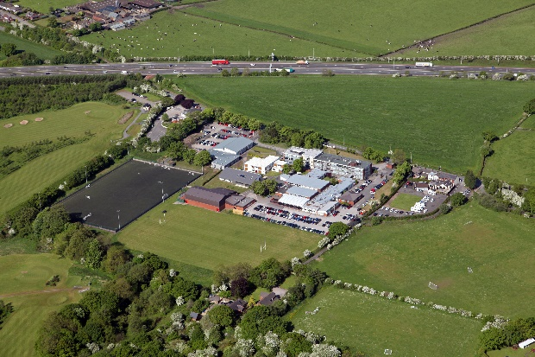
The College occupies a large and attractive site of 10 hectares in a semi-rural location to the west of Wigan.
All classrooms are well maintained and equipped with data projectors, a teacher’s desktop computer and speakers.

In 2006 the main block (A Block) was re-furbished and extended providing: a bright and quiet Chapel, a central Chaplaincy Office in the heart of the College and a Library. This extension was officially opened in June 2006 by Cardinal Vincent Nichols, the Archbishop of Westminster, and former Chaplain of the College.

This main block houses the Science, Mathematics, MFL, Religious Studies, Foundation Learning, English, and Media Departments.
A thirteen-classroom modular building (B Block) was opened in September 2012 and houses the Social Sciences department. Health & Social Care and Creative Arts are accommodated in C Block. Further new buildings opened in September 2013 and 2014 to provide new accommodation for Music and Performing Arts, Sport and PE respectively.

Our latest building opened in November 2015 and provides specialist accommodation for the Business, Economics, IT and Computing Department.
The College has made a successful bid to the ESFA for £1.9m to fund a “T-Level Building”. This new building will be at the front of College between A and F blocks. In addition to housing some of the College’s T-Level courses it will create opportunities to use some of the existing accommodation differently. Construction is planned to be completed in January 2023.
Our latest building project opened in November 2015 and provides specialist accommodation for the Business, Economics, IT and Computing Department.
There are 20 computer teaching rooms used by Business, ICT, Media, Health & Social Care, Sports, English, MFL and Learning Support, with bookable laptop facilities for other departmental areas. In addition, there are Apple Mac suites for Photography, Graphics and Music. A centrally located 70 computer Open Learning Centre allows drop in use for students and booking for class groups by staff. This area also has an IT help desk to assist students and staff with technical problems. The College has a Wi-Fi network which allows staff and students to bring in their own Wi-Fi enabled devices and there are a number of iPad and tablet devices that can be booked for classroom use. The overall computer: student ratio is 1:3.
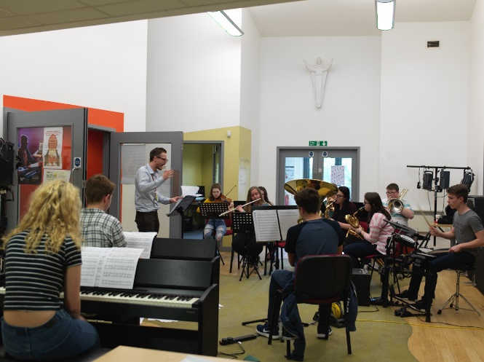
There is also a 96-seat theatre with public performance licence. The College boasts a large, flood-lit synthetic turf pitch and has a well-equipped Sports Hall which has facilities for a range of sports including basketball, volleyball, five-a-side football, netball and a range of other team and individual sports.
There is a large, recently refurbished refectory, including a Starbucks that is available for students and staff. A range of healthy hot and cold food is on offer. Payment may be made in cash, using your College ID card or via chip and pin.

THE COLLEGE STAFF COMMUNITY AND SUPPORT
The College welcomes students and staff who are willing to support our ethos. There are morning prayers held in the Chapel each Monday, Wednesday, Thursday, and Friday at 09:00am, all students and staff are welcome to attend. On Tuesday morning all staff gather for a weekly briefing that starts with a thought for the week and prayer. This is also an opportunity to share the topics being covered in each week’s Values for Living lessons and the tutorial programme, to share important notices and forth-coming events, as well as to catch up with colleagues across the College.
Mass is held every other Friday during the lunch break, again all students and staff are welcome to attend.
Each subject/departmental area has a staff work base where staff have a workplace and access to a computer. There is also a central staff room with toasters, bread, micro-waves, dishwasher, and a drinks machine. The staff room also has a number of computers for staff to use. In normal circumstances, on every other Friday, the staff room hosts a “CAFOD lunch” where soup and a roll is available for a contribution to CAFOD, one of the College’s chosen charities.
In the Sports Hub is a modern and well-equipped gym. This is currently closed to staff and public use but post the COVID-pandemic we plan to return to subsidised staff membership.
All staff are welcome to join “Rig-Staff”, the College staff association, which marks staff who are leaving, getting married, or following bereavement with a small gift. Each Christmas/New Year and summer there is an evening staff social event. Also, at the end of the summer term, staff are invited to attend a voluntary, off-site retreat day and the College holds an annual staff community day.
The Human Resources Manager is available to discuss and support staff with any work-related questions or problems and staff have access to free independent advice and support from the Employee Assistance Programme that is delivered by the Education Support Partnership.

COVID-19 Pandemic: The College’s Response
Following the lockdown in March-June 2020 the College transitioned effectively to teaching and supporting students remotely using MS Teams. From September to December, it was decided to run a timetable where only one year group was on site for face-to-face lessons in a given week, while the other year group was taught and supported remotely. Our reasons for this were two-fold: it dramatically reduced the numbers of students mixing on site on a given day thus limiting Covid-19 transmission and it allowed us, and the students, to further develop ability to teach and learn remotely should a future lockdown be imposed. The College was therefore in a very strong position to move to full remote teaching from January to March 2021.
From September 2021 we have happily reverted to full onsite activity using the “traditional” College timetable. We continue to re-enforce messages about home-testing, mask wearing in communal areas, vaccination, and isolation if symptomatic. There is a thorough risk assessment in place and as we return to more face-to face events these are also risk assessed from a Covid perspective.
As we move forward, we have identified a number of “Covid-keepers” such as the effectiveness of on-line parents’ evenings, a booking system for open events that has greatly helped in controlling the number of visitors on site and changes to our enrolment days and applicant interview evenings.
CONDITIONS OF SERVICE

Salary
As advertised, payable monthly in arrears by direct credit transfer.

Working Time
Teaching staff are required to work for 195 days in any year, of which 190 will be days on which teachers are required to teach in addition to carrying out other duties. Within these 195 days, up to 1265 hours a year will be allocated reasonably to you by the Principal. Details of this directed time will be provided by the Principal.
Support staff working time will be stated in the job advertisement and contract.

Pension Entitlement
Staff are automatically enrolled into the relevant pension scheme, either the Teachers’ Pension Scheme (TPS) or the Local Government Pension Scheme (LPGS) (administered by Greater Manchester Pension Fund) subject to the schemes’ terms and conditions at the time.

Should you wish to opt-out of the relevant pension scheme you will need to contact the scheme directly.

For further information regarding pensions please visit the relevant website:

- www.teacherspensions.co.uk
- https://www.gmpf.org.uk/default.htm

Probation
Confirmation of your appointment will be subject to satisfactory completion of an introductory period of 12 months for teaching staff or 6 months for support staff. During this period, you will be expected to establish your suitability for the appointment. Where a new member of staff fails to achieve a satisfactory probationary review, the probationary period may be extended, or the offer of employment may be withdrawn, and employment terminated.

Newly qualified teachers, with PGCE (schools), may be able to participate in a formal induction period involving the Local Authority. The College will provide further details of this scheme if appropriate.

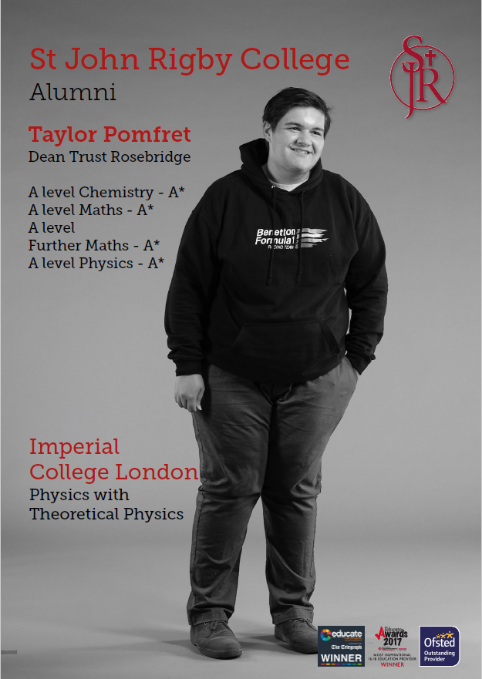
APPLICATION AND SELECTION PROCEDURES

St John Rigby College recognises the importance of recruiting the best candidate for each vacancy to enable the College to deliver high quality services and teaching and learning. Candidates will be appointed on merit in accordance with the College’s policies of Equal Opportunities and Safeguarding and Child Protection. As a “Disability Confident Committed Employer” the College guarantees to interview all applicants with a disability who meet the essential criteria for a vacancy and to consider them on their abilities.
The College is committed to safeguarding and promoting the welfare of young people and vulnerable adults and expects all staff and volunteers to share this commitment.
The Job Description
This provides a full description of the main areas, duties, and responsibilities of the job. This list is not exhaustive but provides a summary of what will be expected of the successful applicant.
The Person Specification
This details the qualifications, experience, skills, knowledge, and abilities we are looking for. The person specification is a list of carefully considered and justifiable criteria, based on the job description. This enables the shortlisting panel to assess, as objectively as possible, your suitability to be shortlisted for the next stage of the selection process. The person specification is particularly important when completing the additional information, as only applicants who can demonstrate that they can meet the criteria given in the person specification will be shortlisted for the next stage of the selection process.
Application Form
Read through all the documents carefully and consider to what extent you have the necessary skills and experience. Think carefully about your experiences. By analysing your present and/or previous jobs and any unpaid work, you may uncover skills that you have taken for granted. You should include any relevant experience gained through your community, voluntary or leisure interests. No guesses or assumptions will be made about your experience or skills. It is therefore essential that you tell us about all your relevant experience and skills.
Completing the form
In the section “Supporting Statement” we ask you why you are interested in the role and how you feel you are suited to it with reference to the criteria in the person specification. As well as judging the substance of your response, judgments will also be made about your written communication skills. You must tell us how you meet the criteria listed.
References
Open references or testimonials should not be sent with your application form and will not be accepted. Unless you have indicated otherwise on the application form, if you are shortlisted, references will normally be taken up before interview. Two confidential references will be requested from current and previous employers (or a previous employer in work with children, young people, or vulnerable adults). References from relatives or people writing solely in the capacity of friends will not be accepted. If you are shortlisted, any relevant issues arising from your references will be taken up at interview. There will be an opportunity for you to ask questions about the job and conditions of service.

Rehabilitation of Offenders Act 1974
Staff employed by the College are exempt from the provisions of the Act and there is a requirement for applicants to declare all convictions, cautions and bind-overs, including those regarded as ‘spent’. Successful applicants (teaching and non-teaching) will have their professional status checked with the Teaching Regulation Agency (if applicable) and are subject to police checks on their criminal record(s) and on the Disclosure and Barring Service check. This may not affect shortlisting unless the conviction is serious, but you may be asked about any convictions at interview. Please note that where a role involves engaging in regulated activity to children, it is an offence to apply for a role if the applicant is barred from engaging in regulated activity relevant to children. Although you may start work pending receipt of these checks, where a successful candidate is found to be on Barred List or the DBS disclosure shows they have been disqualified from working with children by a Court; or an applicant has provided false information in, or in support of, their application, the College will report the facts to the police and/or the DfE Children’s Safeguarding Operations Unit and the offer of employment may be withdrawn, and employment terminated.
Relationship to College Governors/Senior Staff
You are required to state on your application form whether you are related to either a member of the Board of Governors and/or senior member of staff. We want to ensure that the selection process is not prejudiced in any way. Any deliberate failure to make a disclosure will disqualify you. If it is discovered after appointment, you may be dismissed.
Canvassing Members of the College
Canvassing any member of the College directly or indirectly in connection with an appointment shall disqualify the applicant concerned. This provision does not prevent a member of staff from giving a reference of the candidate’s ability, experience, or character for submission with an application.
Equal Opportunities Monitoring
We want St John Rigby College to reflect the diversity of the population we serve, and we welcome applications form people from all backgrounds, especially those from under-represented groups.
All applicants are asked to complete the Equal Opportunities information page, which is attached to your application form. Information on age, ethnic origin, sex, disability religion, sexual orientation and nationality will be collected in order to monitor the numbers of applications from different groups. It will be used only to ensure the effectiveness of our Equality and Diversity Policy, in relation to our recruitment and selection of staff. Please note that only total numbers are submitted; individual details are not disclosed at any time and are seen only by the Human Resources Department. The information will not be used for any purposes other than those stated above. It will be treated as confidential and separated from the application form before you are considered for the post.
Positive about Disabilities
We are committed to the employment and career development of people with disabilities. To demonstrate our commitment, we use the Disability Confident Scheme which is awarded by the Department for Work and Pensions. To demonstrate our commitment to this scheme, we guarantee to interview all applicants with a disability who meet essential criteria for the post.
If you have a disability, there are a number of ways in which we can help you if you need it, from giving assistance with completing the application form, making special arrangements if you are invited for an interview and adjusting the job where reasonable.
Please indicate if you have a disability and your requirements on the Equal Opportunities Monitoring Form within the application form or contact a member of the Human Resources department who will be pleased to help you.

Shortlisting
After the closing date, all application forms are assessed carefully by the shortlisting panel. They assess how each person’s skills and experience relate to the essential criteria on the person specification. Applicants who meet these requirements are called for the next stage of the selection process.
Interviews
In addition to your ability to perform the duties of the post, the interview will also explore issues relating to safeguarding and promoting the interests of young people and vulnerable adults and your attitude towards our mission and ethos. Therefore, you should be prepared to answer questions on both areas.
Data Protection
The College is aware of its obligations under the General Data Protection Regulation (GDPR) and is committed to processing your data securely and transparently.
The personal information you provide in this application will be processed in accordance with current legislation.
Contacting candidates
For practical purposes, successful and unsuccessful candidates may be contacted by e-mail.
If you need advice or assistance in completing the application form or if you have a disability which might present problems for you attending an interview, please contact Yvonne Bimpson, the Human Resources Manager, who will be able to help you. We aim to appoint the best candidate to each post, and to ensure that every applicant is treated fairly, in accordance with our Equality & Diversity Policy Excellence through Inclusion and Safeguarding & Child Protection Policy. The application form plays a crucial part in the selection process.
Please Note
- If you fail to address the person specification fully, you are unlikely to be shortlisted.

- You must ensure that your completed application is well organised and clearly presented.

- CVs will not be accepted and will be removed prior to shortlisting.

- Incomplete application forms will not be accepted.

- Late application forms will only be accepted under exceptional circumstances.

Questions or Queries
If you have any questions about the post for which you are applying or the application or interview process, please contact:

Yvonne Bimpson
HR Manager

Email: hr@sjr.ac.uk
Tel: 01942 214 797 ext 233

Appendix: The Asylum and Immigration Act 1996
For any new member of staff joining St John Rigby College, we are required by law to check whether you are entitled to work in the United Kingdom.
To qualify for employment, you must be able to produce appropriate documentation if you are invited for interview. Applicants should refer to the up to-date lists of acceptable documents taken from the Home Office guidance “An employer’s guide to acceptable right to work documents” as reproduced below:
List A
Acceptable documents to establish a continuous statutory excuse
- A passport (current or expired) showing the holder, or a person named in the passport as the child of the holder, is a British citizen or a citizen of the UK and Colonies having the right of abode in the UK.
- A passport or passport card (current or expired) showing that the holder is a national of the Republic of Ireland.
- A current document issued by the Home Office to a family member of an EEA or Swiss citizen, and which indicates that the holder is permitted to stay in the United Kingdom indefinitely.
- A document issued by the Bailiwick of Jersey, the Bailiwick of Guernsey, or the Isle of Man, which has been verified as valid by the Home Office Employer Checking Service, showing that the holder has been granted unlimited leave to enter or remain under Appendix EU to the Jersey Immigration Rules, Appendix EU to the Immigration (Bailiwick of Guernsey) Rules 2008 or Appendix EU to the Isle of Man Immigration Rules.
- A current Biometric Immigration Document (Biometric Residence Permit) issued by the Home Office to the holder indicating that the person named is allowed to stay indefinitely in the UK or has no time limit on their stay in the UK.
- A current passport endorsed to show that the holder is exempt from immigration control, is allowed to stay indefinitely in the UK, has the right of abode in the UK, or has no time limit on their stay in the UK.
- A current Immigration Status Document issued by the Home Office to the holder with an endorsement indicating that the named person is allowed to stay indefinitely in the UK or has no time limit on their stay in the UK, together with an official document giving the person’s permanent National Insurance number and their name issued by a Government agency or a previous employer.
- A birth or adoption certificate issued in the UK, together with an official document giving the person’s permanent National Insurance number and their name issued by a government agency or a previous employer.
- A birth or adoption certificate issued in the Channel Islands, the Isle of Man or Ireland, together with an official document giving the person’s permanent National Insurance number and their name issued by a Government agency or a previous employer.
- A certificate of registration or naturalisation as a British citizen, together with an official document giving the person’s permanent National Insurance number and their name issued by a Government agency or a previous employer.

List B
Group 1 – Documents where a time-limited statutory excuse lasts until the expiry date of leave
- A current passport endorsed to show that the holder is allowed to stay in the UK and is currently allowed to do the type of work in question.
- A current Biometric Immigration Document (Biometric Residence Permit) issued by the Home Office to the holder which indicates that the named person can currently stay in the UK and is allowed to do the work in question.
- A current document issued by the Home Office to a family member of an EEA or Swiss citizen, and which indicates that the holder is permitted to stay in the United Kingdom for a time limited period and to do the type of work in question.
- A document issued by the Bailiwick of Jersey, the Bailiwick of Guernsey, or the Isle of Man, which has been verified as valid by the Home Office Employer Checking Service, showing that the holder has been granted limited leave to enter or remain under Appendix EU to the Jersey Immigration Rules, Appendix EU to the Immigration (Bailiwick of Guernsey) Rules 2008 or Appendix EU to the Isle of Man Immigration Rules.
- A document issued by the Bailiwick of Jersey or the Bailiwick of Guernsey, which has been verified as valid by the Home Office Employer Checking Service, showing that the holder has made an application for leave to enter or remain under Appendix EU to the Jersey Immigration Rules or Appendix EU to the Immigration (Bailiwick of Guernsey) Rules 2008, on or before 30 June 2021. Entry to be removed - refer to List B, Group 2, no. 2
- A frontier worker permit issued under regulation 8 of the Citizens’ Rights (Frontier Workers) (EU Exit) Regulations 2020.
- A current Immigration Status Document containing a photograph issued by the Home Office to the holder with a valid endorsement indicating that the named person may stay in the UK, and is allowed to do the type of work in question, together with an official document giving the person’s permanent National Insurance number and their name issued by a government agency or a previous employer
Group 2 – documents where a time-limited statutory excuse lasts for six months
- A document issued by the Home Office showing that the holder has made an application for leave to enter or remain under Appendix EU to the immigration rules (known as the EU Settlement Scheme) on or before 30 June 2021 together with a Positive Verification Notice from the Home Office Employer Checking Service.

- A document issued by the Bailiwick of Jersey, the Bailiwick of Guernsey or the Isle of Man showing that the holder has made an application for leave to enter or remain under Appendix EU to the Jersey Immigration Rules or Appendix EU to the Immigration (Bailiwick of Guernsey) Rules 2008 or Appendix EU to the Isle of Man Immigration Rules, together with a Positive Verification Notice from the Home Office Employer Checking Service. Entry amended.
.
- An Application Registration Card issued by the Home Office stating that the holder is permitted to take the employment in question, together with a Positive Verification Notice from the Home Office Employer Checking Service.

- A Positive Verification Notice issued by the Home Office Employer Checking Service to the employer or prospective employer, which indicates that the named person may stay in the UK and is permitted to do the work in question
- A Certificate of Application (digital or non-digital) issued by the Home Office showing that the holder has made an application for leave to enter or remain under Appendix EU to the immigration rules (known as the EU Settlement Scheme), on or after 1 July 2021, together with a Positive Verification Notice from the Home Office Employer Checking Service. Additional document entered on list.

If you are invited to attend for interview for a post at the College, you will be asked to bring the original document, as photocopies are not acceptable. Your document will be photocopied and returned to you immediately. If you are in any doubt about whether your documents qualify you to work in the United Kingdom you should seek help from the local office of the Department for Education or the Citizens Advice Bureau.

St John Rigby College has a strong commitment to equal opportunities. All job applicants, irrespective of race, age, religion, or gender, are required to produce the documentation listed above. Please accept our assurance that we do not wish to interfere with your privacy, but are simply following the requirements set down by current legislation

St John Rigby College

Gathurst Rd, Orrell, Wigan, WN5 0LJ
01942 214 797
www.sjr.ac.uk

