Application for the post of:
Achieve, Care, Enjoy

Assistant Headteacher - Inclusion
(SEND and Vulnerable Groups)
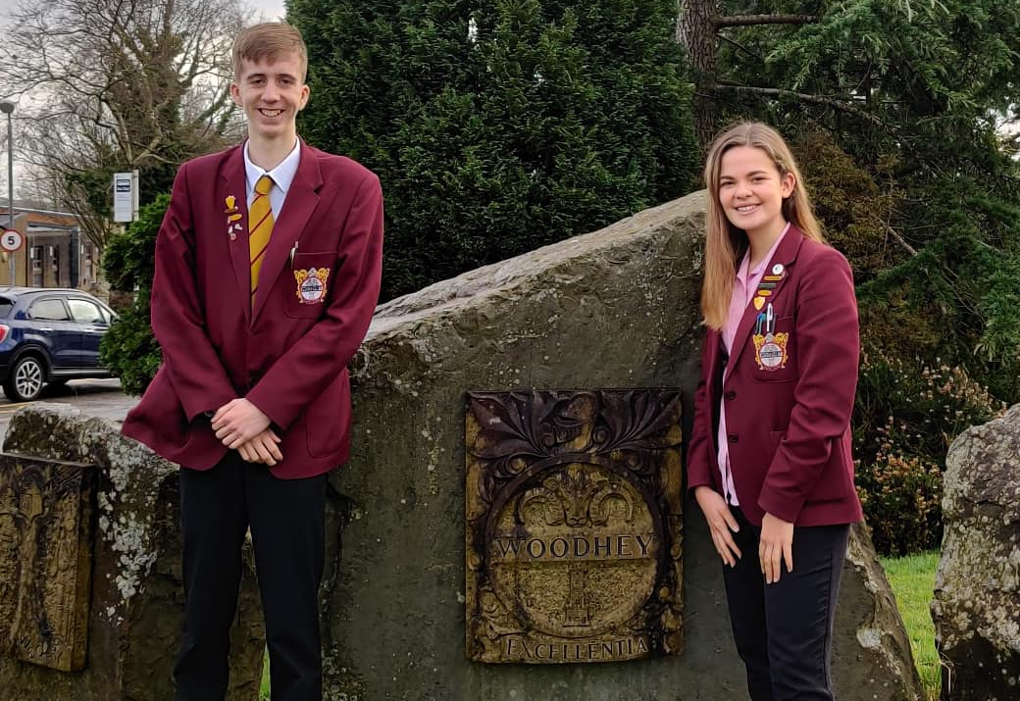
Salary – L14-18

Closing date:
Monday 27 April 2020 (noon)
To start September 2020

Healthy Schools

April 2020

Dear Applicant

Welcome to Woodhey High School and thank you for expressing an interest in the post of Assistant Headteacher.

This is an inclusive, community school which continues to strive for sustained improvement in all areas. We are therefore seeking to appoint a passionate and inspirational individual with exceptional leadership qualities, who will play an important role in the future development of the school. This post offers an excellent opportunity for a talented teacher and leader to gain wide-ranging experience as a member of our Senior Leadership Team. We are seeking a versatile professional who is flexible in outlook, has a positive work ethic and has the potential and ambition for further promotion in the future.

 |  | Appointed
Headteacher | Brian Roadnight | Sept 2013
Deputy Headteacher | Lisa Dobson | Sept 2013
Assistant Headteachers:
Inclusion (Safeguarding,  Pastoral & Behaviour) | Mark Cutting | Jan 2001
Standards | Andy King | April 2005
Teaching & Learning | Adam Downing | Sept 2019
Business Manager | Jane Vosper | July 2009
In 2017, finances did not allow us to replace an outgoing senior leader and consequently we are currently a small senior leadership team for a school of over 1100 pupils. This appointment is an additional post to the current team, the make-up of the current team can be seen here (right). We are seeking to bringing together the strategic leadership of intervention for our vulnerable groups under one leader.

The main aspects of the role are to plan the strategic direction and co-ordinate the day to day management of the way in which we support groups of vulnerable pupils, setting policy and aligning systems and structures. The groups of pupils include those with SEND, SEMH, Children who are Looked After (and, where appropriate, previously looked after), disadvantaged, EAL, Pupil Premium Strategy and those pupils with Medical Conditions. Note that the school also has a SENCO, an Assistant SENCO and an Enhanced Provision for pupils with ASC. In September 2020, the non-teaching pastoral team includes pastoral mentors with specific roles in attending PEPs for Children who are Looked After and medical conditions who will conduct the day to day work in these areas.

We are looking for effective inter-personal and communication skills, evidence of successful leadership and a desire to work through a team approach. Equally important will be a set of values which matches our own and a constructive attitude to externally imposed change. We shall be delighted to consider your application if you decide to apply and wish you the best of luck if you choose to do so.

If any candidate wishes to discuss the post on an informal basis they may contact us by phone (01706 825215). Please note that our interview processes will be different, in the light of the Covid-19 Lockdown.

Yours faithfully

Brian Roadnight,
Headteacher

B Roadnight, Headteacher

Application for the post of:
Salary:
Appointment Process
Fri 3/04/2020

Mon 27/04/2020 (noon)
Wed 29/04/2020
Week beginning 4/5/2020
Assistant Headteacher for Inclusion (SEND and Vulnerable Groups)
Fri 15/5/2020
Friday 15/04/2020
L14-18

Advertised through the TES, School Website

Closing date for applications

Shortlisting

Professional interviews will take place. The format of these interviews will depend on the country’s position regarding COVID-19 Lockdown and will be communicated nearer the time. It is likely that interviews will be conducted individually and not necessarily face to face.

Final date beyond which applicants can assume that their application has been unsuccessful on this occasion if they have not been contacted. We wish you well for the future if this is the case.

The successful candidate will be expected to take up the position on 1/09/2020, or sooner if this is a possibility.

All unsuccessful shortlisted candidates will be offered a debriefing session.

Please find with this information:
1. Job description.
2. Person specification.
3. Information about the school.
4. Application Form.

Further details about the school and a copy of our latest Ofsted Report (Nov 2017) are available on the school
website www.woodhey.bury.sch.uk. For information about Ramsbottom please visit www.Ramsbottom.net.

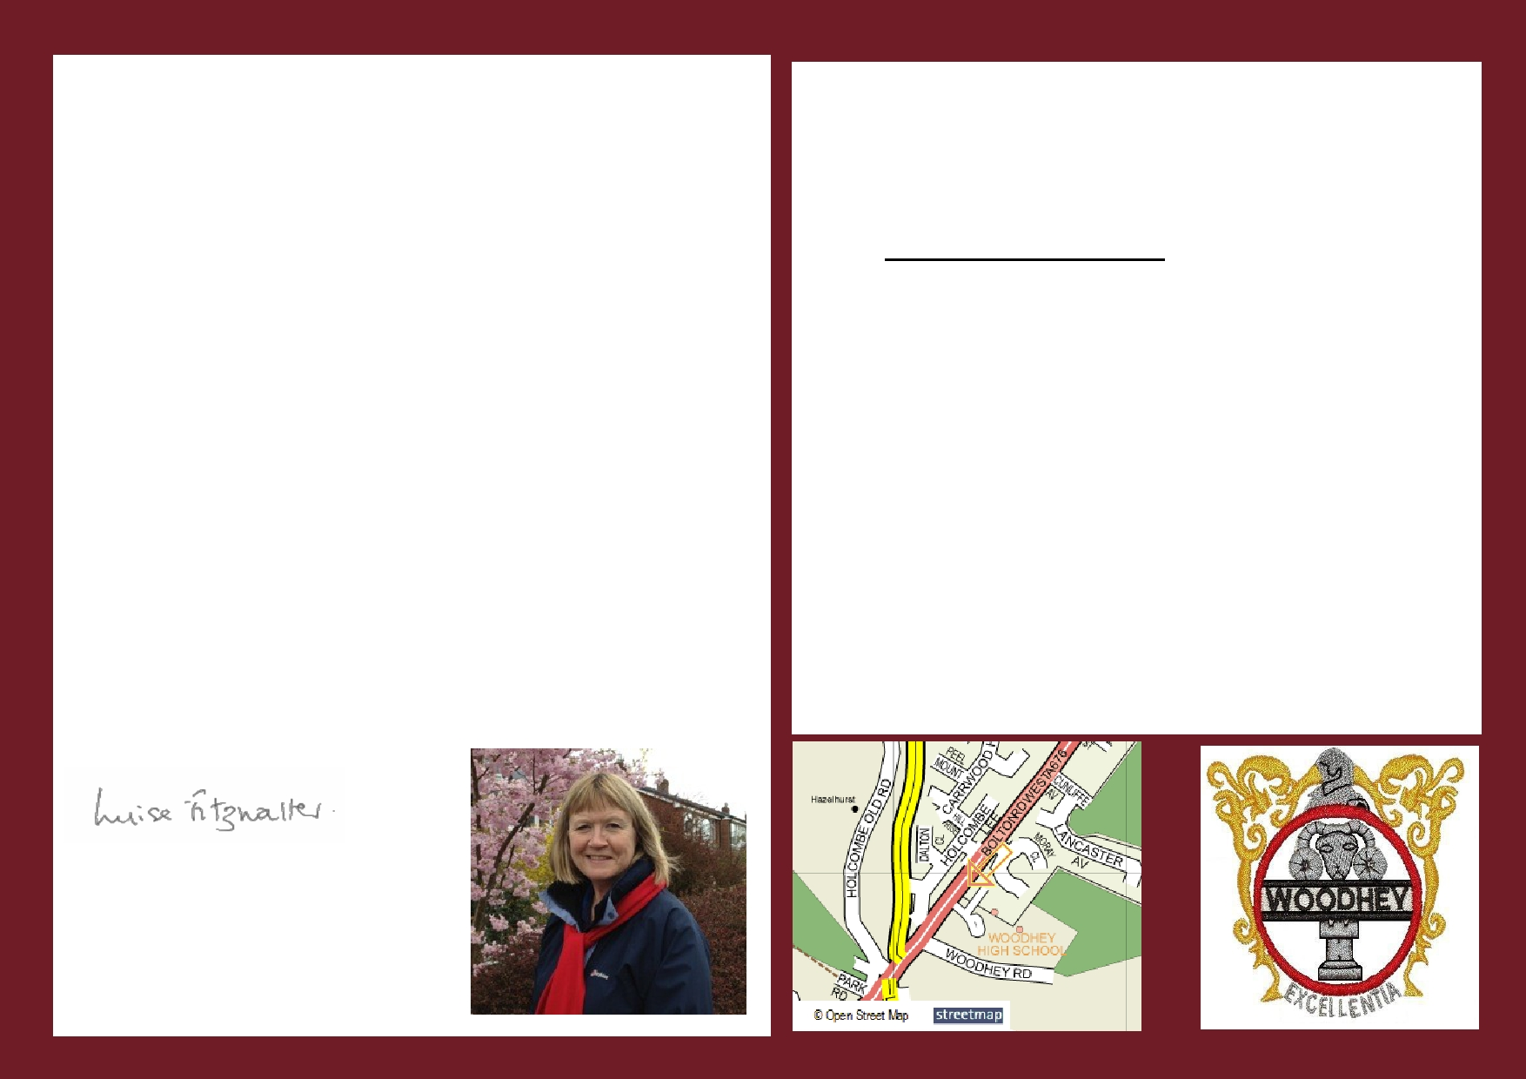
April 2020

Dear Applicant

Thank you for expressing an interest in the post of Assistant Headteacher for Inclusion (SEND and Vulnerable Groups) at Woodhey High School in Ramsbottom.

The Governors wish to appoint an outstanding candidate to lead aspects of Inclusion (including SEND, SEMH, EAL, disadvantaged, CLA and Medical Needs) in this well-respected community school with effect from September 2020. We are looking for a dedicated and inspirational leader who will build on the school's success. We are delighted to be an inclusive school with an enhanced provision for autistic pupils and those with communication difficulties.
Woodhey is a high achieving and inclusive 11-16 community comprehensive school and
Specialist Science College. We are committed to providing a secure and caring learning environment for all our pupils and we ask our pupils to achieve, care and enjoy. Our aim is to develop highly-educated, well-rounded, considerate and confident young people who are willing and able to contribute to society.
There are currently 1119 pupils on the school roll.
Ramsbottom has become more of a residential area than an industrial town. The town
does have some thriving small industries and is a popular shopping centre for the surrounding area. A strong sense of community values still exists in Ramsbottom, but
many residents now commute to Greater Manchester, Merseyside, West Yorkshire and
Lancashire because of the superb access to the nearby motorway network.
We obviously want the right person for our school and you will want the right school in
which to work - so we have tried to include as much information as possible for your consideration. We shall be delighted to consider your application if you decide to apply
and wish you the best of luck if you choose to do so. We would be very happy to see you if you wish to see the school before applying. Visiting times have been put aside on the afternoon of the 5th March and the morning of 9th March.
I look forward to receiving your application.
Yours faithfully
APPLICATION DETAILS

Please complete the enclosed application form, together with a letter of application (no more 1,500 words).

Application forms and details are available on the school's
website www.woodhey.bury.sch.uk. in the section "About us".

Applications should be sent by email (woodhey@bury.gov.uk) or
post to the school to arrive by:-
Monday 27 April 2020 (noon)

Your application must address the person specification and outline your experience, values and vision for the future at Woodhey. You may enclose a curriculum vitae if you wish, but this will only be considered alongside a fully completed application form.

We look forward to receiving your application.
If you have not heard from us by Friday 15 May 2020 please assume that you have not been successful on this occasion. May we thank you in advance for your application and wish you well for the future.

Luise Fitzwalter
Chair of Governors

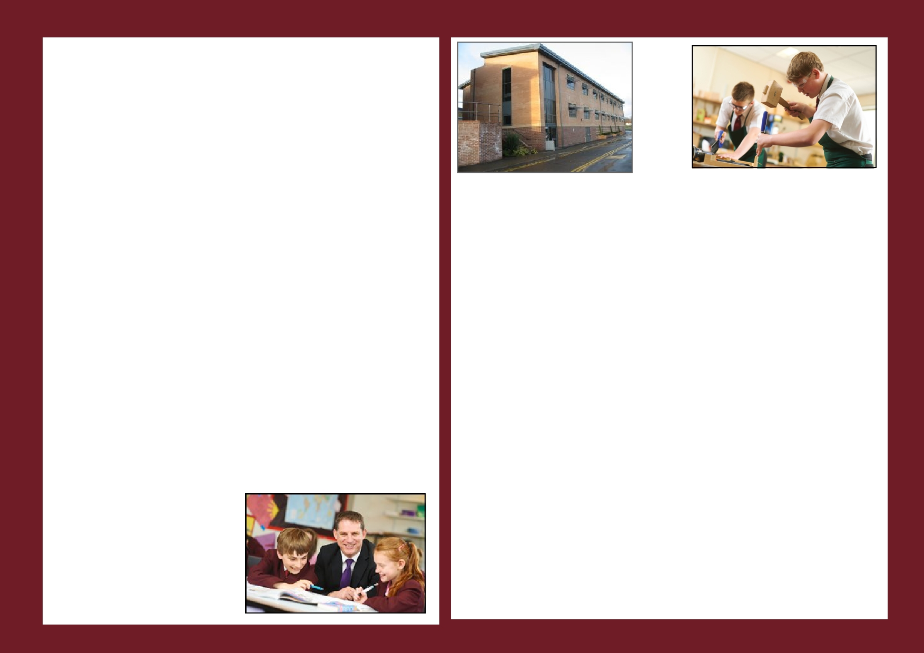
Responsibilities as a Member of the Senior Leadership Team

At Woodhey the Leadership Team will play a major role in collectively;

- Facilitating the work of all staff in school by providing advice and support as needed.

- Formulating and reviewing the vision, aims and objectives of the school.
- Establishing the policies through which they should be achieved.
- Monitoring and evaluating the whole curriculum of the school.
- Contributing to the School Improvement Plan, its development and review.

- Preparing for any Ofsted inspection and implementing the resultant action plan as may be directed by the Governing Body.

- Contributing to the raising of pupil achievement, safeguarding, improving learning, protecting and improving well-being and increasing opportunities in their own area of responsibility.
- Communicating the progress of initiatives to the Governing Body.
- Liaising with the local community and other external agencies (as required).

- Contributing to the overall management and promotion of the whole school as directed by the Headteacher.

In order to contribute to the above there is an expectation that every member of the Leadership Group will contribute on a rota basis to;
- The internal and external supervision of the school corridors and grounds.
- The supervision of the ‘inclusion’ room.
- The school assembly system.
- Whole school functions (where attendance would be deemed appropriate).
- Emergency situations (with pupils, parents or outside agencies).

Leadership Team members should be available before school, at lunchtime and immediately after school. In the event of an emergency/unforeseen problem, all members of the Leadership Team will assume collective responsibility for ‘extra duties’ imposed by the problem/situation.

Senior Leaders will assume the role of ‘link’ person with named faculties (agreed within the Leadership Team on an annual basis). The role will include (alongside the Head of Faculty);

- Monitoring teaching and learning within the department (
- Monitoring the effectiveness of the quality of education offered in the faculty

- Providing support for faculty development and review

- Encouraging and supporting curriculum development.
- Monitoring assessment, recording and reporting.
- Evaluating the faculty’s Improvement Plan and exam results.
- Staffing issues within the faculty, including staff development.

In the absence of the Headteacher and Deputy Headteacher the Assistant Headteachers will be responsible for managing the school on a rota basis.

Information regarding the
Job Description
and
Person Specification
for this position can be found
within the separate
documents attached with this
advertisement

