Vision and Values: Statements
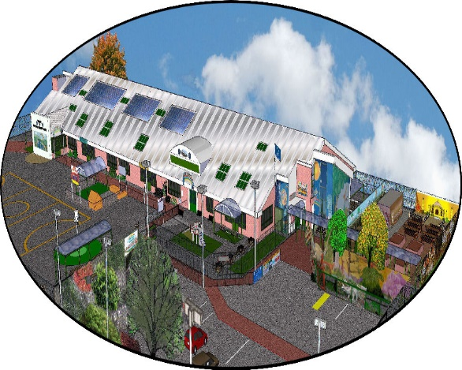
Created December 2018: Reviewed 2020
To be approved by full governors: March 2019

School Vision:
We aspire to become, remain and uphold the standards of -
“A world class centre of outstanding learning”

Mission Statement:
‘Together we’re better’
Our core values:
Acceptance
Fairness
Trust
Equality
Respect

Leadership
Acceptance
- Understanding other people’s opinions and inviting constructive professional criticism
- Willingness to accept new ideas from all sources
- Supporting others in times of need via professional dialogue and interaction
- Volunteering when needed for the greater good of the organisation
- Strong moral principles, acting in the pupil’s best interests
- Open door policy when appropriate
Fairness
- Transparency (of SLT & meetings)
- Clarity of communication, avoiding mixed messages, duplication and having a “single voice”
- Clear policies, used by all that are relevant and appropriate
Trust
- Confidentiality when necessary
- Approachability
- Listening or asking to reconvene when listening can be of quality
- Discreet
- Professional honesty
- Professional opinion sought, invited and welcomed-when asked for
- Effective delegation, to staff with the skills to complete duties
Equality
- Consistent expectations of all staff
- Empower all to achieve
- Inclusive practices
Respect
- Leading by example
- Non-judgemental
- Empathetic
- Outward looking
- Willing to learn
- Demonstrates integrity
- Seeing everyone as part of the wider team

Behaviours: staff and children
Acceptance
- Understanding/ empathising/ different backgrounds/ circumstances
- Jigsaw/ PHSE
- Zero bullying tolerance – homophobic, bullying, racial

Fairness
- Consistent
- Rewards/ sanctions
- Opportunities (extra-curricular)
- Fairtrade
- Inclusion
- Safety & feeling safe
Trust
- Confidentiality
- Comfortable talking to staff – approachable
- Online safety
- Forming and modelling strong relationships
- PPG keywords
- SNA - Keyworkers
- SEND – 1:1 support
Equality
- Of opportunities, expectations, teamwork
- Avoid all gender bias
- Anti-bullying
- Strong safeguarding
Respect
- High expectations
- Modelled language
- Respectful in discussion
- Respect different points of view
- International outlook
- For the whole school environment

Professional Development/ Appraisal

Acceptance
- Meets individual needs
- Inclusion of a variety of staff beliefs, values, religion
- High quality inclusion
Fairness
- Appraisals for all staff
- Opportunities for mentoring and coaching
- Opportunities for all to observe outstanding practice
- Promotion based on school needs and restructure-preparing others with wider aspiration to leave, if necessary
- Transparency of process
- Opportunities to meet peers and provide mutual support
Trust
- Confidentiality
- Listening
- Feel valued
- High quality induction, mentoring and support
- Coaching ethos
- Instructional and supportive
Equality
- CPD available to all
- All training takes place when planned and promised
- Governor monitoring
- Staff development
Respect
- Mutual respect-treating people, when instructing, in a professional manner
- Leading by example
- All staff have a right to development
- Individuality is seen as part of each person’s uniqueness

Curriculum
Acceptance
- Understanding that children will have different strengths and weaknesses
- Interests are supported and encouraged
- Understanding that the need for support is not weakness
- British values are embedded
Fairness
- Opportunities are provided for all
- Access to broad and balanced curriculum – monitored effectively
- Targets to challenge all
- Inclusive of all pupils
Trust
- Peer/ self- assessment is encouraged
- Subject knowledge is deep and shared when possible
- Independent learning is encouraged
- Parents trust the school in what is being taught
- Online safety is essential
- Child led/ enquiry based learning supports a curriculum that meets the child’s interest
Equality
- Differentiation, where possible, to support and challenge
- Relevant/ relatable/ contemporary/ content/ material
- Opportunities/ experiences – providing variety of first hand experiences
- Enriched/ enjoyable
- Non gender specific stereotypical lessons or curriculum opportunities
Respect
- Celebrating differences where possible
- British values/ PHSCE/ Jigsaw/ RE-run through what we teach
- Showing respect for each other via the language we use
- Modelling language and behaviour by all staff
- Fairtrade activities highlights and addresses global inequalities
- We encourage building on children’s prior knowledge

Vision
Acceptance
- Equality: We all can achieve to our absolute maximum level, whilst remaining happy and cared for
- We accept everyone is different and cater for their needs accordingly
- Knowing what is/ is not acceptable and act on it accordingly
- Celebrating our diverse community

Fairness
- Listening to all
- Treating all the same
- No discrimination
- Everyone is valued
- Expectations – induction handbook, staff materials
Trust
- Feedback is essential to success be it written or spoken and its effectiveness diminishes the longer it takes after the error
- SLT all share same school aspiration
- All follow school policies
- Outstanding teaching and care side by side
- Trust that everyone will be treated the same
- Personal touch – links with community, open and friendly
- Introduction to staff profile – building good relationship with community
Equality
- Non- judgemental
- Inclusion at all levels
- Adapt when necessary to include all children/ staff
Respect
We always respect:
- Each individual child/adult
- The building and school resources
- Families – and our close parent partnerships

Key questions:

How do we recruit against these values?

How do we develop CPD alongside these values?

What happens if we don’t display these values day-day?

How do we exemplify these values?

