Job Summary
Strategic Contracts and Procurement Manager
Service: |  | Leisure, Cultural and Property Services | Grade: | G14 |  | Salary: | £49,363 - £52,995
Reporting to: |  | Assistant Director | Location: | Town Hall |  | Hours: | 37

Your job
Provide an effective challenge to commissioning, procurement and contract management advice and guidance across the Council and its partners to ensure Value for Money and all decisions relating to contracts are within the legal and policy framework and realise efficiencies in line with corporate and directorate objectives.
You will |  | Our culture
- Within 6 months, ensure the establishment of robust procurement, commissioning and contract management arrangements across all service areas of the Council.  - Within 6 months, ensure that the Council’s procedures for commissioning, procurement and contract management are fit for purpose to meet the funding and demographic challenges faced by the Council.  - Within 12 months, undertake a strategic review of the Council’s existing and proposed contractual arrangements to ensure that they are compliant with the Council’s constitution and the applicable law and deliver Best Value for the Council, its partners and stakeholders.  - Within 12 months, complete a service plan and full implementation of a strategic and comprehensive review of the Council’s existing and proposed contractual arrangements to ensure that they are compliant with the Council’s constitution and the applicable law and deliver Best Value for the Council, its partners and stakeholders.  - On an on-going basis, prepare reports with relevant comments that ensure that officers and decision-makers are fully informed of the legal implications of proposed courses of action and to ensure that, where appropriate, Committee reports include reference to the legal position.  - On an on-going basis, undertake research into appropriate procurement mechanisms including opportunities for funding and develop proposals for consideration by commissioning teams and managers. |  | For us, it’s not just about all we achieve as an organisation, but how we do it. Therefore, all employees are expected to display our behaviours.  Be Positive… take pride in all that you do  Be Accountable… be responsible for making things better  Be Courageous… be open to doing things differently  In addition to these, our managers are expected to display the three manager behaviours.  Inspire…lead by example and help others to see the big picture  Care… show genuine concern for people as individuals and value their contributions  Engage… I connect with others both within and beyond the organisation
Our ideal candidate |  | Staff Deal
- Provide evidence of extensive and demonstrable experience of operating in a senior role with particular focus on successfully working with commercial contracts, including procurement and commissioning.  - Produce appropriate certification of professional qualification relevant to the role e.g. CIPS or similar.  - Provide evidence of the ability to work corporately and represent the Service positively including the ability to provide training and guidance to Elected Members and Officers, and work as part of a wider team to deliver the highest possible professional service.  - In depth experience of identifying and maximising opportunities for efficiencies and revenue savings and implementing improvement plans as necessary.  - Demonstrate the ability to plan and organise own workload competently, with minimum supervision and to strict deadlines, and a willingness to take appropriate responsibility to act on own initiative and to positively influence clients as part of a wider service team.  - Provide evidence of a detailed knowledge of the areas of law and practice likely to arise in large commercial contracts e.g. contract, procurement, employment and the ability to carry out effective research.  - Provide evidence of the ability to work corporately and represent the Service positively, establish productive relationships and negotiate with people at all levels, both inside and outside the organisation to inspire a "can do" approach  - Demonstrate the ability to effectively produce written documents, as well excellent verbal communication skills.  - Demonstrate an ability to analyse complex information and to produce clear, concise reports, briefing papers and advice to clients and colleagues.  - Provide evidence of experience of either working in a local authority environment or working in the private sector providing advice to Local Authorities on Contract matters and successfully managing staff within a commercial or similar environment. |  | 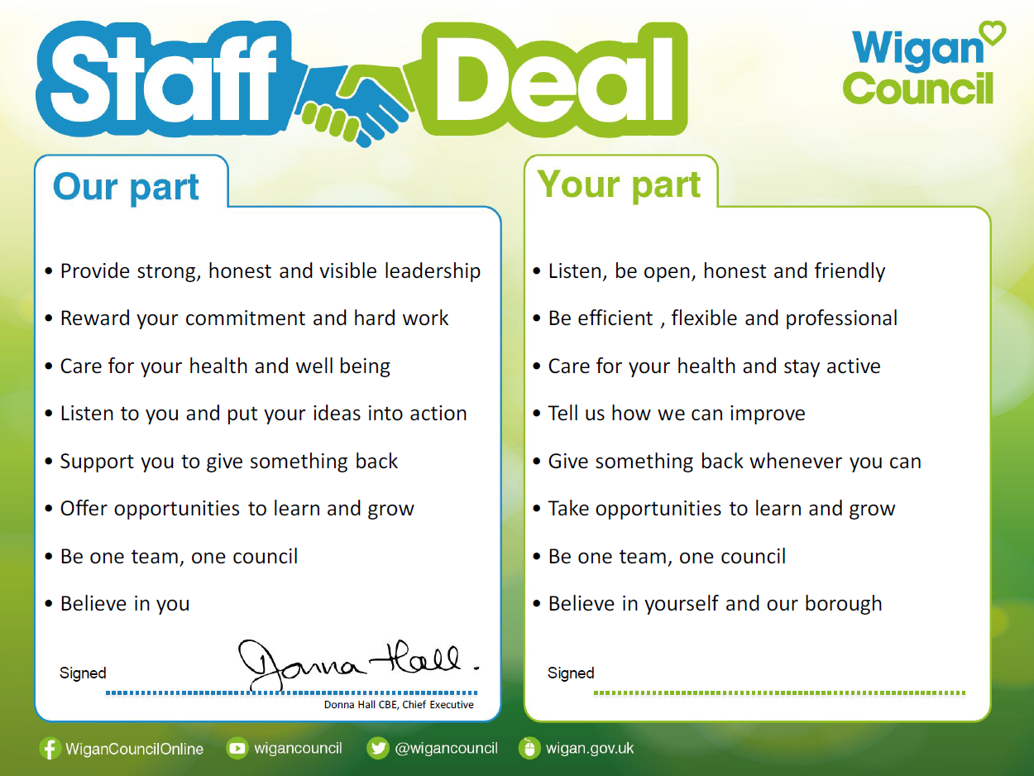  Our Staff Deal is an informal agreement with all staff. It outlines what you can expect from us, and in return what we expect from you

