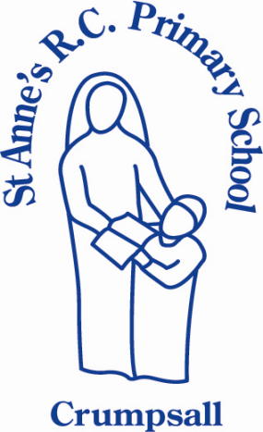
St Anne’s RC Primary School
Mission Statement

In partnership together families, school and parish we are working to meet our mission which is to, ‘work together, learn together, care together and play together in God’s love to enable each unique person to achieve their full potential.’
Everyone wishes to do their best for the children in everything we say and do, to set an example through good citizenship based on Gospel values so that our children too will aspire to be like our patron St Anne.

