Building Surveyor
Service: |  | Urban Vision Partnership | Grade: | 3C | Salary: |  |  | £29,636 - £32,029
Reporting to: |  | Principal Building Surveyor | Location: | Saford Civic Centre, Swinton | Hours: |  |  | 36 hours per week
About the role |  |  |  |  |  |  | Our priorities
- This role is for a Building Surveyor and they will be responsible for service delivery to a wide range of clients in designing solutions in the private, education and local authority sectors.  - Have responsibility for early stage design and feasibility work  - Develop detailed briefs in conjunction with the client  - Carry out detailed design work and prepare production information  - Undertake the role of Project Manager  - Administer building contracts act as ‘Lead Discipline’ on programmed capital projects  - Undertake all aspects of professional surveying work (including surveys, PW work, dilapidations, DDA & FRA’s)  - Carry out inspections when required to resolved building defects, asignng contractors and managing the works. |  |  |  |  |  |  | 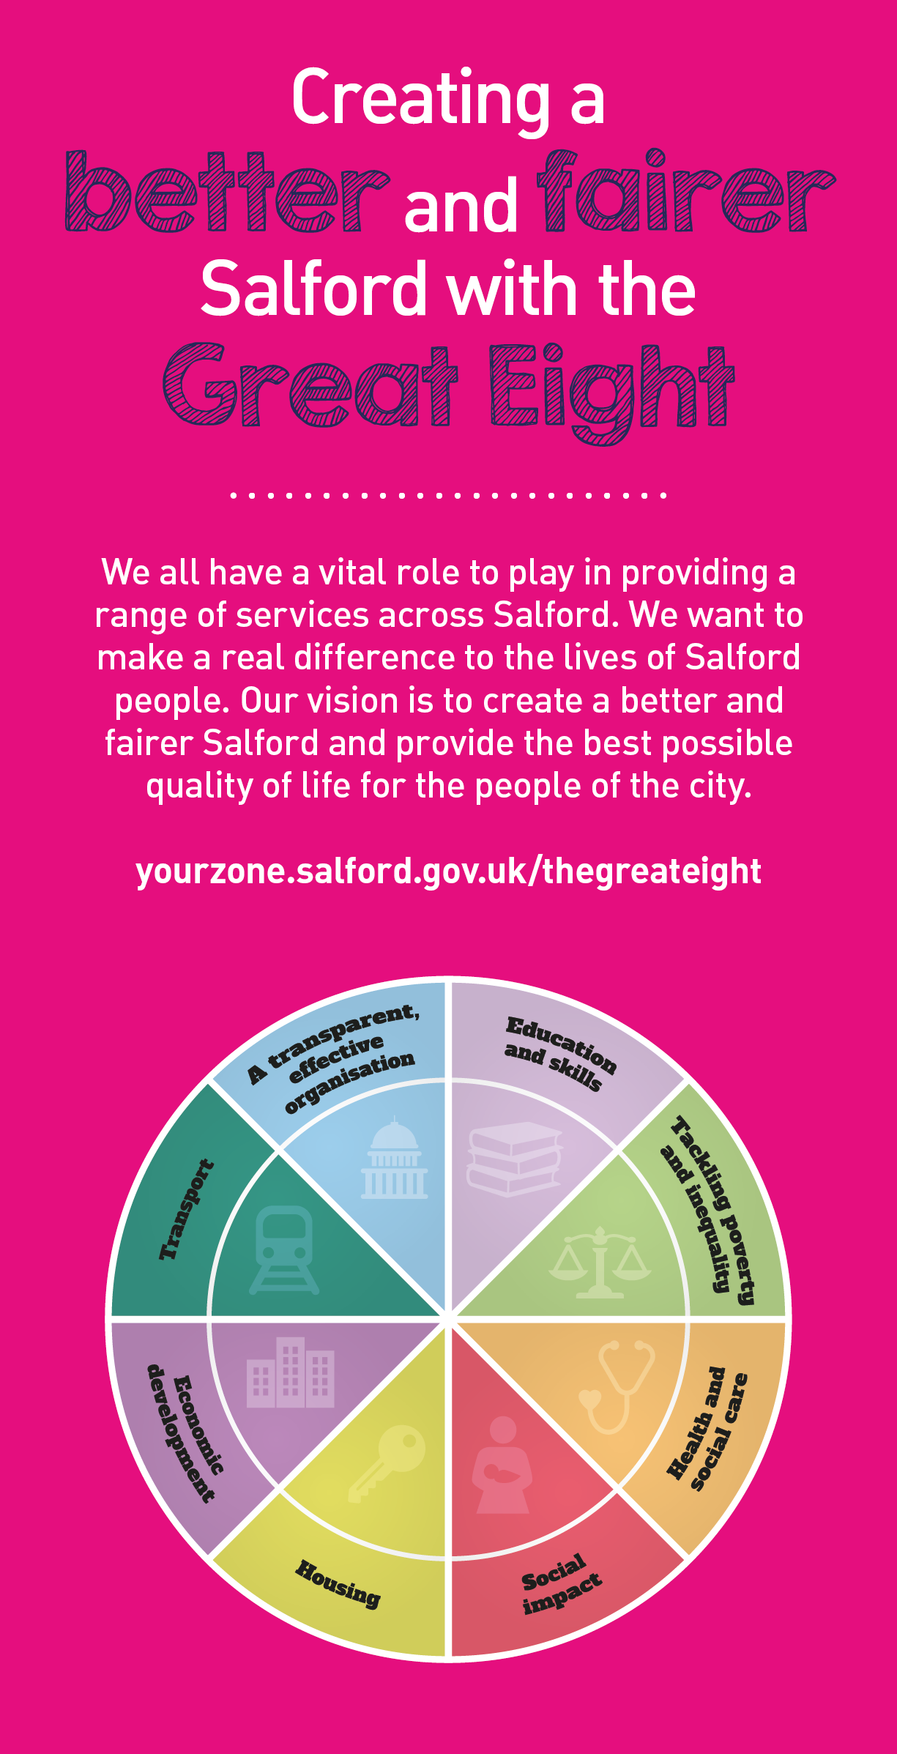
 | Key outcomes
- Arranging the procurement of building works through competitive tendering. Prepare, manage, report and maintain project cost plans.

- Implement projects to meet the requirements of quality, health and safety, environmental standards, and time to both national and corporate standards.
- Preparing schemes for tender using: the JCT minor works 2016 Forms of Contract; specification, CAD drawings to the requirements of current legislation
- Supervision and monitoring of works on site including: making valuations for payment assessments; chairing and managing progress meetings; identification and assessment of additional payments due to variation orders or compensation events; determination of project final accounts and satisfactory completion of the defects period.
- Ensure compliance of the work with a high regard to Health and Safety and the application of the CDM Regulations and other legislation.

What we need from you |  | Our values
- Proven technical skills and ability in the role with a record of accomplishment for delivering outcomes
- Professional credibility through proven relevant experience
- Models and demonstrates our values
- Essential Criteria
- BSc in Building Surveying or equivalent
- Minimum 2-3 years post qualification experience within Building surveying environment (particularly within the Education sector)

- Ability to establish a good working relationship with Clients and colleagues
- Self motivated and able to work without supervision
- Ability to prioritise and work to deadlines

- Good communication and customer skills
- Ability to demonstrate flexible approach to work
- Ability to undertake pre and post contract control of building contracts under appropriate forms of contract in accordance with Quality Assurance procedures
- A knowledge of current legislation, e.g. Health & Safety, CDM, Building Regulations, SWMP, Planning
- Car driver with current driving licence

- Desirable Requirements
- Membership of the R.I.C.S. or C.I.O.B
- Experience in education, health and leisure projects
- Experience in private and local authority sectors
- Experience in education, health and leisure projects
- Experience in private and local authority sectors
- Understanding of Academies Funding
- Use of NBS Specification Manager, MS Project, AutoCAD, REVITHave responsibility for early stage design and feasibility work
- Develop detailed briefs in conjunction with the client
- Carry out detailed design work and prepare production information
- Undertake the role of Project Manager
- Administer building contracts act as ‘Lead Discipline’ on programmed capital projects
- Undertake all aspects of professional surveying work (including surveys, PW work, dilapidations, DDA & FRA’s) Personal qualities and qualifications required

Application guidance

We are a values based organisation so reflecting our values or a values based approach in your evidence will support your application.

The ‘Key outcomes’, ‘What we need from you’ and ‘our leadership behaviours’ sections of the Role Profile are there to give you an understanding of what we would like to see reflected in your application. Don’t give up if you are not able to reflect all of these in your application.

