Chef
Service: |  | Barton Moss Secure Care Centre | Grade: | 2A |  |  | Salary: |  |  | £19,171 - £19,945
Reporting to: |  | Snr Chef | Location: | Barton Moss Secure Care Centre |  |  | Hours: |  |  | 36
About the role |  |  |  |  |  |  |  |  | Our priorities
- To provide good quality, nutritional and balanced meals for young people and staff  - To provide cost effective and attractive meals for the centre’s canteen  - To produce refreshments and buffets for meetings and Conferences  - To ensure that effective, ordering, production, stock control and minimum wastage levels are achieved.  - To assist with the planning of menus for young people, staff and customers.  - To ensure effective portion control  - To ensure that all special dietary needs are met for customers.  - To ensure that all required records and returns are completed accurately and promptly in accordance with relevant policies and regulations.  - To ensure that the condition of all relevant equipment are assessed and reported where necessary.  - To comply with all relevant health, safety and security procedures within the secure centre.  - To accept supervision from the senior chef and participate in any training identified within the personal development plan.  - To participate in the working rota covering the hours of 8.00am to 7.00pm Monday to Friday & 8.00am to 5.00pm Saturday/Sunday. (5 shifts per week averaged over a 4 week rota period) |  |  |  |  |  |  |  |  | 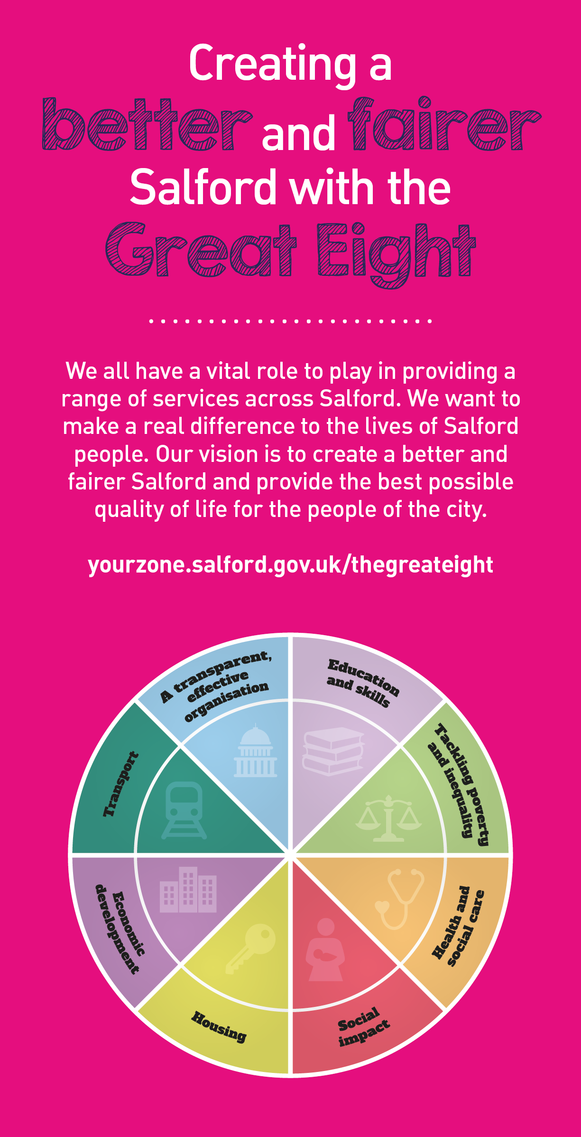
 | Key outcomes
 | - To ensure that nutritional and balanced meals are provided for young people and staff  - To ensure that cost effective and attractive meals are provided in the centre’s canteen  - To provide high quality refreshments and buffets for meetings and conferences  - The successful set up and running of catering events.  - To ensure that 5 star cleanliness rating are achieved in the main kitchen.  - Effective stock control and quality checks |  |  |  |  | - Click here to enter text.
 | What we need from you

- Proven technical skills and ability in the role with a record of accomplishment for delivering outcomes  - Professional credibility through proven relevant experience  - Models and demonstrates our values and behaviours |  | - Qualified to either NVQ 1 or 2 (or equivalent) in a relevant catering qualification.  - Basic skills in English and Maths  - Basic Food Hygience Certificate  - Knowledge of regulations and legislation relating to a catering environment  - Proven experience in a catering environment  - Experience or knowledge of menu planning  - The ability to demonstrate flair and imagination in the preparation of food to a high standard  - Excellent customer service skills and the ability to communicate effectively with a range of customers  - The experience and skills to be able to work flexibily under pressure.  - To be able to work shifts including early evening and some weekends on a rota basis.

Application Guidance |  | Our values
We are a values based organisation so reflecting our values or a values based approach in your evidence will support your application.

The ‘Key outcomes’, ‘What we need from you’ and ‘our leadership behaviours’ sections of the Role Profile are there to give you an understanding of what we would like to see reflected in your application. Don’t give up if you are not able to reflect all of these in your application.

Click here to enter text.

