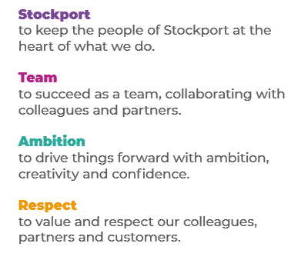
Job Profile and Working for Stockport Council
Our Council
Our employees are our greatest asset. We’re proud of the way we provide vital frontline services every day and work together, as one team.
Our 4 core values as shown above, run through everything that we do, and we aim to stay true to them regardless of the challenges that we may face.
To support our values, we have policies, guidance and procedures around health, safety and welfare, customer care, emergency planning and security that all our colleagues are adhering and working to.
We also pride ourselves on our commitment to wellbeing and inclusivity of our colleagues and residents.
You can find out more about working for Stockport Council and some of the benefits that we offer our employees at https://greater.jobs/locations/stockport/

Role: |  | School Admissions and Transport Officer
Service Area: |  | Business Support, Contracts and Commissioning
Directorate: |  | Corporate and Support Services
Salary Grade: |  | Sc 4
About the Job

Main Purpose of the Job
As a School Admissions and Transport Officer you will support the delivery of services offered by School Places, Admissions and Transport Team.

Key Responsibilities
- Taking personal responsibility for high quality customer services and a safe working environment

- Providing technical expertise in specific specialist areas of work providing supervision and direction to other Support Officers and Apprentices who will support the process

- Undertaking high risk, high cost and complex processes ensuring complete accuracy and quality assurance

- Gaining an in-depth knowledge of the service area; being able to answer complex queries, and signpost to other appropriate services. This will involve induction of new support assistant and Apprentices and ongoing supervision of these staff

- Identifying, responding and resolving issues arising ensuring we are fair, transparent and reasonable in our responses.

- Making decisions based upon specific instructions, standard practices, and established procedures that generally require some interpretation

- Working as part of team understanding and focussing on how the role supports the teams and departments priorities

- To understand the risks associated with the nature of the service you are supporting, identifying areas of concern and raising these appropriately

- To work positively and inclusively with colleagues and customers so that the Council provides a workplace to deliver a service that does not discriminate against people on the grounds of their age, disability, gender reassignment, marriage, civil partnership, pregnancy, maternity, race, religion, belief, sex, or sexual orientation.

- To fulfil personal requirements, where appropriate, with regards to Council policies and procedures, standards of attendance, health, safety and welfare, customer care, emergency, evacuation, security and promotion of the Council’s priorities.

Additional Information
The responsibilities set out in this document, in the advert and any additional information are intended to provide a flavour of the work you will carry out. It is not possible to include everything you will be asked to undertake, and we expect all colleagues to work flexibly according to business needs and to enhance your own development. Your skills, abilities and training needs will be taken into account and discussed with you when any significant changes to your role are needed. In line with our flexible approach you may be required to work from home for a proportion of your time or from any of the Council's sites across the borough.
The Council is an inclusive employer and holds the Disability Confident and Armed Forces Covenant accreditations. If you have a disability, we will support you by implementing reasonable adjustments to enable you to perform your role.

About You
Please use your application to tell us how well you meet the criteria listed below as these are the key skills, experience, technical expertise and qualifications needed to be successful in the role. We will then use all the information you provide in your application to help us decide whether you are shortlisted for interview. Any interview questions or additional assessments such as tests or presentations may also be broadly based on these criteria:
- Experience of supporting projects and/or teams, achieving objectives
- Knowledge and understanding of a work area or specialised skill
- Experience of working within a support environment.
- Experience of working flexibly across teams to support key projects and activities.
- Experience of analysing data and information.
- Effective interpersonal skills, working with colleagues to achieve positive outcomes.
- Effective organisational skills.
- Effective oral and written communication skills
To work to the Council’s values and behaviours by:
- Keeping the people of Stockport at the heart of what we do
- Succeeding as a team, collaborating with colleagues and partners
- Driving things forward with ambition, creativity and confidence.
Showing value and respect to our colleagues, partners and customers.

