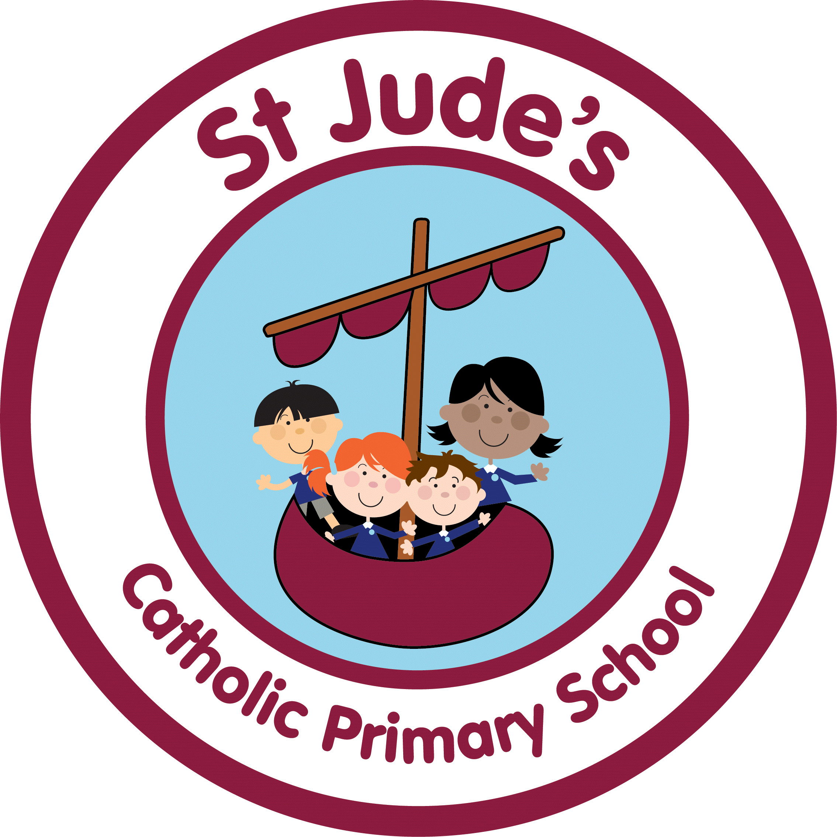
ST. JUDE’S CATHOLIC PRIMARY SCHOOL

Teaching Assistant Level 2

Job purpose: | Under the direction of teaching/senior staff to undertake work/care/support programmes to enable access to learning for pupils and to assist the teacher in the management of pupils and classroom.  To give support for SEN pupils providing particular help on a one-to-one basis for students with learning difficulties and/or behavioural, social or physical disabilities, as required
Reporting to: | Teachers/senior staff – teaching and non-teaching
Responsible for - Staff | None
Liaising with: | Pupils, teachers, senior staff, visitors to the school
Grade of post: | G3 | Gauge ref:
Disclosure level: | Enhanced

Job Outline
- To supervise and provide particular support, ensuring their safety and access to learning activities.
- To assist with the development and implementation of Individual education/behaviour plans and personal care programmes.
- To establish constructive relationships with pupils and interact with them according to individual needs.
- To provide specialist support to students with barriers to learning on a one to one basis, in a small group or in or out of the classroom
- To promote the inclusion and acceptance of all pupils.
- To encourage pupils to interact with others and engage in activities led by the teacher.
- To provide feedback to pupils in relation to progress and achievement under guidance of the teacher.
- To create and maintain a purposeful, orderly and supportive environment, in accordance with lesson plans and assist with the display of pupils’ work.
- To assist with the planning of learning activities.
- To monitor pupils’ responses to learning activities and accurately record achievement/progress as directed.
- To provide regular feedback to teachers on pupils’ achievement, progress and problems.
- To promote good pupil behaviour, dealing promptly with conflict and incidents in line with established policy and encourage pupils to take responsibility for their own behaviour.
- To provide clerical/admin support, for example photocopying, collection of money.
- To assist with the supervision of pupils out of lesson times, including before and after school as may be reasonably directed.
- To accompany teaching staff and pupils on visits, trips and out of school activities and take responsibility for a group under the supervision of the teacher as may be reasonably directed.

Other Specific Duties
To carry out the duties in the most effective, efficient and economic manner available.
To continue personal development in the relevant area.
To participate in the staff review and development appraisal process.
To act as a first aider and undertake the relevant training, if requested.

Health and Safety Training
To undertake Health and Safety Training on areas within the designated work area.

SIGNATURES / AUTHORISATION
Job profiles are general, rather than explicitly describing any particular role and staff would not necessarily be expected to carry out all of the activities described. However staff may also be expected to undertake some duties which are not detailed in the job profile.

I/we agree that this job profile is an accurate reflection of the duties, skills and responsibilities of the post.

Signed Governors: |  | Date
Signed Headteacher: |  | Date
Signed Jobholder: |  | Date
Print Name Jobholder: |  | NI No:
School Name:
DFES

Person Specification / Selection Criteria Teaching Assistant Level 2

A. Experience

 | Essential | Desirable | Source  A = Application  I = Interview  R = References  T = Task/Observation  P = Presentation
Experience of working and interacting with children of a relevant age and or learning need | E |  | A, I

B. Training and Qualifications

 | Essential | Desirable | Source
NVQ level 2 or equivalent qualification or an comparable level of experience | E |  | A, I
Basic level of literacy & numeracy | E |  | A, I
Willingness to undertake further relevant teacher assistant training |  | D | I
Willingness to undertake basic first aid |  | D | A, I

C. Knowledge and Understanding

Applicants should be able to demonstrate knowledge and understanding of the following areas relevant to the post.

 | Essential | Desirable | Source
Knowledge of basic Health and Safety |  | D | A, I
Basic knowledge of how to use ICT to support learning | E |  | A, I
Understanding of how to use relevant equipment/resources | E |  | A, I
Some knowledge of children’s games and activities | E |  | A, I
A knowledge of the national/foundation stage curriculum and other basic learning programmes |  | D | A, I
Understanding of relevant policies, codes of practice and awareness of relevant legislation |  | D | A, I
Basic understanding of child development and learning processes |  | D | A, I

D. Personal Skills, Abilities and Competencies

Applicants should be able to provide evidence that they have the necessary skills and abilities required.

 | Essential | Desirable | Source
Ability to communicate with and relate well to pupils and adults | E |  | A, I
Ability to work under supervision and as a team member | E |  | A, I
Ability to work in accordance with the schools health and safety policies | E |  | A, I
Ability to deal with minor injuries |  | D | A, I

E. Legal Issues

 | Essential | Desirable | Source
Legally entitled to work in the UK | E |  | A, I

