 | Senior Communications Officer (Workforce Communications and Engagement)
 | Service: |  | Communications and HR&OD | Grade: | 4A |  |  |  |  | Salary: |  |  |  | £32,878 - £35,934
 | Reporting to: |  | Communications Manager | Location: | Civic Centre |  |  |  |  | Hours: |  |  |  | 36 hours per week, Fixed Term 12 months
 | About the role |  |  |  |  |  |  |  |  |  |  |  | Our priorities
 | - Play a key role as part of the cross disciplinary enabling squad to support the communication and engagement of the work area programme.  - Deliver communications planning and evaluation within the strategic approach provided by the council’s communications strategy  - Use behavioural insights and practice to deliver effective, creative and influential communication/engagement approaches which raise understanding and change behaviours in line with our vision, values, priorities and culture.  - Lead the development and delivery of joined-up employee communications, engagement and behaviour change plans and strategies for priority projects to introduce new ways of working, measuring their effectiveness.  - Lead the development and delivery of a range of opportunities for employees to get involved, have their say and be empowered and enabled to improve and change ways of working.  - Lead the development and delivery of integrated digital information, communications and engagement solutions for major change projects, based on a robust understanding and targeting of audiences.  - Coordinate with colleagues in Communications and HR and OD to provide consistency and continuous improvement in communications, engagement and behaviour change approaches.  - Provide strategic advice and support to colleagues, partners, leaders and elected members on workforce communications and engagement approaches.  - Coach and support leaders at all levels to improve and enrich opportunities for information sharing, co-production and engagement that increase understanding, engagement and employee voice in changes.  - Work closely with other members of the Communications Team to motivate and support colleagues to ensure effective delivery and development of our workforce communications and engagement ambitions and culture. Where needed mentor and coach colleagues to support their development.  - Take an intelligence led approach to monitor, review and evaluate the impact of our strategies and approaches and through research and insight develop and improve our communications and engagement offer.  - Support the use of a targeted approach to improve, develop and embed the use of social and other media and communications channels as behaviour change, promotion, communication and engagement tools across the organisation.  - Work with stakeholders to identify, develop and support new partnerships to ensure effective and quality collaborative communications and engagement.  - Manage and monitor budgets for projects, events and campaigns as required.  - Support the planning and delivery of wider workforce communication and engagement projects, events and campaigns as needed  - Support the Communications team in providing an out of office hours service, participating in events and acting as lead officer in emergencies as required, including working out of office hours and at weekends when needed. |  |  |  |  |  |  |  |  |  |  |  | 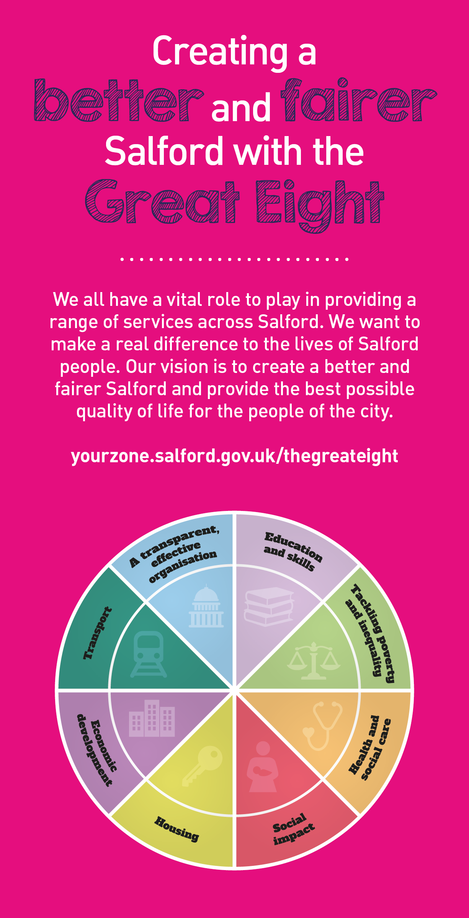
 |  | Key outcomes
 |  | - Lead key communications, engagement and change management to develop and implement a new digital platform for use by a large cohort of employees in the organisation, including the customer facing workforce .  - Develop and deliver a workforce communications and engagement plans as part of this digital transformation programme.  - Lead on the development and delivery of communications and engagement approaches to deliver the key workforce priorities to effectively introduce and embed new ways of working and the council’s digital strategy. Focusing on the delivery of digital transformation programme across a significant cohort of employees – enabling and supporting smarter working practices and delivering better outcomes to our citizens.  - Lead the development and delivery of our workforce communication and engagement approaches including the development and roll out of employee engagement tools and appropriate feedback tools to measure employee engagement levels and culture within targeted audiences, supporting the council’s communications strategy..  - Analyse current trends and themes emerging from employee engagement mechanisms and provide structured, timely feedback to leaders at all levels. |  |  |  |  |  |  | - Use behavioural insights to develop and deliver a range of targeted communication, engagement and OD interventions to promote behaviour change in line with our public service reform and workforce ambitions, including collaborative working with partners.  - Identify good practice that reinforce and promote our workforce ambitions and share stories to grow understanding and engagement across the organisation.  - Support the development of approaches to embed our values.  - Empower and encourage leaders at all levels to take ownership and accountability to drive employee engagement levels further and build effectiveness.  - Review and develop content for our extranet for employees to ensure it is as the ‘go to’ place for information, communications and engagement, for office and non-office employees.  - Work with the communications team to embed the use of social media and digital channels as a two way feedback/engagement mechanism with our existing and potential employees, evaluating the impact of this and co-designing improvements to enhance and develop this further.  - Provide effective workforce communications and engagement campaigns, including evaluations and work closely with Communication Team colleagues on the workforce strands of wider communications planning.
 |  | What we need from you
- Proven technical skills and ability in a similar role with a record of accomplishment for delivering outcomes across communications, workforce engagement, behaviour change or OD.  - Ability to empower and enable employees to be productive, efficient and effective to work, anywhere, anytime, creating a flexible workspace, whilst maintaining a healthy work life balance. ​  - A high level of understanding and practice in communications and engagement planning skills – able to agree and set objectives, target audiences, define messages and develop digitally-led approaches, ensuring evaluation is delivered  - Excellent writing, editing and proof reading skills, with a proven ability to translate complex ideas into concise, meaningful and ‘user-friendly’ content (written/ visual) to ensure audiences understand key messages through engaging story telling.  - Able to work independently, and as part of a cross-disciplinary group, whilst connecting strategically with colleagues in Communications and HR&OD.  - Able to build trust by role modelling ethical behaviour and applying consistent principles and values in decisions and choices.  - Able to see the bigger picture and identify strategic links.  - Able to creatively identify and deliver communication and engagement requirements and develop appropriate strategies and plans.  - Confidence to articulate and influence to gain buy-in whilst being open to the views of others - able to constructively challenge and be challenged. |  |  |  |  |  |  |  | - Able to influence, agree goals with colleagues and partners to develop effective collaborative approaches.  - A commercial mindset with behaviours that enable positive change.  - Strong organisational skills with ability to deliver key projects within agreed timescales.  - Able to bring together multi-faceted activities to improve performance.  - Able to take an intelligence-led approach and look for every opportunity to solve problems and improve the way we work whilst sharing learning with colleagues.  - A skilled communicator who acts with clarity, conviction and enthusiasm and is able to demonstrate build trust and confidence.  - Able to lead face-to-face engagement with forums, design workshops and drop-ins.  - Systems knowledge: Microsoft Office package skills. Ability to use email campaign management tools, social media management tools, content management systems and image and video editing tools to create content across different channels.  - Able to use existing digital skills to deliver the most effective communications and engagement solutions whilst being open to new ideas.  - Able to use technology to collaborate, connect and share to make the most use of digital tools and model new behaviours.  - Modelling and demonstrating our values, leadership and required behaviours.  - Personal responsibility for self-development, identifying opportunities to learn new skills that will enhance capability and impact.
 | Our leadership behaviours |  |  |  |  |  |  |  |  |  |  | Our values
As a values-based leader you will:  - Model the values and embed them in the way your team delivers services  - Hold people accountable for delivering the values  - Respect and care for others, treating everyone fairly, recognising the importance of ensuring equality of opportunity for all, and listening and acting on the things people say  - Be honest, taking responsibility for your actions and decisions  - Use resources that you are trusted with wisely. |  | To lead and develop people you will:  - Listen to understand, not to defend  - Give people the freedom to use their initiative  - Provide opportunities for people to discuss and solve problems and issues  - Regularly provide coaching and support to others to help them achieve their objectives and potential  - Appreciate and build on people’s strengths  - Motivate, engage, encourage and inspire others in order to be the best they can be.
To create a performance and development culture you will:  - Be visible, inject pace, vigour and purpose  - Expect high standards; mediocrity is not acceptable  - Take an evidence and whole system approach in making decisions  - Maximise technology and models to deliver quicker, easier, better services  - Have a digital mindset, fully utilising digital systems and solutions to deliver services differently  - Set context and challenging goals that will motivate people to take ownership, maximise performance, and develop. |  | To build and communicate a vision for the future you will:  Be optimistic and ambitious for the city and its people, helping others to understand the need to transform public services  Build strong collaborative relationships to find creative ways to make services more sustainable and flexible  Recognise and values the strengths of people and places, taking a strengths-based approach to make the most of opportunities  Support people through change, in undertaking new things, and taking risks  Take a place and whole system approach in designing, delivering and leading services  Ensure an inclusive approach with the aim of reflecting the increasing diversity of Salford.

What we can offer you
Your ongoing professional development and success in your role is important to us, and that is why we provide a variety of learning and development opportunities. Within the sections below you will find development options tailored to you which will enable you to further develop your existing skills and learn new ones at a pace that suits you best. If you are joining us now, your development will form part of ongoing discussions with your manager. If you are an existing employee, you should use your Personal Development Reviews to discuss your development with your manager and create your development journey. It’s important you also take full advantage of any informal learning available to you during the course of your work.
- Online Learning - Develop your knowledge across a wide range of areas through our Me-Learning platform, with over 200 free courses to choose from. To have the best possible start and comply with current legislation, you must complete the following modules: Welcome to Salford, Health and Safety in Office, Equality Essentials, GDPR, Safeguarding Children and Adults, and Safer Recruitment. You may also benefit from a variety of courses in categories such as Business Skills, IT and Project Management, Leadership and Management which are available to learn at your own convenience and pace.

- Developing your digital skills – Our ambition is to provide our workforce with the right level of digital capabilities needed to be successful. Whatever your current digital abilities are, we can provide development ranging from essential workplace skills to specialist workplace skills’. These will be delivered through our Digital Skills Academy using both self-directed and guided learning opportunities to enable you to develop. Additionally, you can access free online courses through the iDea website.

- Sharing your digital skills – Our goal is to support you to share your digital knowledge with other people. Our Digital Eagles programme has been designed to cover basic digital skills and build your confidence to assist others. By the end of this programme you will join hundreds of staff members who already are digital eagles, and be able to help colleagues, customers, residents, or people in your personal life with all things digital.

Application guidance

We are a values based organisation so reflecting our values or a values based approach in your evidence will support your application.

The ‘Key outcomes’, ‘What we need from you’ and ‘our leadership behaviours’ sections of the Role Profile are there to give you an understanding of what we would like to see reflected in your application. Don’t give up if you are not able to reflect all of these in your application.

