Senior Community Health Development Worker
Service: |  | Health Improvement Service | Grade: | 3a |  |  | Salary: |  |  | £24799 - £26999
Reporting to: |  | Health Improvement Officer | Location: | Community Based in Salford |  |  | Hours: |  |  | 36 hours
About the role |  |  |  |  |  |  |  |  | Our priorities
- To develop multi-agency working across communities, voluntary and statutory organisations to improve health and address health inequalities, using a community development approach. Encourage and build trusting relationships, participation and involvement in a variety of initiatives with communities and professionals.  - Collect qualitative information, through a variety of methods from the community, identifying needs and issues that affect health and wellbeing. Has responsibility to feed information into relevant organisations and partnerships through written or verbal reports.  - To assist and facilitate activities and events bringing local people and the relevant partners together to create a programme of work to address health inequalities and identify the gaps in the services. As well as, identifying participants for local groups around health and wellbeing.  - Responsible for planning, prioritising, implementing, reviewing own work plan on a daily basis.  - To develop, manage and access funding opportunities for community groups and initiatives as a core feature of community development process  - To support community groups in writing business and action plans, applying for resources, and managing budgets, through training and development  - To produce quarterly written workers reports, weekly performance monitoring forms and provide detailed written or oral reports to community committee, community groups, networks and forums as required, as well as updating appropriate electronic data systems.  - To be responsible for informing the community and other agencies about health and wellbeing initiatives and relevant issues and establishing communication links between different communities and organisations.  - To build the skills and capacity of community groups to influence decision making on local health facilities and projects  - To contribute to the delivery of new and local neighbourhood pilot projects and services, for example, MDG, Social Prescribing and Early Help Partnerships.  - To carry out literature searches, reviews and analyse current evidence for health improvement activities, to ensure best practice and carries out research and health needs assessments as required  - To develop, monitor and evaluate programmes of work.  - To work as a member of a team to deliver health initiatives within a given geographical area.  - To undertake any other such duties that are reasonably commensurate with the level of this post |  |  |  |  |  |  |  |  | 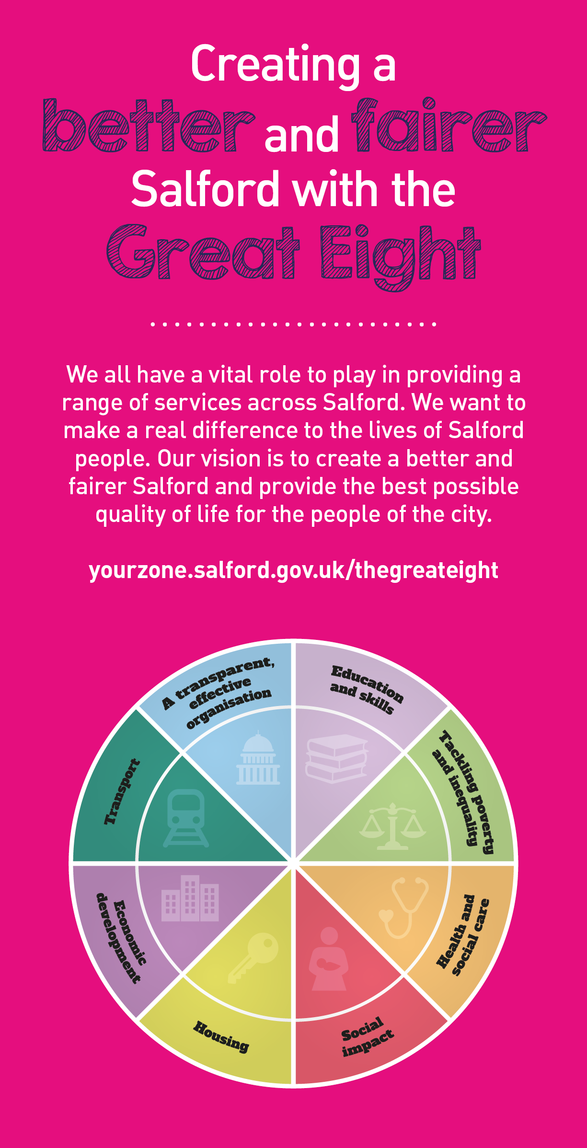
 | Key outcomes
 | - To contribute to the professional operations of the service.  - To communicate with staff and members of the public in a professional manner.  - To ensure work carried out adheres to SCC policies on confidentiality and GDPR.  - To contribute to the income generation for the service and the delivery of relevant new services.  - To be fully familiar with the work of the service and attending any relevant or identified training. |  |  |  | What we need from you | - To engage successfully with community members and volunteers and support their work within the local community.  - To forge links and networks to ensure community cohesion.  - To facilitate the effectiveness of communities working together on common themes and goals.  - Update social media accounts and timely response to clients.

- Proven technical skills and ability in the role with a record of accomplishment for delivering outcomes  - Professional credibility through proven relevant experience  - To model and demonstrate our values and behaviours  - Degree in Youth and Community Studies or equivalent  - Knowledge and understanding of Community Development principles and practice.  - Knowledge and understanding of health and wellbeing and the key determinants of health.  - Knowledge and experience of working in partnerships with a wide range of agencies, the voluntary sector and community organisations.  - Strong leadership and conflict resolution skills, and a non-judgemental attitude.  - A commitment to delivering flexible and responsive services, often outside of normal office hours including evening and weekends. |  | - Experience of project management, developing, monitoring and evaluating programmes of work.  - Developing, monitoring and evaluating programmes of work.  - Experience of developing new and innovative community development interventions an activities  - Experience of creating networks across agencies and communities  - Experience of supervising and managing volunteers or staff.  - Knowledge and experience of accessing funding streams.  - Experience of developing and delivering training in the community.  - Community work experience unpaid or voluntary capacity for 3 years full time equivalent or more, setting up and supporting a variety of community groups and initiatives across diverse communities.

Application Guidance |  | Our values
We are a values based organisation so reflecting our values or a values based approach in your evidence will support your application.

The ‘Key outcomes’, ‘What we need from you’ and ‘our leadership behaviours’ sections of the Role Profile are there to give you an understanding of what we would like to see reflected in your application. Don’t give up if you are not able to reflect all of these in your application.

Click here to enter text.

