Admin Officer - Neighbourhoods and Communities
Service: |  | Urban Vision Partnership | Grade: | 3C | Salary: |  |  | £29,636 - £32,029
Reporting to: |  | Senior Mech Services Surveyor | Location: | Salford Civic Centre, Swinton | Hours: |  |  | 36
About the role |  |  |  |  |  |  | Our priorities
- This role is for a Mechanical Services Surveyor and they will be responsible for service delivery to a wide range of clients in providing servicing, maintenance and repair support for the private, education and local authority sectors  - Have responsibility for early stage design and feasibility work  - Develop detailed briefs in conjunction with the client  - Carry out detailed design work and prepare production information  - Undertake the role of Project Manager  - Undertake all aspects of professional surveying work (including surveys, asset management)  - Delivery of service, maintenance and repair to mechanical building services to comply with statutory requirements and best practice  - Upkeep of service and test records for mechanical building services including uploading and updating the city's statutory compliance portal |  |  |  |  |  |  | 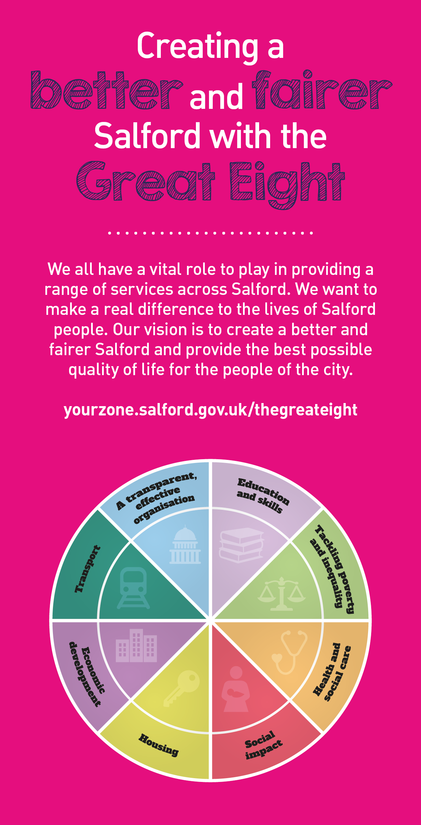
 | Key outcomes
- Provide an efficient and effective servicing, repairs and maintenance service, with minimal requirement for supervision by senior staff
- Ensure that statutory requirements of mechanical building services for properties for which we are responsible are performed the the requirements of the regulations and on time. Ensure the supporting inoforamation is recorded and logged on Salford's statutory compliance portal
- Perform site surveys, site visits and liaise with building occupants or clients to determine the need for and priority of repair or refurbishment work
- Posses the ability to prioritise and manage multiple projects to deadline and budget
- Provide information to senior staff relevent to future programmes of work or individual requirements for major work or renewal of services, etc
- Implement projects to meet the requirements of quality, health and safety, environmental standards, and to both national and corporate standards
- Prepare schemes for tender using the JCT Forms of Contract; specification and CAD drawings to the requirements of current legislation
- Supervision and monitoring of works on site including: making valuations for payment assessments; chairing and managing progress meetings; identification and assessment of additional payments due to variation orders or compensation events; determination of project final accounts and satisfactory completion of the defects period.
- Ensure compliance of the work with a high regard to Health and Safety and the application of the CDM Regulations and other Legislation..

What we need from you |  | Our values
- Proven technical skills and ability in the role with a record of accomplishment for delivering outcomes
- Professional credibility through proven relevant experience
- Models and demonstrates our values

- Essential Criteria

- HNC in Building Services (HVAC) or equivalent
- Minimum 2-3 years post qualification experience within a building services environment
- Ability to establish a good working relationship with clients and colleagues
- Self motivated and able to work without supervision
- Ability to prioritise and work to deadlines
- Good communication and customer skills
- Ability to demonstrate flexible approach to work
- Ability to undertake pre and post contract control of building contracts under appropriate forms of contract in accordance with Quality Assurance procedures
- A knowledge of current legislation, e.g. Health & Safety, CDM, Building Regulations.
- Car driver with current driving licence

- Desirable Requirements

- Membership of the C.I.B.S.E.
- Experience in education, health and leisure projects
- Experience in private and local authority sectors
- Use of AutoCAD

Application guidance

We are a values based organisation so reflecting our values or a values based approach in your evidence will support your application.

The ‘Key outcomes’, ‘What we need from you’ and ‘our leadership behaviours’ sections of the Role Profile are there to give you an understanding of what we would like to see reflected in your application. Don’t give up if you are not able to reflect all of these in your application.

