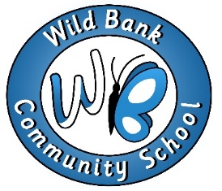
Dear Applicant,

Post: Learning Mentor

Appointment for April 2020

Thank you for expressing interest in this post at Wild Bank Community School. http://www.wildbank.tameside.sch.uk/

Wild Bank is a friendly and nurturing primary school with excellent resources, enthusiastic staff and Governors. We are passionate about education, the future for the children we educate. This is an exciting opportunity to join our supportive team as we grow. We have recently completed considerable alterations to accommodate our rising number of pupils and enhance our learning environments. Wild Bank is a school which cares about community. On 1st April 2020 we will be joining the Victorious Academy Trust.

Our recent OFSTED inspection recognises our strong pastoral care. We were the first primary school in Tameside to achieve the ACSEED award and the Marjorie Boxall Quality Mark. The emotional wellbeing of our pupils is essential if they are to achieve their potential. Our Forest School also enhances the provision that we provide for our pupils.

We are able to offer you many professional and personal opportunities. We have dedicated staff and strong links with other schools within our geographical cluster and within the Victorious Academy Trust. We have a commitment to the professional development of all staff and in supporting all adults in the school community in pursuing and achieving their goals.

We strive to ensure that every child achieve their best academically, socially and emotionally with the knowledge and understanding, ambition and creative thinking skills to open up all the opportunities in their futures. We are looking for an inspirational teaching assistant to join us in playing a key role achieving the school’s vision for our children and families.

If you think you have the drive, energy, ambition and high expectation we are looking for and you want to join us on our journey this is a great opportunity! If you believe that you share our vision and values and have the necessary skills, qualities and expertise to play a key role in our continued development and improvement we look forward to meeting you.

Please refer to the job description and person specification when completing the application form.

Please return completed forms either by post or electronically directly to the school.

We warmly welcome visits from candidates and feel that these are an important part of the application process.

Yours Sincerely,

Mrs. Jenny Callaghan
Head Teacher

Our motto: Working together, we can achieve our best!

