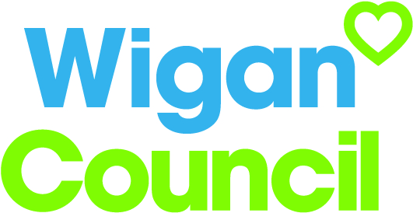
Job specification
Job title: | Marketing Officer
Service: | Public Relations Team
Grade:  Salary Range: | G8  £27,668 - £31,601
Reporting to: | Marketing and campaigns manager

Your job
You will be responsible for a portfolio of services and will deliver a first class marketing service to achieve corporate objectives and increase awareness of council services.

You will manage and enhance the council’s reputation through well planned, well executed and cost effective marketing activity.

You will develop and deliver integrated marketing plans and campaigns offering creative and innovative ideas to communicate key messages to target audiences.

You will promote and defend the reputation of the borough by cultivating partnership work with other agencies and you will be a brand guardian and ambassador for Wigan Council.

In this job you will
On an on-going basis you will

- Play a key role in enhancing the reputation of the council with the public, improve public confidence and increase use of council services.
- Ensure brand identity in all materials through consistent use of brand guidelines.
- Provide expert marketing advice to senior council staff, other employees and elected members.
- Research new marketing techniques to enable the council to better engage citizens.
- Work with colleagues to develop a more in-depth understanding of our customers.
- Work with colleagues to deliver content, layout, design and production of marketing collateral ensuring quality and appropriate tone.
- Utilise social media to deliver campaigns.
- Utilise and enhance digital communication channels.
- Monitor and review campaigns and provide evaluation reports.
- Be an ambassador for Wigan Council in external forums.

In this job you will need
You must be able to demonstrate the following essential requirements:

- A relevant professional or academic qualification or demonstrable experience relevant to the job.
- A proven track record in providing first class marketing service and advice.
- Significant experience of marketing.
- Demonstrable experience of planning, creating and delivering innovative marketing campaigns.
- Demonstrable knowledge and use of digital and social media channels.
- Ability to research for accurate customer intelligence and utilise, shape and evaluate campaigns
- Demonstrable experience of campaign budget planning and budget monitoring.
- Experience of protecting and policing a corporate brand.
- Demonstrable experience of establishing and maintaining positive relationships with a range of stakeholders.
- Excellent communication, negotiation and influencing skills.
- Ability to make decisions and resolve complex problems.
- Strong project management skills.

Our culture
For us, it’s not just about all we achieve as an organisation, but how we do it. Therefore, all employees are expected to display our Be Wigan behaviours.
Be Positive… take pride in all that you do

Be Accountable… be responsible for making things better

Be Courageous… be open to doing things differently

Individuals with line management responsibilities are also expected to …
Inspire…lead by example and help others to see the big picture

Care… show genuine concern for people as individuals and value their contributions

Engage… I connect with others both within and beyond the organisation

Staff Deal
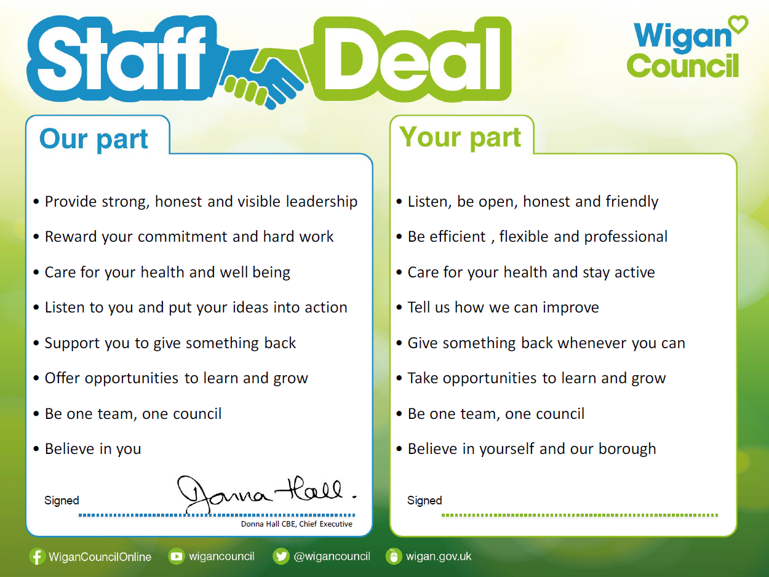
Our Staff Deal is an informal agreement with all staff. It outlines what you can expect from us, and in return what we expect from you

