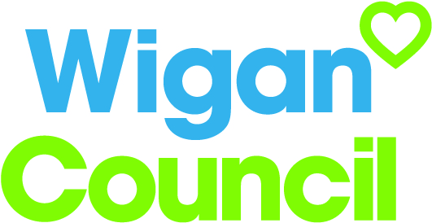
Job specification
Job title: | CVD Pathway Facilitator – Acute
Service: | Adult Social Care and Health – Public Health
Grade: | G9
Reporting to: | Public Health Programme Manager

Your job
This role offers an exciting opportunity to radically take charge in transforming systems and processes to contribute in the delivery of the Heart of Wigan Population Programme to improve the health and wellbeing outcomes of our residents.

The core role is to work with the acute sector in Wigan Borough to develop, shape and embed key health improvement interventions within appropriate care pathways and treatment to improve management, recovery and reduce potential escalation of recurrence.

This unique role will play a fundamental role in helping to transform health and social care and contribute to the delivery of the Wigan Borough Locality Plan ‘Further Faster Towards 2020’.

In this job you will
Within the first 3 months you will:

- Develop a robust action plan to direct and shape the delivery of embedding heath improvement interventions (NRT and Fuel Poverty) within targeted clinical pathways in the Acute setting
- Ensure robust systems are in place to monitor and evaluate programme delivery

Within the first 12 months you will:

- Lead on the implementation of the action plan across the Acute setting
- Embed NRT prescribing and dispensing into targeted care pathways e.g. Respiratory, Cardiac, as well as within pre-operative process for elective surgery
- Embed Fuel Poverty assessments into targeted care pathways e.g. Respiratory, Cardiac

On an ongoing basis, you will:

- Lead the development, implementation and management of embedding health improvement interventions within targeted clinical pathways
- Engage and build effective partnership working with key stakeholders across the Acute setting and wider to ensure sufficient collaboration for transforming systems and processes

In this job you will need
You must be able to demonstrate the following essential requirements:

- Significant experience of working within an Acute setting
- Hold a nursing or equivalent qualification
- Strong project management skills
- Excellent problem solving skills linked to ability to advice and influence others
- Excellent communication skills including establishing and maintaining trust and effective working relationships across all levels
- Excellent decision making skills
- Be innovative and solution focussed
- Experience of effectively monitoring and evaluating programmes
- Ability to work on own initiative demonstrating effective organisation and management skills to meeting deadline

Our culture
For us, it’s not just about all we achieve as an organisation, but how we do it. Therefore, all employees are expected to display our Be Wigan behaviours.
Be Positive… take pride in all that you do

Be Accountable… be responsible for making things better

Be Courageous… be open to doing things differently

Individuals with line management responsibilities are also expected to …
Inspire…lead by example and help others to see the big picture

Care… show genuine concern for people as individuals and value their contributions

Engage… I connect with others both within and beyond the organisation

Staff Deal
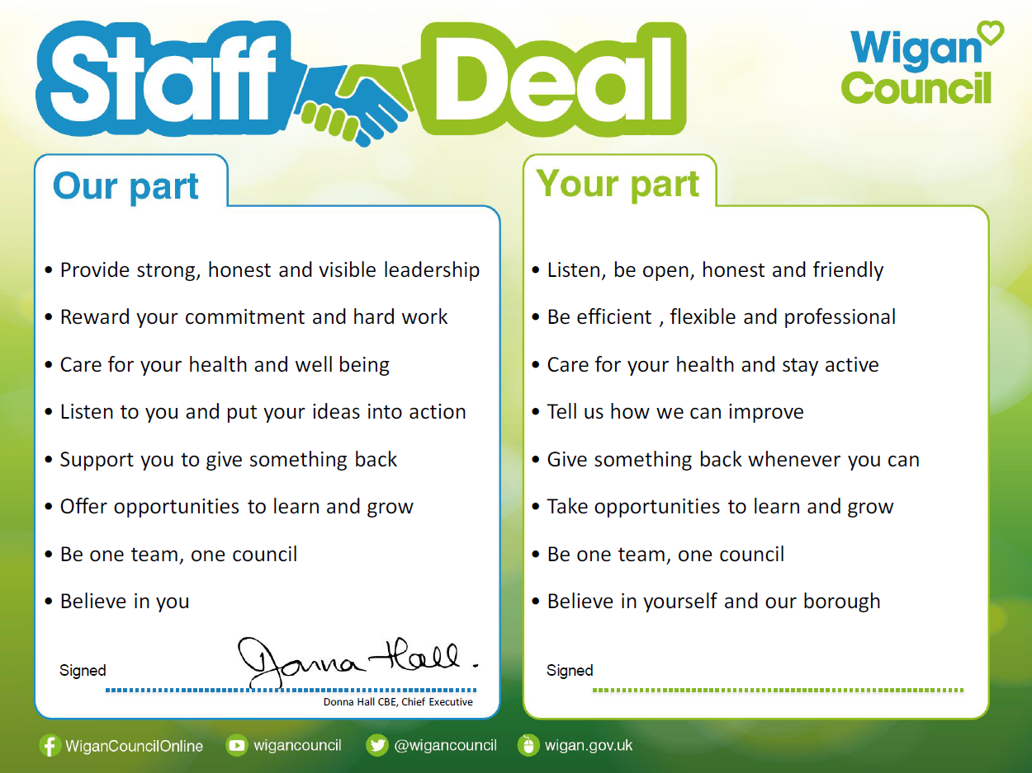
Our Staff Deal is an informal agreement with all staff. It outlines what you can expect from us, and in return what we expect from you

