Edge of Care/Residential Keyworker
Service | Reporting to | Location | Grade
Route 29 | Caroline Pickersgill | Various Areas around Salford | 3A plus 2

About the role
As a Residential / Edge of Care Worker, you will value and actively contribute to the vision of the Route29 (formerly No Wrong Door) Service
You will demonstrate a commitment to the Route 29 (No Wrong Door) way of working, helping to ensure that services are responsive to the needs of service users and their families/carers.
You will work effectively as part of a wider multi-agency team to ensure that the needs of children and young people are met.
You will be directly involved in the care and development of young people, making sure that they have appropriate plans in place, they know their options and their views are listened to.
You will support young people in all areas of their lives including physical, emotional health, forming relationships, developing life skills, keeping safe, education/training/employment and accessing appropriate housing.
You will act as a key worker for young people, advocating for them in a professional manner where required.
You will take a positive interest in the young person’s development, maintaining contact with the family/ carers, and any other professionals, including attending meetings and reviews and providing reports and information as necessary.
You will maintain effective recording systems ensuring all records pertaining to the young person are up to date and accurate, to comply with regulations and Ofsted requirements and the organisation’s policies and practices.
You will demonstrate an awareness and knowledge of child protection and safeguarding procedures and participate in assessing risks, managing risk appropriately through a risk managed (not risk averse) approach.
You will be flexible, working on a Rota system, including sleep-in duties, evenings and weekends shift work, as required to meet the needs of the service
You will work on your own initiative, often in an outreach setting, and will be able to demonstrate resilience, and a solution-focused approach to issues that arise, working with young people and their families/carers in order to help them rebuild relationships, increase their achievements, reduce their risks and build on their strengths.
You will develop and maintain positive working relationships with colleagues and other professionals, young people and their families/carers, communicating well at all levels, showing consideration, concern and respect for other people’s feelings, opinions and differing needs and viewpoints.
You will understand the impact of trauma, neglect and early adversity on adolescents.
You will establish and maintain personal and professional boundaries.

Key outcomes

Children and young people within the Route 29 (No Wrong Door) Service will be fully engaged, motivated and committed to their individual Intervention and care plans.

You will encourage and support young people to make steady progress and achieve their full potential, by giving them the skills to meet their own individual needs, in a safe, warm and welcoming environment, in which diversity & equality underpins the opportunities offered to all the young people.

You will proactively support young people to return to their families or remain with their families where appropriate.

You will undertake planning, preparation and support for young people to achieve more independent living;

To improve the outcomes for all young people in Route29 (No Wrong Door0, by enabling them to have a right to have an active say in decision making, including and valuing the contributions of families and carers.

You will offer advice, support and guidance to adults, carers, families and children in need. Working as part of a multi agency team you will display a genuine commitment to the needs and welfare of vulnerable children and adults to ensure the best outcomes for them.

You will ensure that the safety and welfare of children, young people and vulnerable adults that you come into contact with during the course of your professional duties is paramount at all times, responding appropriately to signs of harm, abuse and neglect and managing risk appropriately.

You will support, encourage and motivate young people ensuring that every young person becomes a confident, resilient adult by focusing on building strong relationships, developing resilience, learning life skills and exploring opportunities to help them achieve their goals, in order that they lead more fulfilling lives and contribute positively to their communities..

What we need from you.
You will model and demonstrate our values and behaviours.
You will have previous relevant experience of working with young people and families.
Minimum Level 3 Diploma in Residential Childcare or equivalent qualification or willingness to work towards obtaining relevant qualification.
You will be required to undertake and successfully complete relevant training programmes as required by governing regulations, guidance and the City Council policies and procedures.
Enhanced DBS clearance
Commitment to the Route29 (No Wrong Door) Multi-agency approach, proactively supporting young people and their families/carers to ensure the best outcomes for them.
Willingness to flexibly work outside of standard office hours as required by the needs of the service
To sleep in as and when required.
You will be a good listener, have patience, understanding, humour and passion to “stick” with and support the young people within the Route29 (No Wrong Door service).
You will support the young people to manage their own behaviors both individually and in a group setting by the use of positive professional relationships, seeking at all times to de-escalate possible confrontational situations. Carrying out restraint when required in line with Children’s Home Regulations.
You will promote good emotional and physical health, working in partnership with other agencies to best meet individual’s needs.
As required, to undertake medication training and be competent in administering medication to young people including controlled drugs where prescribed. Ensuring that procedures for the administration of medication are followed and appropriately recorded.
To be prepared to move to other homes within the service to ensure a balance of expertise amongst staff teams.
To work in accordance with the Children’s Homes Regulations, and other statutory guidance, and co-operate with any inspection process.
To undertake financial management and be accountable for monies allocated as required in accordance with Salford City Council’s and the Route29 (No Wrong Door) policies and procedures.
Demonstrate a willingness to engage in reflective practice and commit to ongoing personal & professional development.
To be a positive role model to assist young people in the development and sustaining of positive social networks with adults and other peer groups.
Complete reports for and participate in statutory reviews and meetings concerning the young people where required
To write and implement comprehensive behaviour management, risk management and placement plans, following advice when required from specialised services, and make professional judgements based on the young person’s developmental stage and risk.
You will be able to demonstrate awareness of relevant legislation and implement / adhere to it as appropriate.
Demonstrate knowledge of Trauma Informed Approach and Restorative Practice.
Detailed knowledge of National Minimum Standards, Children’s Home Regulations and Safeguarding Frameworks.
You will need to demonstrate problem solving skills and the ability to find innovative solutions
Ability to communicate equally, appropriately and effectively with the widest range of individuals and groups across all sectors and levels of society.
You will have a good level of competency in basic computer skills including the use of Word, databases, the internet and email having regard to the GDPR and associated policies.
You will ensure that all information received and disseminated, whether verbal or written, concerning all employees, prospective employees or clients, is treated in the strictest confidence, and that all such information held is regulated and controlled in a similar manner.
You will carry out your duties to the highest standard, with full regard to the City Council's and service’s Policies, procedures, protocols and Code of Conduct.
You will actively promote equality by identifying potential for discrimination and challenging inequality in all circumstances. Through personal example, open commitment and clear action, you will ensure diversity is positively valued.
You will regularly reflect on practice (both your own and general operating practices) and take full advantage of professional supervision and appraisals.

The post holder will be expected to undertake the duties commensurate within the range and grade of the post or any lesser duties as directed.
NB: The aim of the role profile is to indicate the general purpose and level of responsibility of the post. Please be aware that duties may vary from time to time without changing their character or general level of responsibility. Duties may be subject to periodic review (in consultation with the postholder where appropriate) to reflect the changing work requirements.

What we can offer you

Your ongoing professional development and success in your role is important to us, and that is why we provide a variety of learning and development opportunities. Within the sections below you will find development options tailored to you which will enable you to further develop your existing skills and learn new ones at a pace that suits you best. If you are joining us now, your development will form part of ongoing discussions with your manager. If you are an existing employee, you should use your Personal Development Reviews to discuss your development with your manager and create your development journey. It’s important you also take full advantage of any informal learning available to you during the course of your work.

Online learning
Develop your knowledge across a wide range of areas through our Me-Learning platform, with over 200 free courses to choose from. To have the best possible start and comply with current legislation, you must complete the following modules: Welcome to Salford, Health and Safety in the Office, GDPR, Equality Essentials, and Safeguarding Children and Adults. You may also benefit from a variety of courses in categories such as Business Skills, IT and Project Management which are available to learn at your own convenience and pace.

Professional Development
Gain role-specific skills and time to learn through a wide range of development opportunities. Learn whilst working and get support towards your qualification through an apprenticeship standard. Access professional development ranging from entry-level to master’s type qualifications, including achieving a role-appropriate qualification. Details can be found on the Institute of Apprenticeships website.
A digital organisation
Developing your digital skills
Our ambition is to provide our workforce with the right level of digital capabilities needed to be successful. Whatever your current digital abilities are, we can provide development ranging from essential workplace skills to specialist workplace skills. These will be delivered through our Digital Skills Academy using both self-directed and guided learning opportunities to enable you to develop. Additionally, you can access free online courses through the iDea website.

Sharing your digital skills
Our goal is to support you to share your digital knowledge with other people. Our Digital Eagles programme has been designed to cover basic digital skills and build your confidence to assist others. By the end of this programme you will join hundreds of staff members who already are digital eagles, and be able to help colleagues, customers, residents, or people in your personal life with all things digital.

Our vision and priorities

Our vision
The council has a vision is to create 'A fairer, greener and healthier Salford'. To help us achieve this vision we have identified some key priorities to tackle the problems people in Salford are currently facing, the Great Eight.
Salford is beginning a journey of economic transformation, with the mapping out of the city’s economic future through key pieces of city council work. We’re calling this The Salford Way.
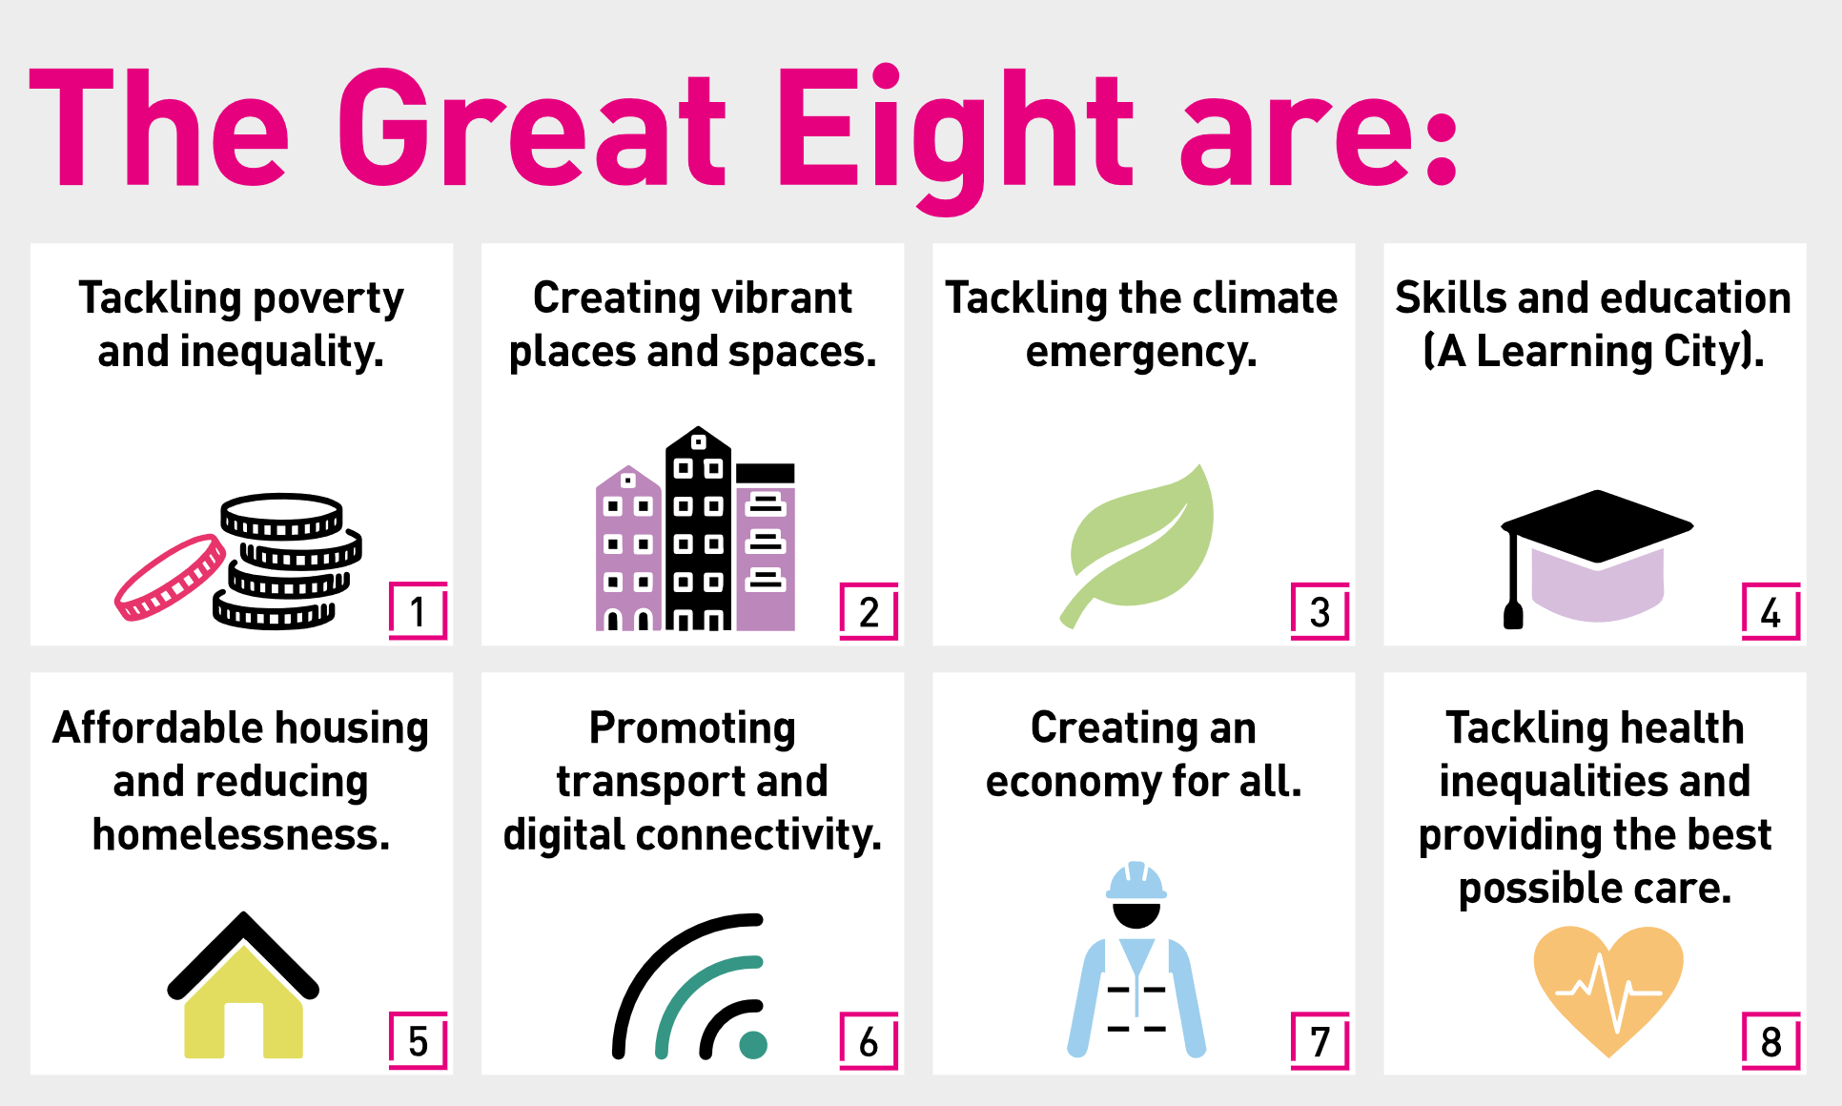

Our organisation’s values
We have four values: Pride, Passion, People, Personal responsibility.
Our four values are central to the way we communicate about the council and the way in which we behave with colleagues, customers, and partners - so that we live and breathe our values each day.

Application guidance
We are a values-based organisation so reflecting our values or a values-based approach in your evidence will support your application.
The different sections of this role profile are there to give you an understanding of the purpose of the role. The ‘what we need from you’ section outlines the minimum criteria you will need to meet within your application.

Role details
Completed by:
Date:
Job code:
Job score:
Date of evaluation:

